ANTIBACTERIAL EFFECT OF Thuja LEAVES EXTRACT

A
Project work submitted to
Department of Microbiology
Central Campus of Technology, Tribhuvan University

In Partial Fulfillment for the Award of the Degree of
Bachelor of Science in Microbiology

Submitted by
Sunil Regmi
Department of microbiology, CCT, Tribhuvan University
Hattisar, Dharan
September, 2016

RECOMMENDATION

This is to certify that Mr. Sunil Regmi has completed this project work entitled “ANTIBACTERIAL EFFECT OF Thuja LEAVES EXTRACT” as a part of partial fulfillment of the requirements of Bachelor’s degree in Microbiology under my supervision. To my knowledge this work has not been submitted for any other degree.

………………………..
Mr. Shiv Nandan Sah (Asst. professor)
Supervisor
Department of Microbiology
Central Campus of Technology
Hattisar, Dharan, Nepal

Date:

CERTIFICATE OF APPROVAL

On the recommendation of Mr. Shiv Nandan Sah, this project of Mr. Sunil Regmi entitled “ANTIBACTERIAL EFFECT OF Thuja LEAVES EXTRACT” has been approved for the examination and is submitted to the Tribhuwan University in Partial fulfillment of the requirements for Bachelor’s degree in Microbiology.

......................................................
Mr. Shiv Nandan Sah (Asst. professor)
Head of Department
Department of Microbiology
Central Campus of Technology
Hattisar, Dharan, Nepal

Date:

BOARD OF EXAMINERS

Recommended by:
..........................................
Mr. Shiv Nandan Sah
Supervisor

..........................................
Mr. Man Kumar Tamang
Co- supervisor

Approved by:
..........................................
Mr. Shiv Nandan Sah
(Assistant Professor)
Head of Department
Department of Microbiology

Examined by:
..........................................
(Internal Examiner)

..........................................
(External Examiner)

Date:

ACKNOWLEDGEMENTS
It is a great privilege to be able to acknowledge the people without whom this project work wouldn’t have been possible. Firstly; I would like to express my gratitude to my respected supervisor as well as HOD of microbiology Mr. Shiv Nandan Sah for his guidance throughout my work. His supportive guidance was the base for my work. I would also like to thank my co-guide Mr. Man Kumar Tamang and lecturer Prince Subba for their help and support. I am also thankful to Mr. Suman Rai for providing me ideas for the work and help on the literature. I am also thankful to my entire teaching and non-teaching staffs of microbiology department for their constant support.
I would also like to thank:
Mr. Aindra Bahadur Karki, Kamana Bantawa Rai, laboratory persons of microbiology department for providing necessary materials and their help on my works.
My loving and respected parents, Mr. Ishwari pd. Regmi and Mrs. Parbati Regmi for their love, support and encouragement to make me stand here today.
My very dear friends: Tin Maya Rai, Sushmita Phattepuri and Hookman jimi Rai for their great support and encouragement during the study.
Above, I have gratefully acknowledged people who have been invaluable to me in completing this project work. However, all the opinions expressed in this work, and all errors, are mine.

-----------------------------
Sunil Regmi
Date:

ABSTRACT

Plants have been one of the important sources of medicines even since the dawn of human civilization. Various medicinal plants are common in use in Nepal for the treatment of different diseases. Nowadays, drug resistance has emerged as a major problem for various infections, in such case plants can be used as alternative for the production of new antimicrobial agents. Thuja is a small evergreen genus of the Cupressaceae family. This species is widely cultivated as a common ornamental plant in Nepal and India. This study examined and documented the antibacterial activity of Thuja leaves extract on both gram positive i.e. Staphylococcus aureus and Streptococcus sp. and gram negative bacteria i.e. E. coli and Pseudomonas aeruginosa. Thuja leaves were collected from different localities of Dharan and dried under shade for 10 days. They were then grinded using mechanical grinder. Leaf extract was obtained by soxhlet extraction technique using mixture of Ethyl acetate, Ethanol and chloroform in the ratio 40:30:30 as the solvent. The antibacterial activity of Thuja oleoresin was tested using both Agar well diffusion as well as disc diffusion technique. MIC was also determined by agar well diffusion on MHA plates. Thuja oleoresin showed distinct antibacterial activity towards all four isolates on both agar well and disc diffusion methods. MIC for Pseudomonas aeruginosa and Streptococcus sp. was found to be 12.5µl whereas E. coli and Staphylococcus aureus have a MIC of 25µl. Thus from the result it is concluded that Thuja leaves have medicinal values and can be a potential source for production of antibacterial drugs.

Contents

RECOMMENDATION ii
CERTIFICATE OF APPROVAL iii
BOARD OF EXAMINERS iv
ACKNOWLEDGEMENTS v
ABSTRACT vi

INTRODUCTION 1
1.1 Background 1
1.2 Rationale of study 3
1.3 Objectives 4
1.4 Limitations of the study…………………………………………………..4
LITERATURE REVIEW 5
2.1 Medicinal plants 5
2.2 Common medicinal plants of Nepal 6
2.3 Use of Thuja as medicinal plant 6
2.4 Antibiotic resistance of diseases 9
2.5 Minimum Inhibitory Concentration 11
MATERIALS AND METHODS 13
3.1 Site of the study: 13
3.2 Laboratory setup 13
3.3. Research method: 13
3.4. Type of study: 13
3.5. Population and sample: 13
3.5.1. Population 13
3.5.2 Sample 13
3.5.3 Bacterial sample 13
3.6 Research design 14
3.7 Drying of Thuja leaves 15
3.8 Preparation of extracts 15
3.9 Preparation of standard inoculums of test organisms 15
3.10 Screening of antibacterial activity (Evaluation methods) 16
3.11 Agar well diffusion method 16
3.12 Minimum Inhibitory Concentration 16
3.13 Disc diffusion method 16
3.14 Data collection 17
3.15 Data analysis 17
RESULT 18
4.1 Effect of oleoresin on the isolates 18
4.2 Effect of oleoresin on the isolates on well as well as on agar diffusion 18
4.3 MIC assay 19
DISCUSSION 20
CONCLUSION AND RECOMMENDATIONS 22
6.1 Conclusion 22
6.2 Recommendations 22
6.2.1 Recommendation 22
6.2.2 Recommendations for further study 23
REFERENCES 24

APPENDIX I: MATERIALS USED I
APPENDIX II: COMPOSITION OF MEDIA USED II
APPENDIX III: TABLES III

TABLES

Table I: Effect of oleoresin on the isolates on both well and agar diffusion
Table II: Zone of inhibition of different isolates for MIC determination

PHOTOGRAPHS
Photograph 1: Effect of oleoresin on E. coli on well diffusion
Photograph 2: Effect of oleoresin on Staphylococcus aureus on well diffusion
Photograph 3: Effect of oleoresin on E. coli on disc diffusion
Photograph 4: Effect of oleoresin on Streptococcus sp. on disc diffusion
Photograph 5: Determination of MIC for Pseudomonas aeruginosa
Photograph 6: Determination of MIC for Staphylococcus aureus

ABBREVATIONS

MHA Muller Hinton Agar
MIC Minimum Inhibitory Concentration
MRSA Methicillin Resistant Staphylococcus aureus
MT Mother Tincture
NB Nutrient Broth
WHO World Health organization

PART I

INTRODUCTION

1.1 Background
The history of traditional medicine is as old as human civilization. Many ancient documents revealed that plants were used medicinally in china, India, Egypt and Greece long before the beginning of Christian era. During the same period, particular efforts had been progressing to examine and classify the medicinal herbs. (Gyawali 2013) Plants were used as antimicrobials before microbiological study had even been started.
An antibacterial substance is anything that destroys bacteria or suppresses their growth or their ability to reproduce. In the 1940s antibacterial (also called antibiotics) was defined as a substance produced by one microorganism which in low concentrations inhibits the growth of other microorganisms. The meaning of the term has changed over the years, both because of increasing number of synthetic analogues as were as their production from other biological sources like plants and animals. (Hugo and Russel 2013) Plants are rich source of antibacterial components. Different plant extracts are being used in daily life to combat bacterial and fungal infections.(Duhan et al 2013) In this study, oleoresin extracted from Thuja leaves by a mixture of ethyl acetate: ethanol: acetone (40:30:30) was explored for their antibacterial activity against various bacteria (i.e. S. aureus, Streptococcus sp., P. aeruginosa and E. coli).
Thuja is a small evergreen genus of the Cupressaceae family comprising five extant species. (Tsiri et al 2009) It is called ‘Dhupi’ in Nepali. It grows naturally in china, Korea, Japan and Iran. Also this species is widely cultivated as a common ornamental plant in Nepal and India. (Shah and Qadir 2013)
Bacteria nowadays due to improper use of drugs are getting antibiotics resistant day by day. Emerging of new disease as a new threat has become common. To solve these types of problems new drugs are to be examined and prepared. The target of the present study is to unravel the effect of Thuja species on some common gram positive (Staphyloccus aureus, Streptococcus sp.) and gram negative bacteria (E. coli, Pseudomonas aeruginosa)
Escherichia coli are usually a commensal bacterium of humans and animals. Pathogenic variants cause intestinal and extra-intestinal infections, including gastroenteritis, urinary tract infection, meningitis, peritonitis, and septicemia. (Baum 2005; Sodha et al 2006) Pseudomona aeruginosa is a non-sporing, non-capsulate, gram-negative bacillus. It can affect almost any external site or organ. Infection in hospital patients includes urinary tract infection, infected ulcers, burns and eye infections. (Greenwood et al 2007)
Staphylococci are gram positive cocci about 1µm in diameter that are commonly found on skin of healthy individuals. Staphylococcus aureus is present in the nose of 30% of healthy individual but can causes infections at sites of lowered host resistance, such as damaged skin or mucous membranes. Methicillin resistant staphylococcus (MRSA) in many cases has been a major public health issue. Streptococci are gram positive cocci that typically grow on chains or pairs. They cause a wide range of suppurative infections in the respiratory tract and skin, life threatening soft tissue infection and certain types of toxin-associated reactions. (Greenwood et al 2007)
Essential oils derived from many aromatic plants are well known to possess cytotoxic, antioxidant, antifungal, insecticidal and antimicrobial activities. (Shah and Qadir 2013) In folk medicine, Thuja occidentalis has been used to treat bronchial catarrh, enuresis, cystitis, psoriasis, uterine carcinomas, amenorrhea and rheumatism. (Tsiri et al 2009)
A wide range of technologies is available for the extraction of active components and essential oils from medicinal and aromatic plants. The choice depends on the economic feasibility and suitability of the process to the particular situation. Many of the plant materials used in traditional medicine are readily available in rural areas at relatively cheaper than modern medicine. (Duhan et al 2013)

1.2 Rationale of study
People have been using plant as medicine since a very long time and the knowledge of plant as medicine have been transferred from generation to generation. However, much of the knowledge has been based only on the experience of the people and not much of study had been done in Nepal. Scientific approach is to be made to determine the effect of the plants, reasoning is to be done and applications are to be determined. Nowadays due to emergence of new drug resistant diseases there is a necessity for the discovery of new drugs in a scientific way. As Thuja is used in most of the traditional system, the findings will support for scientific validation for the use of this plant for antibacterial activity, against both gram positive (Staphylococcus aureus and Streptococcus sp.) and gram negative bacteria (E. coli and Pseudomonas aeruginosa). It can also be used as proof for the implication of this plant in the field of medicine and pharmaceuticals.

1.3 Objectives
- General objective
- To determine the antibacterial activities of Thuja leaves on some common gram positive and negative bacteria.

- Specific objectives
- To extract essential oils from Thuja leaves using soxhlet extraction.
- To determine the antibacterial effect of Thuja oleoresin on E. coli, Pseudomonas aeruginosa, Staphylococcus aureus and Streptococcus sp.
- To determine minimum inhibitory concentration of the extract on each bacteria.

1.4 Limitations of the study

In this study antibacterial effect of Thuja leaf extracts was determined on some common pathogenic bacteria on culture media. Thus, this study does not guarantee for its direct usage on treatment of disease for humans. This study also does not show inhibitory effect of Thuja on fungi, actinomycetes, plant pathogens as well as other untested bacteria. This study also does not show the exact phytochemical component responsible for the antibacterial activity of Thuja leaves.
PART II

LITERATURE REVIEW

2.1 Medicinal plants
Medicinal plants are one of the major sources of drugs all over the world. They are used, mostly in the form of extracts, as traditional drugs or as source of semi-synthetic bioactive drugs. The WHO estimates that medicines, derived directly or indirectly from plants constitute about 25% of the pharmaceutical arsenal. The Nepalese biosphere is a very rich one due to different climate that have high biodiversity with about 1900 medicinal and aromatic plants. There is undeniably a growing need for pharmacists to understand the role of medicinal plants to develop new drugs especially with the emphasis on Himalayan medicinal plants. (Gyawali 2013)
Natural products have long been investigated for their potential benefits. By continuous process of trails and selection, primitive man has learnt to use certain plant juice and crude extracts as antidotes for human disorder. In the 1900s most medicines were obtained from the cooking, infusion, or maceration of roots, barks, leaves, or flowers. Today natural products still have a huge importance as a source of new drugs and leads. (Reedy and Grac 2016)
Among nearly 300000 species of higher plants available, only a small proportion has been investigated for medicinal properties, and still smaller number yield well-defined drugs. The same is the case with lower plants and with plants of sea. Approximately, only 10% of the organic constituents of plants are reported to be known and the remaining 90% are yet to be explored. (Farooqi and Sreeramu 2014b)
In ancient time, the reasons for the usage of specific medicinal plants for treatment of certain diseases were being discovered; thus, the medicinal plant’s usage gradually abandoned the empiric framework and became founded on explicatory facts. People have tried to find medications to alleviate pain and cure different illnesses. In every period, every successive century from the development of humankind and advanced civilizations, the healing properties of certain medicinal plants were identified, noted, and conveyed to the successive generations. (Hudson et al 2011)
An estimated 400000 tones of medicinal and aromatic plants are traded every year, with around 80 percent of the species harvested from the wild. About 15000 species of medicinal and aromatic plant species are used in traditional and modern medicine in the world. (Gyawali 2013)

2.2 Common medicinal plants of Nepal
Various medicinal plants are common in use in Nepal for the treatment of different diseases. Different parts of medicinal plants serve for its medicinal property. For e.g. Leaves of Ocimum santum (Tulsi) are used in daily life to treat coughs, colds, fever and other viral infections. Juice of Aloe vera leaves is used for burns and skin treatment. Dried steam barks of Saraca indica (Asoka) are used in uterine disorder and dysentery. Flowers of Swertia chirata (Chiraito) have its use on Stomachic, febrifuge and bitter tonic. (Agrawal and Paridhavi 2012)
Medicinally leaves of Azadriacjta indica (Neem) are used to cure many diseases of bladder, kidney, eyes and skin. Oil extract of flower are used for skin diseases. Trunk bark is useful in fever, thrist, nausea, vomiting, skin diseases and snake bite. (Farooqi and Sreeramu 2014a) Similarly Thuja (Dhupi) has also its use as an Antiseptic, expectorant and in tuberculosis and diabetis. (Agrawal and Paridhavi 2012)

2.3 Use of Thuja as medicinal plant
T. occidentalis has been given various names, including arbor vitae, white cedar of the east, white cedar of the north, the tree of life, white cedar, swamp cedar or yellow cedar. The medicinal parts of this plant are composed of oils extracted from the leaves and extremities of the branches, which must be young, dry and fresh. The mother tincture (MT) diluted or hydro- alcoholic have been widely used in homeopathy and human and veterinary phytotherapy, one of the main uses being the treatment of acute and chronic infections of the upper respiratory tract, and as an adjuvant to antibiotics for severe bacterial infections, such as bronchitis, angina, pharyngitis, otitis media and sinusitis. (Alves et al 2014)
According to Duhan et al (2013) Thuja orientalis can be used as natural remedy for treatment of various bacterial and fungal infections. It was also concluded that many complications associated with resistant bacterial infections can be overcome by the use of drugs prepared from natural sources in order to replace synthetic antibiotics
Thuja occidentalis is commonly used herb in Ayurvedic medicine. Thuja occidentalis has an effective natural origin that has a tremendous future for research as the novelty and applicability of Thuja occidentalis are still hidden. In Western herbal medicine, cedar leaf oil was used as an emmenagogue, abortifacient, vermifuge, diuretic, and digestive aid. It was applied externally to relieve the pains of arthritis and rheumatism, to treat external fungal infections of the skin (ringworm and thrush), and to remove anal or genital warts. Native Americans used cedar leaf preparations to relieve headache and to prevent scurvy. In traditional Chinese medicine, the leaves and stems of Thuja orientalis are used to treat nervous disorders, insomnia, and heart palpitations, as well as to stop hemorrhages and bring down fevers. Traditional Chinese physicians also make a preparation of fresh cedar leaves steeped for seven days in a 60% alcohol solution to promote hair growth. (Kumar et al 2012)
A group of German researchers reported in 2002 that an extract prepared from cedar leaf, alcohol, and water inhibits the reproduction of influenza virus type A, while a team of researchers in Japan found that an extract of Western red cedar was effective in treating eczema. Lastly, another group of Japanese researchers reported in 2003 that several compounds isolated from the stem bark of Japanese cedar appear to have significant antitumor activity. (Kumar et al 2012)
It is grown as an ornamental plant in Asia. Traditionally, it is used for variety of problems by folk healers but majority of medicinal uses have not been scientifically proved. In folk medicine Thuja is used as an abortificiant and as contraceptive. In folk medicine, Thuja occidentalis has been used to treat bronchial catarrh, enuresis, cystitis, psoriasis, uterine carcinomas, amenorrhea and rheumatism. Today, it is mainly used in homeopathy as mother tincture or dilution. (Tanveer et al 2015; Naser et al 2005)
According to Chaudhary et al (2015) Thuja occidentalis leaves showed a good antibacterial activity against these selected bacterial species such as Bacillus subtilis, Bacillus megaterium, Bacillus amyloliquifaciens, Proteus vulgaris and Salmonella typhi. It is more effective against Bacillus subtilis, Bacillus megaterium, Bacillus amyloliquifaciens, Proteus vulgaris and Salmonella typhi.
In the form of a tincture, it is used in the lower genital tract for the treatment of warts, papillomas, condylomas, and various types of excrescence, especially those related to Human papilloma virus (HPV). There are reports that the cure rate for warts is 84.2%. (Alves et al 2014)
In human homeopathic medicine Thuja occidentalis is used in form of the mother tincture and dilutions thereof. Thuja occidentalis is also used in traditional medicine therapy. Thuja occidentalis leaves and twigs are rich in essential oils, mainly terpenes with thujone being the predominant constituent. The leaves of Thuja occidentalis contain 0.4% to 1% essential oils. The pharmacodynamic properties of Thuja occidentalis are mainly attributed to the essential oils especially Thujone. Possible effects are various and are generally considered to include antimicrobial, antihelmintic, uterine stimulant as well as psychedelic activity. (EMEA 1999)
Their leaves contain essential oils used to treat fungus infections, cancer, moles and parasitic worms. The essential oil derived from the leaves is toxic. α-thujone is useful as an insecticide and an antihelminthic agent for the treatment of parasitic worms. (Srivastava et al 2012)
The pharmacodynamic properties of Thuja occidentalis are mainly attributed to the essential oils, especially thujone. Thujone is a strong irritant and has cytotoxic properties, possible effects are various and are generally considered to include antimicrobial, antihelmintic, uterine stimulant as well as psychedelic activity. Also antidote effects to opium and other central nervous system depressant poisons have been described. Besides these effects, Water soluble extracts of Thuja occidentalis with a high content of thujoploysaccharides and proteins were reported to have immune stimulating potency. (EMEA 1999)
According to Hudson et al (2011) Cedar leaf oil (CLO), derived from the Western red cedar, Thuja plicata, was evaluated as a safe and acceptable broad spectrum antimicrobial agent, with a view to its potential applications in buildings, including the alleviation of sick building syndrome. Various Gram-positive and Gram-negative human bacteria, and two fungal organisms, all known to be common environmental sources of potential infection, were selected and tested quantitatively, and all of them were found to be susceptible to CLO liquid and vapor. Bacterial spores and Aspergillus niger were sensitive, although less so than the vegetative bacteria.

2.4 Antibiotic resistance of diseases
The emergence of new infectious diseases, the resurgence of several infections that appeared to have been controlled and the increase in bacterial resistance have created the necessity for studies directed towards the development of new antimicrobials. Considering the failure to acquire new molecules with antimicrobial properties from microorganisms, the optimization for screening methods used for the identification of antimicrobials from other natural sources is of great importance. (Valgas et al 2007)
There are high proportions of antibiotic resistance in bacteria that cause common infections (e.g. urinary tract infections, pneumonia, bloodstream infections) in all regions of the world. A high percentage of hospital-acquired infections are caused by highly resistant bacteria such as methicillin-resistant Staphylococcus aureus (MRSA) or multidrug-resistant Gram-negative bacteria. (WHO 2016)

In a study among E. coli isolates, resistance to sulfonamide was one of the most common resistance proﬁles identiﬁed among our study isolates and showed a monotone increasing resistance trend over time. Tetracycline resistance was the most common type of resistance observed and the most prevalent resistance phenotype in animal isolates (71.1%). A small percentage of E. coli showed resistance to chloramphenicol. One human E. coli isolate recovered in 1997 showed resistance to ceftiofur and ceftriaxone. This isolate was also resistant to 9 other antimicrobial drugs. Gentamicin was approved for use in 1963. Although gentamicin resistance was rare in human E. coli isolates, we found resistance rates <40% among animal E. coli in 2002. Since 1980, resistance to gentamicin has increased among animal E. coli isolates. (Tadesse et al 2012)

In Europe, signiﬁcant decline in susceptibility rates to β-lactams, aminoglycosides, and quinolones was recently observed in this pathogen, and nosocomial outbreaks of MDR P. aeruginosa have been described in various European hospitals. (Moniri et al 2005) Some strains of Pseudomonas aeruginosa have been found to be resistant to nearly all or all antibiotics including aminoglycosides, cephalosporins, fluoroquinolones, and carbapenems. Approximately 8% of all healthcare-associated infections reported to CDC’s National Healthcare Safety Network are caused by Pseudomonas aeruginosa. About 13% of severe healthcare-associated infections caused by Pseudomonas aeruginosa are multidrug resistant, meaning several classes of antibiotics no longer cure these infections. An estimated 51,000 healthcare-associated Pseudomonas aeruginosa infections occur in the United States each year. More than 6,000 (or 13%) of these are multidrug-resistant, with roughly 400 deaths per year attributed to these infections. (CDC 2013)

Methicillin-resistant Staphylococcus aureus (MRSA) causes a range of illnesses, from skin and wound infections to pneumonia and bloodstream infections that can cause sepsis and death. MRSA in many hospitals has become a major public health issue, with concern expressed by patients and members of the public about the clinical implications. (Greenwood et al 2007) Staphylococcus has also been showing resistance to vancomycin. These are also resistant towards methicillin and related antibiotics (e.g., nafcillin, oxacillin) and resistance to cephalosporins are also of concern. CDC estimates 80,461 invasive MRSA infections and 11,285 related deaths occurred in 2011. An unknown but much higher number of less severe infections occurred in both the community and in healthcare settings. (CDC 2013)

Streptococcus pneumoniae (S. pneumoniae, or pneumococcus) is the leading cause of bacterial pneumonia and meningitis. It also is a major cause of bloodstream infections and ear and sinus infections. S. pneumoniae has nowadays developed resistance to drugs in the penicillin and erythromycin groups. Examples of these drugs include amoxicillin and azithromycin (Zithromax, Z-Pak). S. pneumoniae has also developed resistance to less commonly used drugs. In 30% of severe S. pneumoniae cases, the bacteria are fully resistant to one or more clinically relevant antibiotics. Resistant infections complicate treatment and can result in almost 1,200,000 illnesses and 7,000 deaths per year. (CDC 2013)

2.5 Minimum Inhibitory Concentration

The minimum inhibitory concentration was defined as the lowest concentration that completely inhibited the growth of microorganisms for 24 hours. MIC of the extracts can be carried out using agar well diffusion technique. (Duhan et al 2013) The method allows comparisons between the microorganisms exposed to the same antimicrobial agents, but does not allow analog comparisons between the activities of different agents. MIC determines a range of disinfecting activity on a given group of selected microorganisms, suggesting which microorganism could be employed as biological indicator in every specific case. (Moniri et al 2005) This method is also utilized to select the commercial chemical agent presenting the better performance, as compared with others. (Mazzola et al 2009)
The hole plate method is the only suitable diffusion technique for testing aqueous suspensions of plant ethanol extracts. (Hugo and Russel 2013) In this method, the presence of suspended particulate matter in the sample being tested is much less likely to interfere with the diffusion of the antimicrobial substance into the agar than in the filter paper disc. (Valgas et al 2007)

PART III

MATERIALS AND METHODS

3.1 Site of the study:
The study was carried out in Dharan, Sunsari.

3.2 Laboratory setup
The laboratory work was carried out in the microbiology lab of Central Campus of Technology, Hattisar, Dharan 14. The laboratory was provided with all the necessary materials and equipments that were required for this study.

3.3. Research method:
The method for this study was qualitative as well as quantitative. This study was based on the culture method.

3.4. Type of study:
The study was of descriptive type.

3.5. Population and sample:

3.5.1. Population
Thuja leaves

3.5.2 Sample
Thuja leaves of dharan.

3.5.3 Bacterial sample
Culture of Staphylococcus aureus, Streptococcus sp., E. coli and Pseudomonas aeruginosa

3.6 Research design

Fig 1: Flow chart for research design

3.7 Drying of Thuja leaves
The first step involves the drying of Thuja leaves. Removing of sufficient moisture content of crude drugs, so as to improve its quality and make it resistant to the growth of microorganisms. Leaves may be discolored during sun drying so best dried under shade. (Gyawali 2013) The plant material was dried under shade at room temperature for about 10 days. The dried plant samples were then powdered by mechanical grinder and sieved to give particle size between 0.5 – 1.5 cm. The powder was stored in polythene bags at room temperature before extraction. (Jasuja et al 2013)

3.8 Preparation of extracts
10gm sample was weighted using a digital balance. The sample was then placed in a thimble and enclosed in it. Solvent (mixture of ethyl acetate: chloroform: ethyl alcohol in the ratio 40:30:30) was prepared. The thimble was placed on the soxhlet apparatus for solvent extraction. The solvent was then placed on the soxhlet apparatus. The solvent was left to siphoned single time. Then again the solvent was added, so as to just cover the thimble. The temperature was adjusted at around 55-60 ^{O}C, near the boiling point of the mixture, where boiling point of ethanol is 78.4 ^{O}C, ethyl acetate is 77.1 ^{O}C and that of chloroform is 61.2 ^{O}C. Then the process of siphoning was started. Siphoning was done until the extraction becomes transparent. The extracts were poured on a beaker and concentrated to dryness using rotary evaporator. This process was repeated when more plant extract was required. The extracts were ready for testing antibacterial activity. (Jasuja et al 2013)

3.9 Preparation of standard inoculums of test organisms
The antibacterial activity of Thuja leaf extract was tested against four bacterial species: Staphylococcus aureus, Streptococcus sp., Escherichia coli and pseudomonas aeruginosa. For this, each isolated colonies from pure culture were taken and inoculated on 2ml nutrient broth. The tubes were then incubated at 37 ^{O}C for 24 hours and the culture was maintained.

3.10 Screening of antibacterial activity (Evaluation methods)
In order to access the antimicrobial activity, two different methods were performed, i.e. Agar well diffusion test and Agar disc diffusion method. Besides, we use well diffusion method for the determination of minimum inhibitory concentration. (Hudson et al 2011)

3.11 Agar well diffusion method
Agar well diffusion method was used to determine the antibacterial activity. In this assay, Mueller-Hinton agar (MHA) plates were used for the growth of each bacterial species. MHA media was prepared and autoclaved at 121 ^{O}C for 20-30 minutes. It was then allowed to cool and was plated at about 50 ^{O}C. Each plate was uniformly swabbed with bacteria by dipping in the standardized suspension with sterile swab and streaking it on the surface of the agar plate. (Basri and Nor 2014) Into the wells of 5 mm diameter created in the inoculated agar media with sterile cork borer, 50ml of extract was loaded into each well and incubated at 37 ^{O}C for 24 hours and the plates were checked to determine the effect of the extracts on desired bacteria by appearance of zone of inhibition by around the well.

3.12 Minimum Inhibitory Concentration
MIC was determined using well diffusion method. The prepared MHA plates were inoculated with respective test organisms, i.e. E. coli, Pseudomonas aeruginosa, Staphylococcus aereus and streptococcus sp. Four wells of 5mm diameter were made at least 1.5cm from edge of the plate. Each well was labeled for the amount of oleoresin to be kept on. Various Thuja leaf extracts of 50, 25, 12.5 and 6.25 µl of oleoresins were respectively poured on the wells and were allowed to dry for few minutes. The plates were then incubated at 37 ^{O}C for 24 hours for the determination of minimum inhibitory concentration.

3.13 Disc diffusion method
5 mm (Whatman, no. 3) filter paper discs were made by punching machine. The sterility of the disc was maintained. Then the filter paper disc was impregnated with 25µl of oleoresin. The discs were allowed to remain at room temperature until complete diluents evaporation and kept under refrigeration until ready to be used. The prepared MHA plates were inoculated with respective test organisms, i.e. E. coli, Pseudomonas aeruginosa, Staphylococcus aureus and streptococcus sp. Discs loaded with natural products were placed onto the surface of the agar. (Valgas et al 2007)

3.14 Data collection
Data collection was based on experimental outcomes. The zone of inhibition was measured in mm using scale.

3.15 Data analysis
The data was analyzed, inferred and presented in tables and figures as required. Data were analyzed to determine the MIC values. Comparision of oleoresins effect on bacteria was done by comparing Zone of inhibition on different bacteria and amount of extracts used.

PART IV

RESULT
After collection of sample, they were successfully dried on shade. Then they were subjected to mechanical grinder and small sieved particles were obtained. Thimble of Thuja leaf powder was prepared and soxhlet apparatus was run which at end gave oleoresin with some residue which was pale yellow in colour. The oleoresin was then used to determine the antibacterial activity.

4.1 Effect of oleoresin on the isolates

The study was carried out for the investigation of antimicrobial activity of Thuja leaves oleoresin against some common gram positive (Staphylococcus aureus, Streptococcus sp) and gram negative bacteria (E. coli and Pseudomonas aeruginosa). Well diffusion method as well as disc diffusion methods was performed to observe the effect of oleoresin on the isolates. Well diffusion method, with four wells on each plate was used to determine the MIC values.

4.2 Effect of oleoresin on the isolates on well as well as on agar diffusion

It was observed that Thuja oleoresin has inhibitory effect on both gram positive as well as on gram negative bacteria. All the four isolates were inhibited by the oleoresin whereas none were resistant to it. 50µl Oleoresin was poured in the well with 5mm diameter and after overnight incubation zone of inhibition was observed. In disc diffusion 25µl oil was applied on the sterile 5mm disc and was allowed to evaporate. The zone of inhibition was observed as follows:

Fig 2: Bar diagram for zone of inhibition (mm) on well and disc diffusion

E. coli showed 14mm zone of inhibition, Pseudomonas aeruginosa showed a zone of 16mm, Staphylococcus aureus showed a zone of 13mm and Streptococcus sp showed a zone of 15mm. It was revealed that Thuja leaf extracts were effective against all the given bacterial isolates.
On disc diffusion, E. coli showed 14mm zone of inhibition, Pseudomonas aeruginosa showed zone of inhibition of 11mm, Staphylococcus aureus showed a zone of 12mm and Streptococcus sp. showed a zone of 13mm.

4.3 MIC assay
MIC was determined for all four isolates (E. coli, Pseudomonas aeruginosa, Staphylococcus aureus and Streptococcus sp). Pseudomonas aeruginosa and Streptococcus sp have MIC of 12.5µl whereas E. coli and Staphylococcus aureus have a MIC of 25µl.

PART V

DISCUSSION
Finding healing powers in plants is an ancient idea. People on all continents have long applied thousands of indigenous plants, dating back to prehistory. Emergence of new diseases resistant to several antibiotics has been one of the major problems. Despite the access to large chemical drugs for the treatment of different diseases, use of herbs as the natural drugs used to remain the alternative to treat deformities made in the normal physiological system by foreign organisms or by any malfunctioning of the body. This study was performed to evaluate the antibacterial activity of Thuja leaf extracts on some common gram positive and gram negative bacteria.
Thuja leaves were collected from different localities of Dharan. Then they were subsequently dried under shade. According to Gyawali (2013), immediate drying prevents microbial fermentation and degradation of metabolites. And protection from direct sunlight is essential to minimize chemical reactions induced by ultraviolet rays. Then the sample was sieved using mechanical grinder. Grinding of leaves is needed to break the cell wall and reduce its size which facilitates subsequent extraction process by increasing the surface area and by facilitating the penetration of solvents into cells. As the plant material constitute different bioactive compounds of different polarities a mixture of solvent i.e. ethyl acetate: ethanol: chloroform in the ratio 4:3:3 was used (Jasuja et al 2013), among which chloroform has low polarity, ethyl acetate has medium and ethanol has high polarity. Soxhlet extraction was performed for the extraction of essential oil as fresh solvent can continually extract the herbal material efficiently with minimum solvent.
Thuja leaves oleoresin was found to be effective against all four isolates. On both disc as well as well diffusion technique, oleoresin showed a distinctive zone of inhibition on tested bacteria, having zone of inhibition between 11 and 16 mm diameter. MIC of E. coli and Staphylococcus aureus was found to be 25µl and that of Pseudomonas aeruginosa and Streptococcus sp. was found to be 12.5µl.
The present work reveals that the Thuja plant is found to have therapeutic uses in treating various diseases. A detailed research work in the characterization and standardization is strongly required for this potential plant in developing its various formulations, which can ultimately be beneficial for humans as well as animals. The extracted essential oils have been assayed for their antimicrobial activity. Antibacterial activity of Thuja leaf extract was observed against both gram negative and gram positive bacteria. Thuja leaves shows a good antibacterial activity against these selected bacterial species i.e. E. coli, Pseudomonas aeruginosa, Staphylococcus aureus and Streptococcus sp. Thus, this study confirms its use as a medicinal plant.
From these results it is concluded that there might be some secondary metabolite which had present in the Thuja plants which had more potent antibacterial activity. This metabolite can be subjected to isolation and purification for the production of new antibacterial agent.
According to Kumar et al (2012) a critical factor for Thuja occidentalis use as a medicinal herb is its content of essential oil. The fresh plant (related to the dry substance) contains 0.6% essential oil, 2.07% reducing sugar, 4.9% water-soluble polysaccharides, 2.11% water-soluble minerals, 1.67% free acid and 1.31% tannic agents .The essential oil of the fresh leaves (related to the monoterpene fraction) contains 65% thujone, 8% isothujone, 8% fenchone, 5% sabines and 2% α-pinen as the main monoterpenes. According to Alves et al (2014), the content of the essential oils, especially thujone, is a critical factor for the use of T. occidentalis as a medicinal plant.
In a similar work done by Shah and Qadir, (2013), the oil showed appreciable antibacterial effect against all Gram-positive and Gram negative bacteria tested with MIC values between 12.8-25.6 mg/ml which also supports the validity of this work.
PART VI

CONCLUSION AND RECOMMENDATIONS

6.1 Conclusion
It is concluded that the oleoresin extracted from Thuja leaves is inhibitory to E. coli, Pseudomonas aeruginosa, Staphylococcus aureus and Streptococcus sp. Therefore, the leaves of Thuja are ethno-botanically used and has great significant role in the treatment of many diseases. This study also revealed that the Thuja leaves extract may be useful as an antibacterial agent following extensive investigation.
The results obtained from our investigation confirm the use of Thuja as medicinal plant. In addition, these results form a good basis for selection of the plant for further phytochemical and pharmacological investigation. The results of the present study supports the medicinal usage of the studied plant and suggests that the plant extract possess certain constituents with antibacterial properties that can be used as antimicrobial agents in new drugs for the therapy of infectious diseases caused by pathogens. The most active extracts can be subjected to isolation and purification of the therapeutic antimicrobials and carry out further pharmacological evaluation.

6.2 Recommendations
On the basis of the above study, following recommendations are suggested

6.2.1 Recommendation
- Awareness programme should be performed for people to understand about conservation of biodiversity and medicinal uses of Thuja.
- Pharmaceuticals should give emphasis on use of Thuja for treatment of diseases and production of pharmaceuticals.

6.2.2 Recommendations for further study
- Research can be performed to determine its phytochemical constituents, their uses and effects on different microorganisms (including drug resistant species).
- Research can be carried out to determine use of Thuja and its impact in humans.
- Research can also be performed to determine the effect of Thuja on plant pathogens for the control of plant diseases.

REFERENCES

Agrawal SS & Paridhavi M (2012). Essential of crude drugs. Herbal drug technology. 2nd ed. Hyderabad, India: University press (India) private limited, 28-48.
Alves LDS, Figueirêdo CBM, Silva CCAR, Marques GS, Ferreira PA, Soares MFR, Silva RMF & Rolim-neto PJ (2014). Thuja occidentalis l. (cupressaceae): Review of botanical, phytochemical, pharmacological and toxicological aspects. International journal of pharmaceutical sciences and research. 5, 1163-1176.
Basri DF & Nor NHM (2014). Phytoconstituent Screening and Antibacterial Activity of the Leaf Extracts from Canarium odontophyllum Miq. American Journal of Plant Sciences. 5, 2878-2886.
Baum HV, R. M. (2005). Antimicrobial resistance of Escherichia coli and therapeutic implications. International Journal of Medical Microbiology. 11, 295.
Centers for Disease Control and Prevention (CDC) (2013). Antibiotic resistance threats in United states. Available: http://www.cdc.gov/.
Chaudhary P, Gauni B & Mehta K (2015). Carotenoid and Antibacterial Analysis of Thuja Occidentalis. Indian journal of applied research. 5, 112-114.
Duhan JS, Saharan P & Surekha (2013). Phytochemical analysis and Antimicrobial potential of leaf extracts of Thuja orientalis. Asian Journal of Pharmaceutical and Clinical Research. 6, 291-294.
European Medicines agency (EMEA) (1999). Thuja occidentalis Summary report. 602, viewed 20 september (2016), http://www.ema.europa.eu/.
Farooqi AA & Sreeramu BS (2014a). Neem. Cultivation of medicinal and aromatic crops. 2nd ed. Himayatnagar, Hyederabad: university press (India) limited.
Farooqi AA & Sreeramu BS (2014b). History, importance, present status and future prospects of medecinal crops. cultivation of medecinal and aromatic crops. 2nd ed.: University press (India) limited.
Greenwood D, Slack R, Peutherer J. & Barer M (2007). Bacterial pathogens and associated disease. Medical Microbiology. 17 ed.: Churchill livingstone Elsevier limited.
Gyawali R (2013). A handbook of pharmacognosy. 1st ed. Bagbazar, kathmandu, Nepal: Nabodit Hamro pustakk bhandar.
Hudson J, Kuo M & Vimalanathan S (2011). The Antimicrobial Properties of Cedar Leaf (Thuja plicata) Oil; A Safe and Efficient Decontamination Agent for Buildings. Available: http://www.ncbi.nlm.nih.gov/.
Hugo WB & Russel AD (2013). In: Denyer, S. P., Hodges, N., Gorman, S. P. & Gilmore, B. F. (eds.) Hugo and Russell's pharmaceutical microbiology. 8th ed. Delhi: Lalit printer and Binder.
Jasuja ND, Sharma SK, Saxena R, Choudhary J, Sharma R & Joshi, SC (2013). Antibacterial, antioxidant and phytochemical investigation of Thuja orientalis leaves. Journal of Medicinal Plants Research. 7, 1886-1893.
Kumar B, Rani R, Das S & Das S (2012). Phytoconstituents and Therapeutic potential of Thuja occidentalis. Research Journal of Pharmaceutical, Biological and Chemical Sciences . 3, 354-361.
Mazzola PG, Jozala AF, Novaes LCDL, Moriel P & Penna TCV (2009). Minimal inhibitory concentration (MIC) determination of disinfectant and/or sterilizing agents. Brazilian Journal of Pharmaceutical Sciences. 45, 241-247.
Moniri R, Mosayebi Z, Movahedian AH & Mousavi GA (2005). Emergence of Multi-Drug-Resistant Pseudomonas aeruginosa Isolates in Neonatal Septicemia. Available: http://www.idthai.org/.
Naser, B., Bodinet, C., Tegtmeier, M. & Lindequist, U. (2005). Thuja occidentalis (Arbor vitae): A Review of its Pharmaceutical, Pharmacological and Clinical Properties. Hindawi Publishing Corporation. Available: http://www.ncbi.nlm.nih.gov/pmc/
Reddy ARK & Grac JR (2016). Anticancer activity of methanolic extracts of selected mangrove plants. International journal of pharmaceutical sciences and research. 7, 3852-3856.
Shah WA & Qadir M (2013). Chemical composition, Antioxidant and Antibacterial activity of Thuja orientalis essential oil. World Journal of Pharmaceutical Sciences. 2, 56-60.
Sodha S, Lynch M, Wannemuehler K, Leeper M, Malavet M & Schaffzin J (2006). Multistate outbreak of Escherichia coli O157:H7 infections associated with a national fast-food chain. http://dx.doi.org/10.1017/ S0950268810000920.
Srivastava P, Kumar P, Singh DK & Singh V K (2012). Biological Properties of Thuja Orientalis Linn. Available: DOI: 10.5923/j.als.20120202.04
Tadesse DA, Zhao S, Tong E, Ayers S, Singh A, Bartholomew MJ & Mcdermott PF (2012). Antimicrobial Drug Resistance in Escherichia coli from Humans and Food Animals, United States, 1950–2002. CDC. Available: https://wwwnc.cdc.gov/.
Tanveer MZ, Javeed A, Ashraf M, Rehman MU & Anjum SMM (2015). Evaluation of anti-inflammatory and analgesic potential of aqueous methanolic extract of Thuja orientalis in albino rats. The journal of animal and plant sciences. 25, 1183-1186.
Tsiri D, Graikou K, Pobłocka-olech L, Krauzebaranowska M, Spyropoulos C & Chinou I (2009). Chemosystematic Value of the Essential Oil Composition of Thuja species Cultivated in Poland—Antimicrobial Activity. Molecules. 14, 4707-4714.
Valgas C, Souza SMD, Smânia EFA. & JR AS (2007). Screening methods to determine antibacterial activity of natural products. Brazilian Journal of Microbiology. 369-379.
World health organization (WHO) (2016). Antimicrobial resistance. Available: http://www.who.int/.

APPENDICES

APPENDIX I: MATERIALS USED
Glassware:
Pipettes
Test tubes
Petri plates
Conical flask
Round bottom flask
Beakers
Glass rods
Glass tubes
Slides
Equipments:
Autoclave
Soxhlet apparatus
Hot air oven
Microscope
Refrigerator
Chemicals
Ethanol
Chloroform
Ethyl acetate
Materials:
Motor and pestle
Test-tube rack
Wash bottle
Burner
Others:
Cotton swab
Sample:
Thuja leaves

APPENDIX II: COMPOSITION OF MEDIA USED

Nutrient broth
Ingredients Gm/l
Peptone 5
Sodium chloride 5
Beef extract 1.5
Yeast extract 1.5
Agar 15
Final P^{H} 7.2

Muller Hinton Agar medium
Ingredients Gm/l
Beef extract 2.0
Acid hydrolysate of casein 17.5
Starch 1.5
Agar 17
Final P^{H} 7.3

APPENDIX III: TABLES
Table I: Effect of oleoresin on the isolates on both well and agar diffusion
S.N | Materials used | Organism | Zone of inhibition in mm
 |  |  | Well diffusion | Disc diffusion
1 | Thuja leaf oleoresin | E. coli | 14 | 14
2 |  | Pseudomonas aeruginosa | 16 | 11
3 |  | Staphylococcus aureus | 13 | 12
4 |  | Streptococcus sp | 15 | 13
Note: Most effective towards Pseudomonas aeruginosa on well diffusion
Table II: Zone of inhibition of different isolates for MIC determination
 | Zone of inhibition in
Organism | 50µl | 25µl | 12.5mµl | 6.25µl
E. coli | 1.4 | 0.7 | - | -
Pseudomonas aeruginosa | 1.6 | 1.3 | 1.0 | -
Staphylococcus aureus | 1.3 | 0.8 | - | -
Streptococcus sp | 1.5 | 1.1 | 0.8 | -

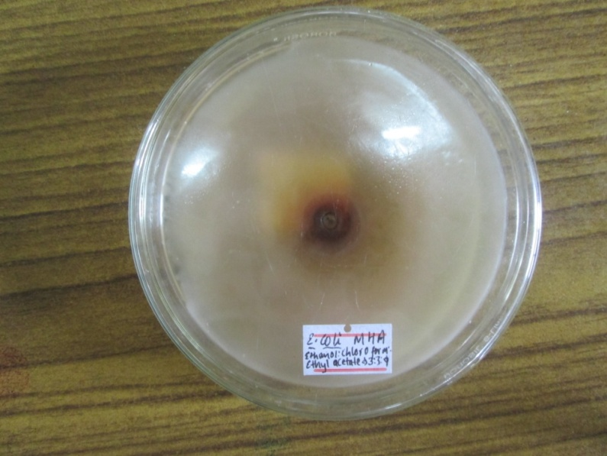
Photograph 1: Effect of oleoresin on E. coli on well diffusion

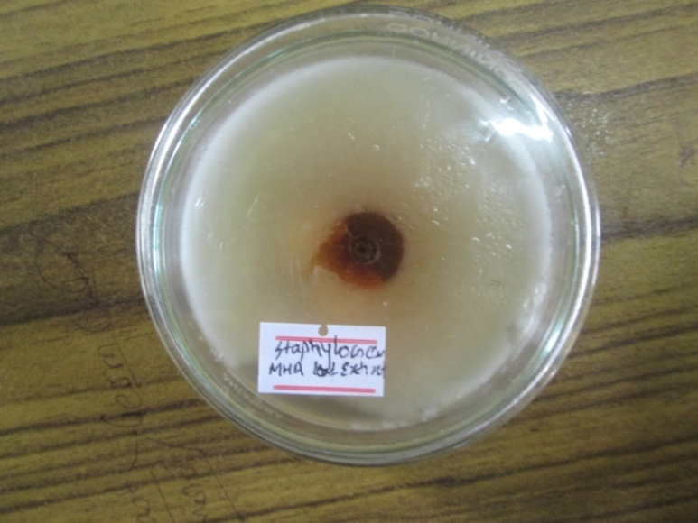

Photograph 2: Effect of oleoresin on Staphylococcus aureus on well diffusion

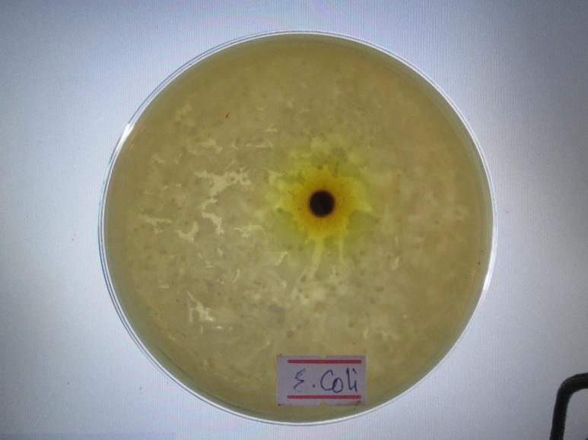
Photograph 3: Effect on oleoresin on E. coli on disc diffusion
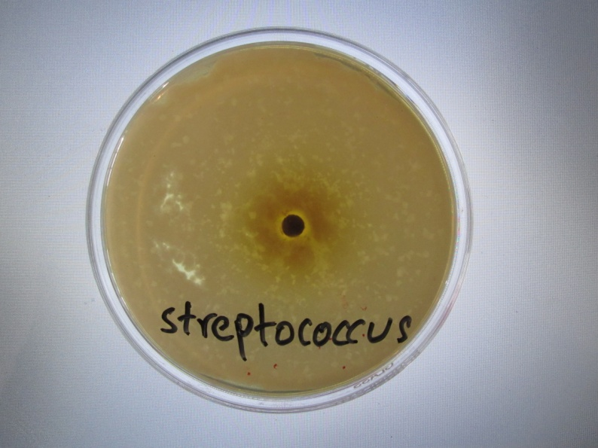
Photograph 4: Effect of oleoresin on Streptococcus sp. on disc diffusion

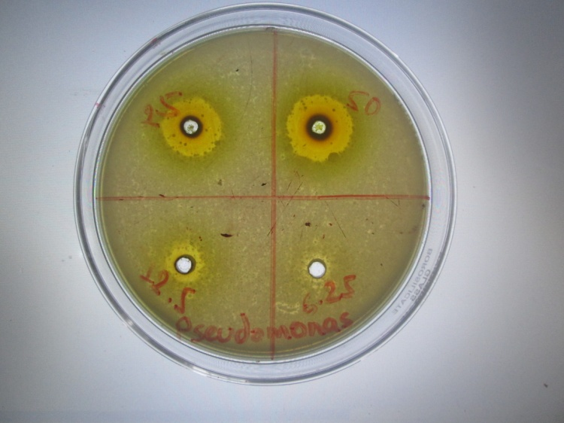
Photograph 5: Determination of MIC for Pseudomonas aeruginosa
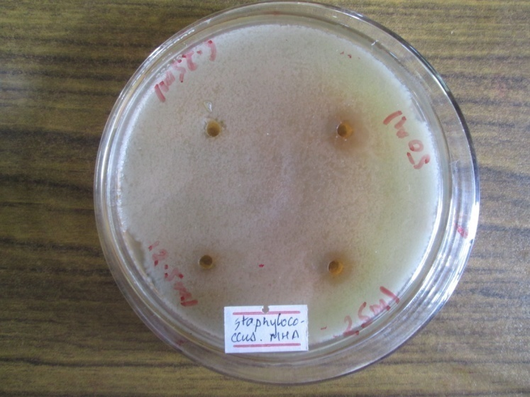
Photograph 6: Determination of MIC for Staphylococcus aureus

