PHOTOGALLERY
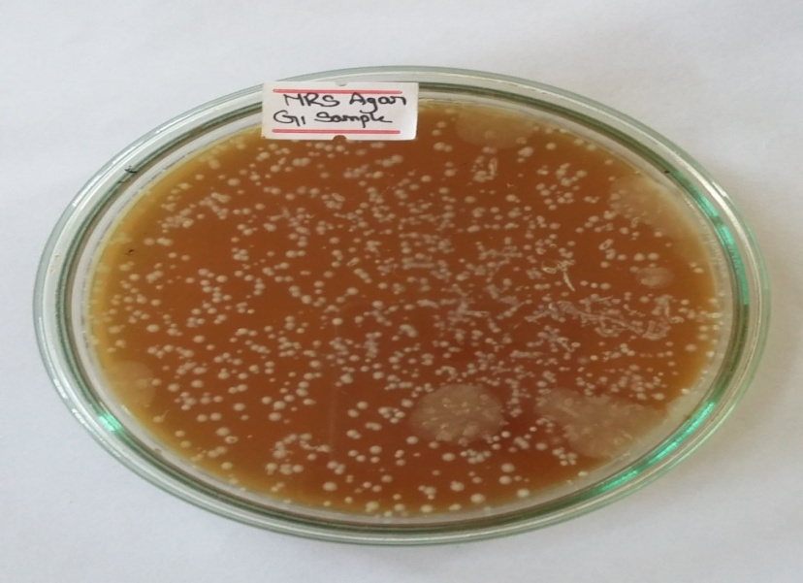
Photograph 1: Colonies of LAB grown in MRS agar

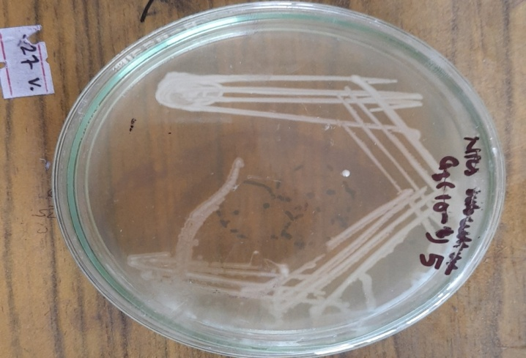
Photograph 2: Subculture of LAB in Nutrient agar.

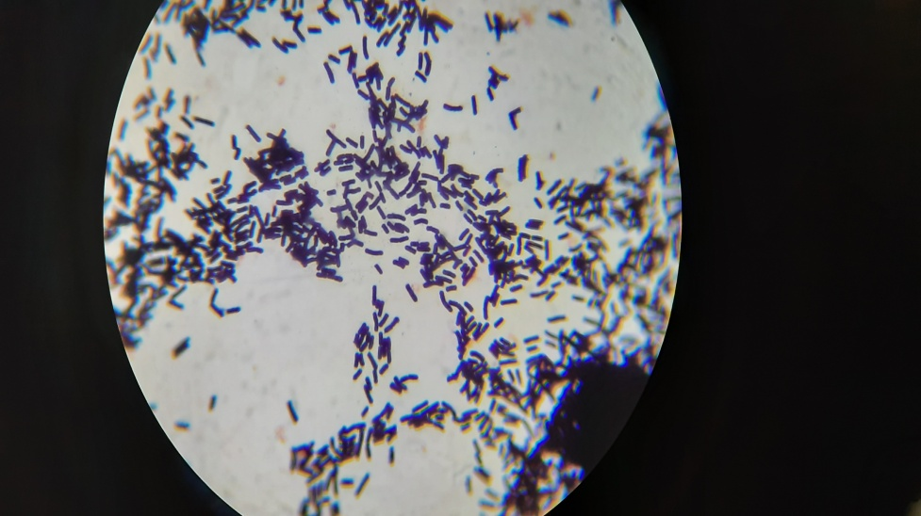
Photograph 3: Microscopic view of LAB

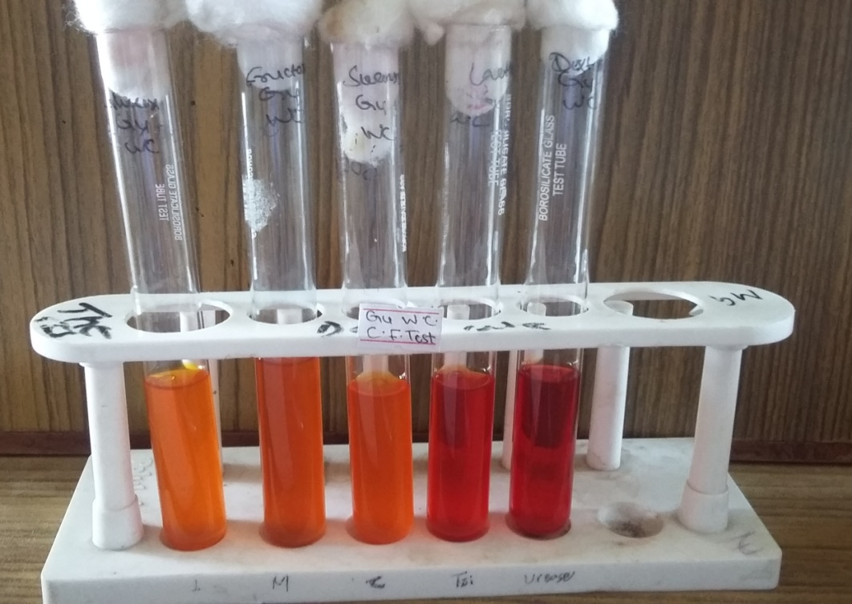
Photograph 4: Carbohydrate fermentation test for LAB

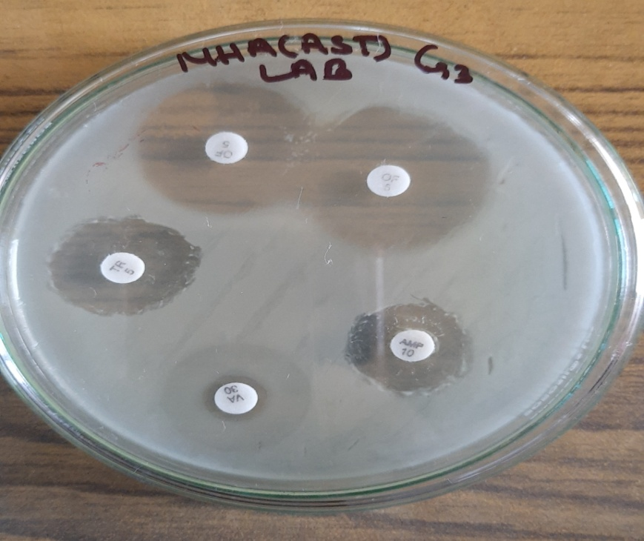
Photograph 5: AST Pattern of LAB 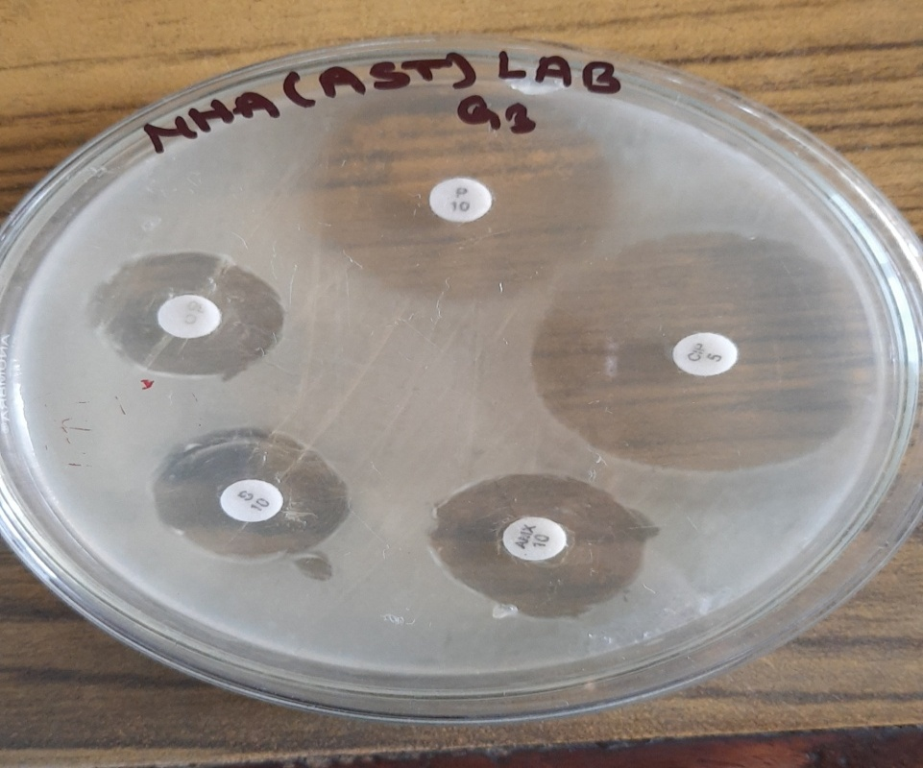
Photograph 6: AST Pattern of LAB

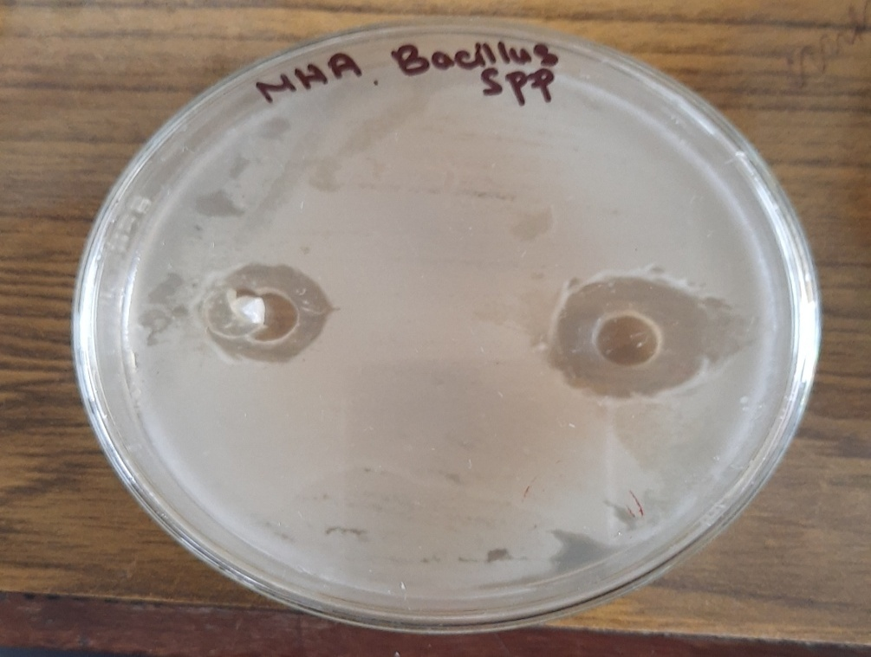
Photograph 7: Antimicrobial activity of Gundruk Sample
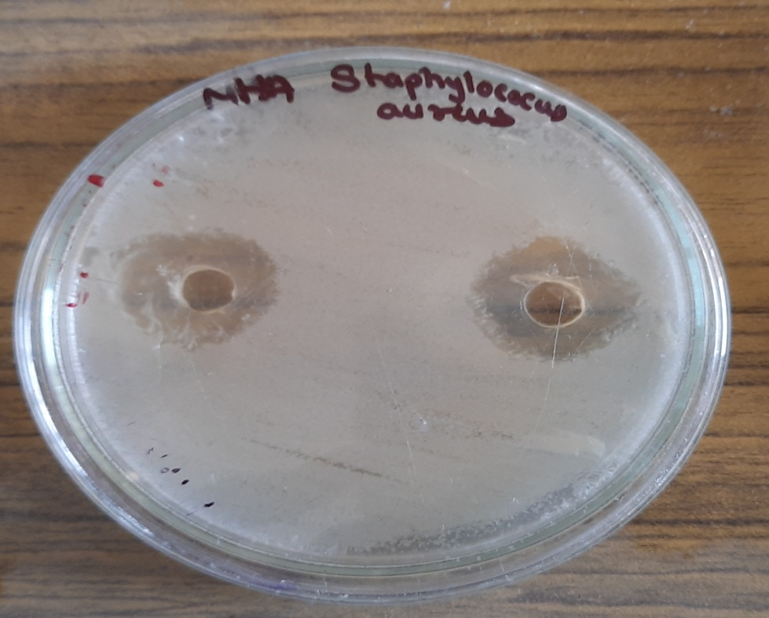
Photograph 8: Antimicrobial activity of Gundruk Sample

