Illegal Trade, Distribution, and Conservation Status of Pangolin
(A case Study from Chuchchekhola Community Forest, Makwanpur Nepal

Researcher
Animesh Gautam
B.Sc. Forestry
Agriculture and Forestry University, Hetauda

Email: animeshgautam20510506@gmail.com
Phone: +977-9845030784

Advisor
Ramesh Kumar Pandey
Faculty

Agriculture and Forestry University
Hetauda Campus, Hetauda

Co-Advisor
Prakash Sigdel
Monitoring and Surveillance Officer
Zoological Society of London

Submitted to
Agriculture and Forestry University
Faculty of Forestry
Hetauda Campus, Hetauda

(As a partial fulfillment of the requirements for the B.Sc. Forestry Degree)

©Animesh Gautam
May 2018
E-mail: animeshgautam20510506@gmail.com

Citation:
Gautam animesh, 2018; Illegal Trade, Distribution and Conservation Status of Pangolin in Chuchchekhola Community Forest (A case Study from Chuchchekhola CF, Makwanpur District). A Project paper submitted for the partial fulfillment of Bachelor of Science in Forestry degree, Agriculture and forestry University, Faculty of Forestry, Hetauda

Declaration

I hereby declare that the work presented here is my own effort and has not been submitted elsewhere for the award of any degree. All sources of information or work done by others are cited within this report and have been specifically acknowledged and listed in the reference section.

.................................
Animesh Gautam
April, 2018
Email- animeshgautam20510506@gmail.com
Agriculture and Forestry University
Faculty of Forestry, Hetauda Campus
Hetauda, Nepal

LETTER OF ACCEPTANCE
This is to certify that the project paper entitled “Illegal Trade, Distribution and Conservation Status of Pangolin in Makwanpur (A case study from Chuchchekhola CF, Makwanpur District)” prepared and submitted by Mr. Animesh Gautam has been accepted as a partial fulfillment of the requirement for the Bachelor Degree in Forestry Science, Faculty of Forestry, Hetauda Campus, Agriculture and Forestry University.
The assistance received by him during the course of investigation has been fully acknowledged. I congratulate him for this success and wish him all the best in career ahead.

………………………..
Advisor
Ramesh Kumar Pandey
Faculty,
Faculty of Forestry,
Hetauda Campus,
Hetauda,Makwanpur

ACKNOWLEDGEMENT

Firstly, I am extremely indebted and want to give heartily thanks to my research Advisor Mr.Ramesh Kumar Pandey for his generous encouragement and undertakings of the supervision of my entire research work. I am also thankful to my co-advisor, Mr. Prakash Sigdel for the constant guidance with important suggestions towards improving the thesis from the outset to the end of the project. I would like to thank Chuchchekhola Community Forest for its assistance in granting permission to research and use of the resources of Chuchchekhola CF.
This study would not have been possible without the continuous and tireless efforts of my field supervisor Mr. Prachanda Maharjan. I express sincere gratitude to him for this help.
I express my sincere gratitude to Mr. Uday Pudasaini (senior brother) for supporting research work and Mr.Arjun Prasad Dahal (Chairman of Community forest) for giving permission for data collection, without whom my research would not made possible. I would like to express my sincere thanks to all those respondents within my study site of Chuchchekhola Community Users who provided their valuable time to answer my questionnaires, in absence of whom, the completion of this study would not have been possible.
And at last but not least, I am heartily thankful to my colleagues Mr.Sankalp Shah Sankar, Mr. Pawan Devkota,Jirel Hikmat, Mr. Sagar Kunwar, Mr. Krishna Paudel for helping me in data entry during the work and for their co-operation, moral encouragement, and full support and for helping in preparation of this research.
Also I would like to thanks ZSL for providing cameras for capturing pictures and videos of live pangolin, thanks to this organization for support and guidance for the research.
My cordial and affectionate regard goes to my family; Father, Mother, Sister and Brother for their encouragement and loving support to complete my B.Sc. degree.

ACRONYM & ABBREVIATIONS
AFU Agriculture and Forestry University
B. Sc Bachelor of Science
CBAPU Community Based Anti Poaching Unit
CCF Chuchchekhola Community Forest
CFUG Community Forest User Group
CITES Convention on International Trade in Endangered Species of Wild Fauna and Flora
Cm Centimeter
DFO District Forest Office
Dr. Doctor of Philosophy
FOF Faculty of Forestry
GIS Geographic Information System
GPS Global Positioning System
IUCN International Union for Conservation of Nature
Km Kilometer
M Meter
M Meter
NTNC National Trust for Nature Conservation
NTNC-BCC National Trust for Nature Conservation- Biodiversity Conservation Center
PA Protected Area
Rs. Rupees
VDC Village Development Committee
WWF World Wildlife Fund
ZSL Zoological Society of London

ABSTRACT

Pangolins are least studied burrowing mammals. There is great role of this species in nature to maintain ecological balance. Due to illegal trade and habitat destruction, Pangolins are in great risk of extinction although being protected by national as well as international laws. This research was carried out to find illegal trade, distribution and conservation status of Pangolin in Chuchchekhola CF, Makwanpur district, Nepal. This study was done with direct field observation followed by direct observation along the tracks and random search, group discussion, key informant survey and questionnaire survey.
This study showed the presence of indirect signs of pangolins such as 290 burrows (including 110 new and 180 old) in Chuchchekhola CF, Makwanpur district. The distribution pattern of Pangolins was found to be of clumped type. The habitat utilized by pangolins was found to be forest and agricultural land. In the forest, the maximum numbers of burrows were located at the crown cover of 30-60%. People perception towards pangolins scales is that it protects from evils and bad spirit if children keep in their body. The conservation status of Pangolins in the study area was found to be very good, as the whole community people were concerned about the protection and conservation of pangolin. Several works were done for the proper management of habitats and other managing tools were adopted to minimize its threat to be extinct. Camera trapping methods was also used during the research work.

Keywords: Pangolin, burrow, habitat, extinction, trade

zf]w ;f/
;fns g]kfndf sd cWoog x'g] :tgwf/L hLj xf] . kfl/l:ylts ;Gt'ng sfod /fVg k|s[ltdf of] k|hfltsf] 7"nf] e"ldsf 5 . u}/sfg"gL Jofkf/ / cfjf;sf] ljgfzsf] sf/0f, ;fns ljn'Kttfsf] 7"nf] hf]lvddf 5g\ . /fli6«o tyf cGt/fl{\i6«o sfg'g åf/f ;+/lIft eP tfklg of] hLj clt ;+sf6fkGg cj:yfdf /xb} cfPsf] 5 . of] cWoog r'Rr]vf]nf ;fd'bflos jg pkef]Qmf ;d"x dsjfgk'/ lhNnfdf ul/Psf] xf] . g]kfndf ;fnssf] cj}w Jofkf/, ljt/0f / ;+/If0f l:ylt km]nf kfg{ of] cg';Gwfg ul/Psf] xf] . of] cWoog k|ToIf kmLN8 cjnf]sg ;+u clgoldt vf]h, ;d"x rrf{, s'~hL ;"rgfsf/ ;j]{If0f / k|ZgfjnL ;j]{If0f ;lxt k|ToIf cjnf]sg ;+u ul/of] .

o; cWoogn] g]kfnsf] dsjfgk'/ lhNnf r"Rr]vf]nf ;fd'bflos jgdf @() b'nf -!!) gofF / !*) k'/fgf]_ ;fnsx¿sf] ck|ToIf lrGxx¿sf] pkl:ylt b]vfpFb5 . b'nfsf] ljt/0f 9fFrf SnDk]8 k|sf/df /x]s]f lyof] eGg] hgfp5 . ;fnsåf/f k|of]u ul/g]] cfjf; jg / s[lif e"ld kfPsf] lyof] . zfnssf] vj6fsf] ljifodf dfG5]sf] wf/0ff of] 5 ls olb aRrfx?n] cfˆgf] z/L/ df /fVg] xf] eg] o;n]] a'/fO{ / v/fa cfTdfaf6 ;'/Iff ub{5 . cWoog If]qdf ;fnssf] ;+/If0f l:ylt w]/} /fd|f] tl/sfn] ul/Psf] kfO{of] lsgsL ;Dk"0f{ ;d'bfosf] dflg; ;fnssf] ;+/If0fsf] af/] df lrlGtt lyP . cfjf;sf] plrt Joj:yfkgsf nflu w]/} sfdx¿ / cGo Joj:yfkg pks/0fx¿ ljn'Kt x'g] o;sf] vt/f sd ug{sf nfuL ckgfO{Psf] lyof] . o; ;fd'bflos jgdf Sofd/fsf] klg k|of]u ul/Psf] lyof] .

Contents
LETTER OF ACCEPTANCE 4
ACKNOWLEDGEMENT 5
CHAPTER I 10
INTRODUCTION 10
1.1 Introduction 10
1.2 Rational of study 12
1.3Objective of the study 13
1.3.1 General objective 13
1.3. 2 Specific objective 13
1.4 Limitations of the study 13
CHAPTER TWO 14
REVIEW OF LITERATURE 14
2.1 Evolution and Scientific classification 14
2.2 Species of Pangolin in the World 14
2.3 Pangolins and African Pangolins 14
The Asian Pangolins include: 14
The African Pangolins include: 15
Species of Pangolin in the Nepal 15
2.4 Description of the Pangolin 15
2.5 Behavior 16
2.6 Habitat 16
2.7 Food 17
2.8 Reproduction 17
2.9 Life Span 17
2.10 Ecological Importance 17
2.11 Other Importance 18
2.12 Conservation Threats 18
2.12 Conservation Action 19
CHAPTER THREE 20
Research Methodology 20
3.1 Study Area 20
3.2 Biophysical Features 22
3.2.1Climate 22
3.2.2 Hydrology 22
3.2.3 Geology 22
3.2.4 Flora 22
3.2.5 Fauna 22
3.2.6 Features 22
3.3 Materials 22
3.4 Methodology 23
3.4.1 Primary data 23
3.4.2 Secondary data 24
3.5 Data analysis 24
CHAPTER FOUR 25
Result and Discussion 25
4.1 Distribution of Burrows 25
4.4 Distribution of Burrow with respect to crown cover 26
4.5 Socio-economic status of the respondents 26
4.5.1 Gender 26
4.5.2 Age group of the respondent 26
4.5.3 Educational status of the respondent 27
4.5.4 Occupational status of the respondent 27
4.6 Conservation action by District Forest Office 27
4.6.1 Involvement of different ethnic groups and number of people 27
4.6.2 Punishment and Penalty in Rupees 28
4.7 Conservation Status 28
4.7.1 Population trends and Threats of Pangolin 28
Causes of habitat degradation and hunting of pangolin 29
4.8 Existing Illegal Trading Methods 30
4.8.1 Method used to catch Pangolin 30
4.8.2 Best place to catch Pangolin 30
4.8.3 Camera Trapping 30
4.9 Habitat Utilization 31
4.10 DISTRIBUTION 31
4.11 Conservation status 31
4.12 Social belief 32
4.13 Conservation in captivity 33
CHAPTER FIVE 33
CONCLUSION AND RECOMMENDATION 33
5.1 Conclusion 33
5.2 Recommendation 34
REFRENCES 34

Figure 1 Map of study area 20
Figure 2 : Distribution of burrows in study area 23
Figure 4 Distribution of holes according to altitude 25
Figure 5: Distribution of burrow with respect to crown cover 26
Figure 6: Sex of respondent 26
Figure 7: Age group of the respondent 27
Figure 8: Educational status of the respondent 27
Figure 10: Conservation action by District Forest Office 28
Figure 9: Occupational status of the respondent 28
Figure 11: Punishment and penalty in rupees 29
Figure 12: Population trends and Threats of Pangolin 30
Figure 13: Causes of habitat degradation and hunting of pangolin 30
Figure 14: Pangolin conservation strategies and its valuable parts 31
Figure 15: Method used to catch pangolin according to respondent 31
Figure 16: Best place to catch Pangolin 32

CHAPTER I

INTRODUCTION
  - Background
Pangolins are often called "Scaly Anteaters". Their body is covered in through, overlapping scales. The scales are made of Keratin - the same protein from which human hairs and finger nails are made up off. These are burrowing mammals with small conical heads and jaws lacking teeth, Pangolin have amazingly long muscular and sticky tongues. Pangolins have generally poor vision but have strong sense of smell which helps them to catch prey. Their limbs are stout and well adapted for digging. Each Paw has five claws and their forefeet have three long claws used to demolish the nests of termite and to dig nesting and sleeping burrows.
Eight different Pangolin species are found in Asia and sub-Saharan Africa. Among four in Asia two types of Pangolins are found in various places of Nepal. The two species of pangolins in Nepal are: Chinese pangolin (Manis pentadactyla) and Indian pangolin (Manis crassiaudata) (Baral and Shah, 2008; Jnawali et al., 2011).The Chinese pangolins occur in the Himalayan foothills in eastern Nepal, Bhutan and India, Bangladesh, Myanmar, Vietnam, Thailand, China and Taiwan (Duckworth et al., 2008); whereas Indian Pangolin occurs in Pakistan, India, China, Bangladesh, and Nepal (Molur, 2008). In Nepal, the species are found in central Nepal and eastern Nepal (Baral and Shah, 2008). Pangolins are widely distributed in primary and secondary tropical forests, limestone forests, bamboo forests, grasslands and agricultural fields (Gurung, 1996; Suwal, 2011) which digs its own burrows, or enlarges passages made by termites.
Pangolin is solitary and nocturnal animal commonly found Bardia National Park, Chitwan National Park, Shukla Phanta National Park, Parsa Bational Park and surrounding districts Makawanpur, Bara, Chitwan, and Parsa. (The Status of Nepal’s Mammals, IUCN). They are found in variety of flooded Forest, thick bushes, grassland scrubland, and lightly wooded forest near human settlement agricultural land and mostly in the area where eggs, ants and termites are available. The generic name of pangolin in Nepal is 'Salak' although it has some local names that are popular in particular areas. For instance, it is called "Kaynaya" (Newari Language),"Kose" (Tamang Language) and "Hilemaccha" in hill by virtue of its bronze like overlapping scales (Kaspal, 2008).
Pangolin live predominantly on diet of ants and termites, which they may supplement with other various invertebrate including bee, worm, larvae, flies, earthworm and crickets. According to save pangolin organization an average adult pangolin eat more than 70 million individual insect each year , meaning that if they were removed from a particular habitat , insect population will increase and upset the delicate balance of the local ecosystem, so pangolins have greater role in ecological balance. Indian pangolins (Manis crassiaudata) in tropical areas spend the winter months in deep burrows. The winter burrows are strategically excavated near termite nests that provide a lasting food source. Pangolins’ insatiable appetite for insects gives them an important role in their ecosystem: pest control.
Pangolins are strange small mammals with some typical morphological characteristics. Although pangolins are protected nationally and internationally, detail biological information are lacking (Suwal, 2011). Male and female are sexually dimorphic. Males are generally heavier than female by 10-50 percent. Pangolin reaches sexual maturity at two year and generally gives birth to a single offspring. Chinese Pangolins are black in color and Indian Pangolins are grey in color (S.H.PRATER, 1980). The study made by Kaspal (2008) showed its presence in Suryabinayak range post, Bhaktapur. There is presence of pangolin in the plain and in the hilly areas of Nepal. It was found that the habitats of pangolin have been encroached and degraded by people.
The name Pangolin is derived from Malayan phrase “Pen Gulling” meaning ‘rolling ball’, while the term ‘Pholidota’ came from Greek word meaning ‘scaled animals’.
- Pangolins/Scaly Ant Eater/ Tame salak/kalo salak
- Thick tailed Indian Pangolins
- Diet of Pangolin is composed of 11 species of ant and termites.
- Reproduction throughout the year except in May and June.
- Ecological role – natural predator of ants and termite, increase soil fertility and aeration.
- They are 84–122 cm long with tail 33–47 cm and are covered with large rounded overlapped scales of pinkish-brown skin.
- Listed as a protected mammal in NPWC act 2029, Appendix I of CITES, and Critically Endangered in IUCN red list.
- Out of eight species globally, four species are in Asia and out of four Asian species Indian and Chinese pangolins are found in Nepal.

Rational of study

Although, Pangolins are ecologically beneficial they are receiving less scientific attention (kaspal, 2009). There is comparatively less research done on these nocturnal small mammals throughout Nepal. The regional decline of most of species has occurred largely within the last 50 years, because of hunting for subsistence has been increasingly outweighed by hunting for the market due to weak law enforcement (Corlett, 2007). Due to habitat destruction (construction of road, deforestation, human encroachment etc) and illegal trade, pangolins are in greater risk in Nepal. The illegal trade of pangolin has been flourished in Nepal. Pangolins are the world’s most poached mammals and Nepal has been the main transit for poaching and illegal trade. So the study of status, distribution, and threat is must for the conservation of this less scientific attention received species. It is also listed as endangered species in IUCN Red List.
As the research site is Chuchchekhola Community Forest, Pangolins are recorded from many parts of this site but there is not any significance of study in the site. I hope this research will be useful for the protection and conservation of this species by identifying cause and threat posed to its habitat destruction as well illegal trade. After the completion of this study it will also provide baseline information regarding status, distribution and conservation threat of Pangolin. It can be a tailor for further study throughout the Nepal.

1.3Objective of the study

1.3.1 General objective

Illegal Trade, Distribution and Conservation Status of Pangolins in Chuchchekhola Community Forest.

1.3. 2 Specific objective

- To study the conservation status and habitat pattern of Pangolins;
- To understand the attitude of local community on pangolin conservation.
- To explore the illegal trade existence in the study area.

1.4 Limitations of the study

- Data were collected by surveying during the time of January 2018. So it does not represent distribution of Pangolin throughout the year.
- Distribution of pangolin was based on burrows (old, new) records.
- Identification of Indian and Chinese Pangolin was carried out by showing two separate pictures of pangolin, along due to the nocturnal habits.
- Respondents may not response all questions related to illegal trade due to its sensitivity. So, we cannot fully rely on trade related information of this research.

CHAPTER TWO

REVIEW OF LITERATURE

2.1 Evolution and Scientific classification

Pangolins are native to Africa and Asia, are not closely related to other living mammals. There back and tails are covered with large scaled similar in arrangement to dinosaur bone plates. Pangolin do not have teeth, instead they have an organ similar to a bird gizzard. Due to these unique traits pangolins are classified into their own group within class mammilla. There are Eight Species of pangolins found in world. The origin of Pangolin is in mystery. Oldest bones of this animal have been unearthed from Pleistocene deposit of South India, which has been dated back to some hundred million years ago (Shrestha, 1981). Although modern Pangolins live only in Africa and Asia, Pangolin fossils have also been found in Europe and North America (www.environmentalgraffiti.com). Among Eight pangolin, there are four species of pangolins found in Asia, Indian Pangolin (Manis crassicaudata), Sunda Pangolin (Manis javanica), Chinese Pangolin (Manis pentadactyla) and Palawan Pangolin (Manis culioensis) Abdullah, 30 June – 2 July 2008). There is very little information on pangolin population, biology, ecology and conservation; however, it is known that pangolin is in serious decline throughout their range. Two species of pangolins are found in Nepal: Chinese pangolin (Manis pentadactyla) and Indian pangolin (Manis crassicaudata) (Baral and Shah, 2008; Jnawali et al., 2011).

2.2 Species of Pangolin in the World

There are total eight type of Pangolin species are found globally. All the species of Pangolins belong to the genus Manis in the family Manidae, which is the only family within the order Pholidota (Thapa, 2012). Pangolin’s closest living relatives are the Xenarthrans – anteaters, armadillos, and sloths (savepangolin.org, 2012).

2.3 Asian Pangolins and African Pangolins

The Asian Pangolins include:

1. Indian or thick-tailed Pangolin (Manis crassicaudata)
2. Chinese or Formosan Pangolin (Manis pentadactyla)
3. Malayan or Sunda Pangolin (Manis javanica)
4. Palawan or Philippine Pangolin (Manis culionensis)

The African Pangolins include:

1. Giant Pangolin (Manis gigantean)
2. Cape Pangolin (Manis temminckii)
3. Long-tailed Pangolin (Manis tetradactyla)
4. Tree Pangolin (Manis tricuspis)

Species of Pangolin in the Nepal

Two out of eight pangolin species are distributed in Nepal (Manis Pentadactyla and Manis crassicaudata) Pangolins are one of the species confiscated in Nepal from the illegal poaching and trade. Nepal is considered as route and transit point for illegal trade in between India and China. High price and soaring price are recorded in markets for meat and scales.

2.4 Description of the Pangolin

The most distinct character of pangolin is its armor of protecting scales. The upper part of the head, the back and sides of the body, the whole tail, the outside of the limbs are covered with large overlapping scales. Pangolins are strange animal with streamlined body with a long tail (S.H.PRATER, 1980). This long tail help to maintain body balance during movement and they keep their body in curved position (Suwal). Pangolins have Fifteen to Eighteen scales which brown in color. Their scales are composed of Keratin which offers excellent protection not only against potential predators, but also from the bites and stings of their ant and termite prey (Lim & Ng, 2008). They have long tail and jaws lacking teeth, Pangolin have amazingly long muscular and sticky tongues. These tongues help to catch insects and ants. Their limbs are stout and well adapted for digging. Each Paw has five claws and their forefeet have three long claws used to demolish the nests of termite and to dig nesting and sleeping burrows.
- Indian Pangolin/Scaly Ant Eater/ Tame salak
- Chinese Pangolin/ kalo salak
- Least studied burrowing mammal.
- Nocturnal and non-aggressive.
- Diet - ants and termites
- Diet of Pangolin is composed of 11 species of ant and termites.
- Reproduction throughout the Year except in May and June.
- Ecological role – natural predator of ants and termite, increase soil fertility and aeration.
- They are 84–122 cm cm long with tail 33–47 cm and are covered with large rounded overlapped scales of pinkish-brown skin.
- Listed as a protected mammal in NPWC act 2029, Appendix I of CITES, and Critically Endangered in IUCN red list.
- Out of eight species globally, four species are in Asia and out of four Asian species Chinese and Indian pangolins are found in Nepal.
- The Indian pangolin measure: head and body, 2 ft, to 2ft, 6 in. and tail of 18 inch (45cm), and has 11 to 13 rows of scales.
- The Chinese pangolin head and body measures 40-58 cm & tails about 25-38 cm.
- Matured Chinese pangolin weighs about 2-7 kgs with 18 overlapping scales.

2.5 Behavior

Pangolins are solitary nocturnal animal and highly secretive animal, Shrestha (1981) recorded the behavior of Pangolin in Panauti Bebar area. And he found that the Pangolins use to wriggling out the burrows at night for stalking termites and remain alive till dawn. These animals have large home range and usually sleep at day underground inside their burrows. They curl their tail to protect from predator and other enemy. They make their home underground at night in mainly steep slope. Though terrestrial in habit, they are excellent climbers, using ‘caterpillar locomotion’, with the firm grip of forefeet on the tree (Chakraborty et al., 2002). They also climb tree in search of food. These animals are mainly found near termite mound.

2.6 Habitat

Pangolins are found in wide range of habitats including primary and secondary tropical forests, limestone forests, bamboo forests, grasslands and agricultural fields (Chao Jung-Tai 1989; Gurung 1996: as cited by Duckworth et al., 2008). Pangolin usually live in home made by themselves and feed on ants and termite, which commonly have to be dug out of the earth. They dug up burrow up to 8 feet (120cm.) in length and some four feet underground in a circular chamber about 2 ft.(60cm) in diameter. The depth of burrows varies with nature of soil. In rocky ground 5 to 6 ft is enough and in loose soil it may up to 20ft or more (PRATER, 1980). It is difficult to discover animal nest but for the peculiar tracks they leave round and about their earth. Though pangolins are terrestrial in habit, Pangolin climbs well and easily too probably to quest of tree ants.

2.7 Food

Pangolin live predominantly on diet of ants and termites, Which they may supplement with other various invertebrate including bee, egg, worm, larvae, flies, earthworm and crickets (S.H.PRATER, 1980). According to save pangolin organization an average adult pangolin eat more than 70 million individual insect each year , meaning that if they were removed from a particular habitat , insect population will increase and upset the delicate balance of the local ecosystem so, pangolins have greater role in ecological balance. Pangolin living in desert areas must go without water is available they drink freely. Their way of drinking as observed in captive specimen is to lap up water with a rapid in and out shuttling of the tongue (PRATER, 1980). In captivity a special type of food that is ant powder is also fed which is highly costly (Central Zoo of Nepal).

2.8 Reproduction

Little definite is known of the breeding habits of pangolin. The young appear to be produced at different times of the year. In south India there is record of born of pangolin in July. A single one is produced more rarely two. Pangolins are exceptionally vulnerable to over-exploitation, as they are easily hunted, have a very slow reproduction rate and do not easily breed in captivity (Lim and Ng, 2007; Wu, et al., 2004). The new born babies have soft scales with hairs on its body. The young one is usually fed with mother milk and lives with both male and female in same burrows (S.H.PRATER, 1980). Male Pangolin has been observed to exhibit remarkable parental instincts and share a burrow with the female and young. The mother carries the baby on tails of its body for movement though it can walk by birth. The baby gets maturity at the age of one year.

2.9 Life Span

Pangolin life span is unknown in wild but it was stated that it can live up to twenty year in captivity (www.savepangolins.org). A pangolin lives in captivity for two year (S.H.PRATER, 1980). According to Assish Bista Assistant co coordinator of Central Zoo of Nepal Pangolin was live for five month in captivity. The main reason for the least survival in captivity was its diet.

2.10 Ecological Importance

Pangolins are most important creature, which helps to keep ecological balance, control the population of insects. Pangolin mainly feed on ants and termite which help to control their population. According to save pangolin organization an average adult pangolin eat more than 70 million individual insect each year , meaning that if they were removed from a particular habitat , insect population will increase and upset the delicate balance of the local ecosystem so, pangolins have greater role in ecological balance. They also help to increase soil fertility by digging soil and help to preserve good aeration inside the soil. They also provide home for large number of animal as they are burrowing animals.

2.11 Other Importance

Pangolin can be used for a range of products; below is a list of utilization type's record in Cambodia
- The meat is used as a local source of protein
- Fetuses are use for traditional medicine
- The scales are used in traditional medicine, as well as for the production of souvenirs
- The blood is used in traditional medicine and can be found in restaurants
- Stuffed pangolins are sold as souvenir
- The skin is used for the production of leather accessories such as bags and shoes (Abdullah, 30 June-2 July 2008).

2.12 Conservation Threats

Pangolins are one of the most valuable and widely traded taxon in the Southeast Asian illegal Wild life trade, yet little is known of their ecology and they are rarely reported in biodiversity surveys (Newton, 2007). Due to hunting pressure for utilization, populations of Pangolins have presumably dropped by 80% over the end of 1960’s in China (Zhang, 2008). Zhang believes that hunting for utilization is prime threat to China’s Manis crassicaudata population. Besides harvest pressure, secondary threats to this species include loss, deterioration and insularity of available habitat as well as fragmented distribution pattern. In additional to such external factors, threatened status can also partly be attributed to inherent characteristics of this species, including its monotypic taxonomy, low reproductive rate, poor capability of defense and highly specialized food. Because of particular significance is Indian pangolin is reported to be an easier species to locate and hunt in the wild (P. Newton, 2013.). This is because it is more terrestrial, and is thus: easier to track their scent using specialized hunting dogs (a, scent of Manis javanica is often lost at points at which animal climbed a tree); and b) has conspicuous soil burrows that are more easily accessed than tree hollows favored by Manis javanica (P. Newton, 2013.). For these reasons, the hunting threat to Manis crassicaudata is perhaps even greater than that to Manis javanica (P. Newton, 2013). Indian pangolin is intensively used, for its skin, meat and scales, and is evidently subject to heavy collection pressure in many parts of its range. It may be harvested for local (i.e. national-level) use or for international export either before or after processing. Observations in mainland Southeast Asia indicate that there is very heavy unofficial, or at least unrecorded, international trade in pangolins and pangolin products. The species trade levels are significant across its range, although precise estimates are unknown (CITES 2000).The potential extinction risk for this animal is very high and high threatening index (Ti=0.6947) suggests that this species in high threatened situation and has become an endangered species (Wu et al., 2004). According to Environmental News Network, Pangolins were worth around US $10
Per kilo in the early 1990s and had soared to US $175 per kg by 2009. Wildlife Alliance’s Suwanna Gauntlett explained in an interview with Mongabay guest writer, Laurel Neme, that the going rate had reached a whopping US $200 per kilogram in 2011 (Project Pangolin, 2012). In Nepal, Study by Acharya et al. ,(1993) showed cost of each scale of Pangolin at five rupees. However, the study of Kaspal (2008) showed the cost of each scale of Pangolin raised to fifty rupees. In eastern districts Terathum and Sankhuwasabha smugglers buy Pangolin scales for Rs 15,000 to Rs 45,000 per kg from local people (Karki, The Kathmandu Post, 2011 Nov 11). Passenger bus charge Rs 1,000 to transport per kg of Pangolin scales from Illam and Taplejung to Kathmandu (Dangal, Republica, 2012 June 27). There are various reasons for illegal trade of Pangolin. Phalla (2008) focuses on the following reasons for illegal trade of Indian Pangolin which are as follows:
- The meat is used as a local source of protein.
- Scales are used for traditional medicine.
- The scales are used in traditional medicine as well as for production of souvenirs.
- The blood is used in traditional medicine and can be found in restaurants.
- Stuffed Pangolins are sold as souvenirs.
- The skin is used for the production of leather accessories such as bags and shoes.
Pangolin scales, both whole and in powdered form, are used in traditional Chinese medicines to treat a variety of medical conditions, including psoriasis, infertility, to improve blood circulation, treat asthma, and even cancer (Duckworth et al.,2008; Challender, 2011). Due to this reason Pangolins are in great threat.

2.12 Conservation Action

This species is listed on CITES Appendix I; a zero annual export quota has been established for specimens removed from wild and traded for primarily commercial purposes. It is protected by national and international legislation in Bangladesh, China, India, Lao, Myanmar, Nepal, Taiwan, Thailand, and Viet Nam. This wide ranging species is present in some protected areas, but protected area designation alone is not sufficient to protect this species. Greater enforcement and management to prevent poaching in protected areas is urgently needed. Large seizures of illegal animals do occur, but the trade continues largely unabated. In Bangladesh, all pangolins are legally protected. On Taiwan, all Mains species have been protected since August 1990 under the 1989 Wildlife Conservation Law. This species is listed as a Class II protected species in China, Wild Animal Protection Law (1989), and also as a Class II protected species in China in the Regulations on the Conservation and Management of Wild Resources of Medicinal Plants and Animals (1987).In Thailand, all Mains species are classified as Protected Wild Animals under the 1992 Wild Animals Reservation and Protection Act B.E. 2535.In India, this species is completely protected, as it is included in Schedule I of the Wildlife Protection Act 1972.Hunting of this species is prohibited in Nepal ( Gaski and Hemley 1991). The legal status of pangolins in Lao PDR is unclear, as a result of internal contradictions in Lao PDR laws applicable to wildlife and wildlife trading. However, Provincial and District Agricultural and Forestry Offices in Lao PDR have been confiscating large numbers of pangolins, so there is evidently a perceived legal basis for doing so (WCMC et al. ,1999). They are listed as protected mammals of Nepal (DNPWC, 1973).

CHAPTER THREE

Research Methodology

3.1 Study Area
The study was carried out in Chuchchekhola Community Forest in central Nepal. It is situated in the inner-terai land of central development region, Hetauda Sub-Metropolitan, Makwanpur, Nepal. The area of Chuchchekhola CF is 238.04 hectares. Total number of users is 1052. The study was mainly carried out in foot hills of Mahabharata as it is more suitable for Pangolin habitat. Chuchekhola community forest was established in 2042 B.S. and was handed over to the community legally by DFO in 2048 B.S. Literally it is the first community forest of Makawanpur district.It is located on the Hetauda 6, Chuchekhola along Hetauda 17 ward. The boundary of Chuchekhola community forest stretches from Rani Community Forest on west, Ashok CF in east, Baghvairab CF on north-east and Chisapani CF from south.
This community forest works on conservation, protection, utilization and management of forest and other components of nature. Basically, this community forest focuses on conservation of nature along with the development of community. It is working on the livelihood development, women empowerment, and social works as cooperatives for the betterment of the community and people. It has been working for the wildlife and soil conservation alongside. Pangolin (Manis species) is found on this area and conservation activities on this project is running on. Besides this CF has its own park “PANGOLIN PARK” named after pangolin. Medicinal herbs like kurilo, rittha, etc are also raised here.

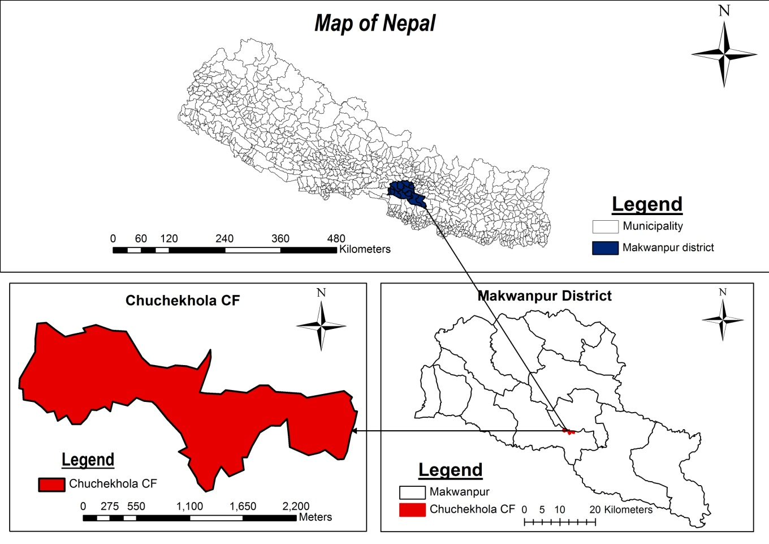
Figure 1 Map of study area

3.2 Biophysical Features

3.2.1Climate
The climate of Hetauda Sub-Metropolitan city ranges from tropical with three distinctive seasons i.e. winter, hot and monsoon. The average maximum and minimum temperature are 38 degree Celsius and 16 degree Celsius respectively.

3.2.2 Hydrology
The Chuchchekhola CF is situated on the bank of Karra River and its perrenial. Though there is annual flow of water in river when we go above altitude there we find dryness.

3.2.3 Geology
The geological condition of Chuchchekhola varies from Mahabharat range, inner terai, and fertile plain Churiya range. This area is rocky in some areas. Different type of soil is also found in the areas sandy to clayey.

3.2.4 Flora
There is diversity in the Flora as the climate ranges from tropical. We will find the main species of Sal (Shorea robusta), Saj (Terminalia alata), Chilaune (Schima wallichi) etc.

3.2.5 Fauna
This area is some in faunal diversity. The wild mammals are Leopard cat, barking deer, Pangolins (Manis species) Procupine (Hystrix sps.), Spotted Deer (Axis axis) etc. The reptiles are found in this area is different types of snakes and lizards including monitor lizard.

3.2.6 Features
This area is mainly the inhabitant of farmers, teachers and Government employ. The main food crops grown are Rice, Millet and Maize and Green vegetable. The main castes of this area are Tamang, Rai, Bharmin and Chhhetri. The main religions are Hindu, Kirat and Buddhist. Main language spoken is Nepali.

3.3 Materials
The main materials used during the field study were:
1. GPS
3. Tape
4. Digital Camera
5. Map of the study area
6. Polythene bags
7. Data sheets
8. Pencils
9. Note book

3.4 Methodology
Different methodology was used to meet the objectives. Direct observations of holes/burrows were carried out in the field visit. The sites were chosen after preliminary survey of the area, key informant surveys through periodic systematic random sampling method and the primary and secondary data were being collected using different methods. Strategically some camera traps were used in the Chuchchekhola community forest area to proven the records of Pangolin availability. The cameras were placed purposively used in front of the pangolin burrows to capture the live Pangolins.

3.4.1 Primary data

3.4.1.1 Reconnaissance survey
Preliminary survey was done before conducting the actual research. This survey was carried out by field visit, discussion with experts, local people and through study of relevant literature. The potential site of Pangolin was assessed through participatory mapping with the local people familiar with Pangolin burrows as community forest user groups were also engaged in the protection and management of pangolins which was the baseline for the study.
3.4.1.2 Key Informant survey
Key Informant Survey was conducted in the study area with local inhabitants of the area community forest user members, especially older people, teacher and the general CF member. This survey was designed to clarify the distribution and status of both the Chinese and Indian pangolin within the boundaries of CF and the results of this survey are presented here. Based on the information thus obtained probable sites will be shortlisted in all the Wards.
3.4.1.3 Direct observation
To find out the habitat of Pangolin, the entire site was observed. GPS was used to get the co ordinate and elevation. The burrow of pangolin was studied considering different factors such as soil type, soil color; ground vegetation cover, crown cover, and moisture level are noted. The depth, diameter, and elevation of burrows were taken. Along with burrows the vegetation type around burrows was also recorded.
3.4.1.4 Household survey
A semi structured questionnaire was prepared for this purpose. About 150 household was taken for survey. Adaptive sampling technique was be used to select the house hold for interview. One person was interviewed from each household as well at the same time any relevant additional information was also collected from other family members.
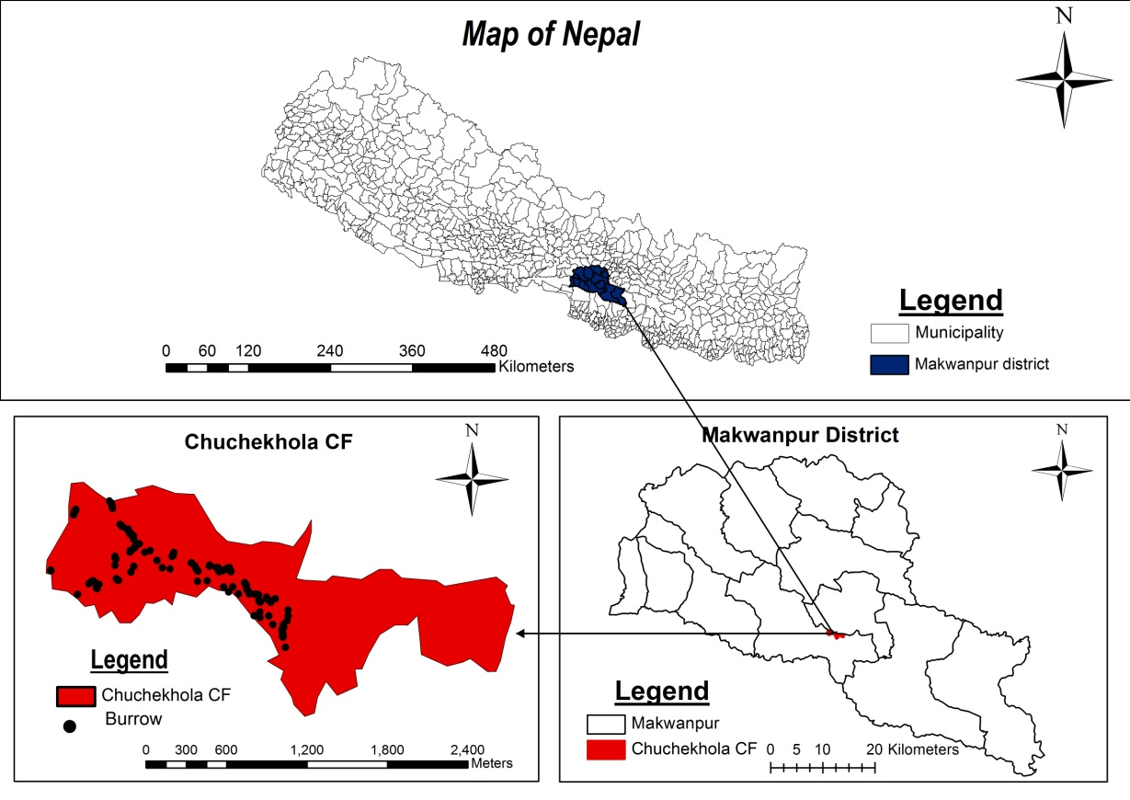
Figure 2 : Distribution of burrows in study area

3.4.2 Secondary data
Different relevant journal papers, books and published and unpublished report was reviewed for secondary data.

3.5 Data analysis
The collected data was analyzed with the use of MS EXCEL 2007. An Arc GIS 10.3 was also used to map out the study area.

CHAPTER FOUR

Result and Discussion

4.1 Distribution of Burrows
The density of burrow was found to be 1.21 per hectare.
Burrow density = no of the burrows (one burrow represent one individual)
The area of Investigation
According to the field visit and survey the total number of burrows was found to be 290 and number of new burrows were 110 and old burrows of 180 in the study area.
Fig 3: Distribution of old and new burrows.

4.2 Distribution of Burrow According to Altitude
It was found that maximum no. of holes were found from 500 to 600m altitude from the sea level.

Figure 4 Distribution of holes according to altitude

  - Distribution of Burrow with respect to crown cover
Higher number of burrows about 49% burrows were found in 30-60% crown cover and 31 % burrows were found in 60-90 % crown cover and 20 % was in 0-30 % crown cover respectively.
Figure 5: Distribution of burrow with respect to crown cover

  - Socio-economic status of the respondents
    - Gender
During the house hold survey it was found that about 60% respondents were male and similarly 40% respondents were female.
Figure 6: Sex of respondent

    - Age group of the respondent
According to survey 30% people were young, 45% people were middle age and 25% people were old age respectivly. As for the study people between 5 to 18 years are considered as young, 18 to 45 years are considered as middle age and 45 over are listed on old.

Figure 7: Age group of the respondent

    - Educational status of the respondent
According to the survey it was found that 30% people were illiterate, about 7% people received primary level education, 40% people achieved secondary level education and 23% people achieved high school level education respectively.
Figure 8: Educational status of the respondent

    - Occupational status of the respondent
By respondent it was concluded that about 45% were engaged in agriculture, 15% were involved in business and 40% were involved in public service and others respectively.

Figure 9: Occupational status of the respondent
  - Conservation action by District Forest Office

4.6.1 Involvement of different ethnic groups and number of people

Figure 10: Conservation action by District Forest Office
By the information gathered from the district forest office it was found that four persons were caught while trading the scales of pangolin in 070-071 fiscal years and 2 persons caught with one live pangolin in fiscal year 071-072.
Similarly, it was found that about 67 % ethnic group of janjati were involved in trading of pangolin, 16 % were of dalits and remaining 17 % were others respectively.

4.6.2 Punishment and Penalty in Rupees
It was found that 75% people were imprisoned for 2-5 years and charged to NRs. 75,000 to
1,00,000 and 25% people were imprisoned for 1-2 years and charged to 50,000 to 75,000 respectively.

Figure 11: Punishment and penalty in rupees
  - Conservation Status
    - Population trends and Threats of Pangolin
According to respondent in last 5 years 53% people said that the status of pangolin is decreasing, 23% people said that it is increasing, 7% people said that it is stable while 17% people said that they don't know about the status of pangolin.
Respondent said that the main reason for declining of the pangolin status was 56% from habitat destruction, 27% from poaching, 7% from predation and 10% from other threats.
Figure 12: Population trends and Threats of Pangolin

Causes of habitat degradation and hunting of pangolin
Out of total respondents 56 % of people believe habitat degradation is imposed by deforestation, 20% people says by house construction, 17% people says by road construction and 75 respondents don’t know about the cause of habitat degradation.
According to the respondents the main cause of hunting the pangolin was 48 % for meat, 26%for medicine, 19% for illegal trade and remaining 7% people don’t know about the reasons.

Figure 13: Causes of habitat degradation and hunting of pangolin

4.7.3 Pangolin Conservation Strategies and its Valuable Parts
During the house hold survey in Chuchchekhola CF it was concluded that 57% parts of the pangolin scales was valuable, 30% of the pangolin meat was valuable and 13% of the whole body was valuable.
According to the ways of conservation of pangolin it was found that 60% conservation can be done through habitat management, 17% by enforcing strict law, 13% by formation of pangolin conservation site and 10% by raising awareness.

Figure 14: Pangolin conservation strategies and its valuable parts

  - Existing Illegal Trading Methods

4.8.1 Method used to catch Pangolin
According to the respondent during the survey it was found that 57% people kill the pangolin by finding the burrows, 27% people kill the pangolin by trapping, 3% people kill the pangolin by gun and remaining 13% people kill the pangolin by other means( Dog, baiting).
Figure 15: Method used to catch pangolin according to respondent

4.8.2 Best place to catch Pangolin
By the respondent it was found that 54% pangolin can be caught from the forest areas, 40% pangolin can be caught from cultivated land, 3% pangolin can be caught from the streambed and similarly, 3% pangolin can be caught from roads/trails.

Figure 16: Best place to catch Pangolin

4.8.3 Camera Trapping
Camera trapping was carried out in the Chuchchekhola CF to determine the existence of pangolin the study area. The Cameras wre strategically fixed on the area in front of the burrows of pangolin old and new both. Various animals and birds were spotted on the area including Pangolin. All the photos of pangolins were captured on the night time that shows the nocturnal habits of pangolin.

4.9 Habitat Utilization
The habitat is a place where animal lives. Pangolin burrows were widely distributed in forest. We could find pangolin burrows in agricultural land. Most of the burrows we found were near termite nests and on sloppy area. There were different types of vegetation around the burrows. The soil type found in burrow was brown to black in color. We have also noted that some of burrows were on inaccessible place.
Pangolins burrows were found in bushes, open land, forest and steep slopes. The burrows were found mainly around the termite mounds. Sal (Shorea robusta), Bamboo (Dendrocalamus spps) and chilaune, khair (Acacia catechu) etc were found near the burrows of pangolin. The burrows were fund to be distributed under various vegetation and habitat type. Mainly the burrows distribution was associated with the place where termites and ants were found. Also, the soil was mainly brown in the study area. At most places it was found that the sandy soil and steep area are also utilized by the Pangolin. The red and brown soil is easy to dig so, most of the pangolin like red and brown soils because the steep areas are not easily accessible by predator and other enemy so they might have used such place as their habitat.

4.10 DISTRIBUTION
Pangolin occurs throughout the Makawanpur district. Only few people in the study area had seen pangolin. In Chuchchekhola CF no any specific study has been done before regarding their distribution. No overall data on distribution is available for this species. Most collected pangolins were stumbled upon crossing the roads, searching for food in residential areas or were accidentally caught. There is a clear indication that pangolins are known to occur in surrounding disturbed areas in villages with fragmented forests. We don’t have any information on pangolin abundance in primary forests. From direct observation of pangolin in study area we found that Pangolins were distributed in forest area mainly in steep slope.

4.11 Conservation status
The conservation status was known by discussion with key informant, Locals, and Citizen Scientists. According to them Pangolin Number has changed drastically. Generally older people had seen the Pangolin in the study area but new generation and young people has not seen the animal yet. Pangolins are not found commonly in the area. There is always threat of pangolin from the local people for meat and its valuable scales. Though there is actively flourishment of the conservation strategies on the behalf of pangolin. Extremely low cases of direct viewing pangolins live. Conservation status of pangolin in the area was found to be good. The Chuchchekhola CF has opened the park for the commercial purpose also regarding conservation activities and management of habitats for pangolin. The status of pangolin was found to be declining in last ten year. The main reason behind it was hunting, illegal trade and habitat loss. Inside the area there was flow of the human for the collection of fodder, fuel wood and other forest product. Some of the ethnic group has settled inside the forest. During survey we found that there was not much evidence of illegal trade or hunting of pangolin in this site because the people of this CF are self motivated and encouragingly heading towards conservation of nature and species. The mainly diverse ethnic groups were found in the study area. They used to hunt for meat and illegal trade in the past. The people of the study site were mainly from lower middle class family to very poor class family. All pangolins in trade are from the wild. People hunt this non aggressive handsome creature for the sake of money. The conservation status of the CF was found fair and the existence of illegal trade or hunting was found to be in low positions.

4.12 Social belief
To know social belief about the Pangolin in the study area, group discussion and informal talk with the key informants was done. It was found that Pangolin scales and meat is taken as high medicinal value. Due to this reason and high market value of Pangolin scales, people were hunting this animal. Some informants said that Pangolins meat is eaten to cure stomach disease and scales are used to make ring. Pangolins had a negative impression in village most of the people were scared by seeing the photo of pangolin. Similar type of belief was also taken in Vietnam (www.huffingtonpost.com) and China (Patel & Chin, 2008) (Cited from (Thapa, 2012)).
The conservation status was known by discussion with key informant, Locals, and Citizen Scientists. According to them Pangolin Number has changed drastically. Generally older people had seen the Pangolin in the study area but new generation and young people are not able to see the creature. Pangolins are not found commonly in the area. There is always threat oto pangolin from the local people for meat and its valuable scales.

4.13 Conservation in captivity
Conservation of pangolin in captivity is very hard. Though there is record of 5 month in captivity in central zoo of Nepal. According to zoo manager Individuals in the captive management are taken opportunistically from rescued pangolins that are donated to the Zoo but it is very hard to keep pangolin in zoo. Pangolins are strong diggers and climbers and are superb escape artists. This is one of the reasons they are difficult to keep in captivity. The feeding habit is also problem of the pangolin to conserve it in to captivity. It was therefore apparent that an escape-proof den had to be constructed that could also house them comfortably and safely. Donated pangolins are brought to the zoo by government agencies, such as the police, the National Parks & WRS staff. As it is very difficult to keep pangolin in captivity they release pangolin to protected areas. However conservation in captivity practices has not been possible in the study area.

CHAPTER FIVE

CONCLUSION AND RECOMMENDATION

5.1 Conclusion
- The study was concentrated at Chuchchekhola CF of Makwanpur district which lies on Central part of Nepal; presence of pangolin is a fact in the study area.
- Burrow was distributed in clumps.
- Forest land with crown cover 30-60% is the best place for pangolin habitat.
- Major threat is caused by habitat detoriation.
- District Forest Office is actively functioning to control the illegal trade of wildlife trophies.
- Pangolins burrows were found on sloppy areas and near termite settlements.
- Not much evidence of illegal trade is found in the study area.
- However people perception about pangolin population is declining, study shows population of pangolin is increasing in the study area from the distribution of burrows and density.
- Active involvement of the local and CFUG for pangolin conservation.
- CBAPU (community based anti poaching approach) is established on the study area that is actively working on protection of pangolin.

5.2 Recommendation
- Deforestation, Forest fire, grazing activity should be prohibited around the Pangolin habitat area and it's better to declare Pangolin Pocket area in different parts of district.
- Care must be given not to destruct the habitat of Pangolin while conducting developmental work such as road construction.
- Awareness program in different school/colleges should be launched.
- Strong law and legislations should be prosecuted to punish the culprits.
- Calculating the amount of scales caught each year and finding out its local market rate can be used to calculate the monetary value of wildlife trade.
- Conservation activities should be handed from generation to generation to reduce threats of pangolins being extinct.
- Regular monitoring and patrolling should be carried to reduce threats against wildlife.
- Restriction of collection of wildlife trophies from the forest area.
- Research should be given priority to explore other trends of pangolin and other wildlife habitats.
- Permanent CCTV cameras can be placed on the forest area to reduce crimes and wildlife monitoring.
- Excessive exploration of forest should be stopped.
- Road trials and fire line should be constructed to reduce other threats.

REFRENCES
Acharya, P., Rana, K., Devkota, M. and Gurung, Y. 1993. A report on conservation status of Pangolins in the protected forest of Nagarjune. Tiger Paper 3(1): 35-38 .

Baral, H. S. and K. B. Shah. 2008. Wild Mammals of Nepal. Himalayan Nature, Kathmandu.
Chakraborty, S. and R. Charkarborty. 2000. Pangolins in India. Zoological society of India. ENVIS Newsletter 9: 5-9.

Challender D. W. S., J. E. M. Baillie, C. Waterman, IUCN-SSC Pangolin Specialist Group. 2012. Catalyzing conservation action and raising the profile of pangolins-the IUCN-SSC Pangolin Specialist Group (PangolinSG). Asian Journal of Conservation Biology 1(2): 140 -141.
CITES. 2000. Prop. 11.13. Manis crassicaudata, Manis pentadactyla, Manis javanica. Transfer from Appendix II to Appendix I (India, Nepal, Sri Lanka, United States). Available at: http://www.cites.org/eng/cop/11/prop/13.pdf.
Corlett, R. T. 2007. The Impact of Hunting on the Mammalian Fauna of Tropical Asian Forests. Biotropica 39(3): 292–303.
Duckworth, J. W., R. Steinmitz, A. Pattanavibool, T. Zaw, D. Tuoc and P. Newton. 2008. Manis pentadactyla. In: IUCN 2011. IUCN Red List of Threatened Species. Version 2011.2. www.iucnredlist.org.
Geng, Y. P. 2009. Pangolin Trafficking-related Crimes in China. In: S. Pantel and C. S. Yun (ed.). 2009. Proceedings of the Workshop on Trade and Conservation of - Pangolins Native to South and Southeast Asia, 30 June-2 July 2008, 75-79.
Gurung, J. B. 1996. A pangolin survey in Royal Nagarjung Forest in Kathmandu, Nepal. Tiger paper 23(2): 29-32.
Heath, M. E. and S. L. Vanderlip. 1988. Biology, husbandry, and veterinary care of captive Chinese pangolins (Manis pentadactyla). Zoo Biology 5(4): 387-390.
Heith, M. E. 1992. The Mammalian Species. The American Society of Mammalogists 414: 1-6.
Jnawali, S. R., H. S. Baral, S. Lee, N. Subedi, K. P. Acharya, G. P. Upadhyay, M. Pandey, R. Shrestha, D. Joshi, B. R. Lamichhane, J. Griffiths, A. Khatiwada and R. Amin (compilers). 2011. The Status of Nepal's Mammals: The National Red List Series. Department of National Parks and Wildlife Conservation, Kathmandu, Nepal.
Karki, C. 2011. Pangolin smuggling on rise. The Kathmandu Post 11 November 2011. Viewed at http://www.ekantipur.com/the-kathmandu-post/2011/11/11/nation/Pangolin-smuggling-on-rise/228102.html
Kaspal, P. 2009. Saving the Pangolins: Ethno zoology and Pangolin conservation awareness in human dominated landscape. A Preliminary report to The Rufford Small Grants Foundation.
Khatiwada, 2013. Pity the pangolin: little-known mammal most common victim of the wildlife trade, world pangolin day, 16th February, 2013.
Molur, S. 2008. Manis crassicaudata. In: IUCN 2011. IUCN Red List of Threatened Species. Version 2011.2. <www.iucnredlist.org>. Downloaded on 17 January 2012.
Lim, N.T.L. & Ng, P.K.L. 2008. Home range, activitiy cycle and natal den usage of a female Sunda Pangolin Manis javanica (Mammalia: Pholidota) in Singapore. Endangered Species Research. Vol. 4 233-240.
Lim, N.T.L. 2007. Autecology of the Sunda Pangolin (Manis javanica) in Singapore. M. Sc. Thesis, National University of Singapore, Singapore.
Majupuria, T.C. &Majupuria, R.K. 2006. Wildlife and Protected areas of Nepal. S.Devi, India.
Newton, P. 2007. Potential Applications of Hunter’s Knowledge for the Conservation of Pangolins in Vietnam. M.Sc. Thesis, University of East Angila, Norwich.
Pantel, S. & Chin, S. Y. 2008 (eds.). Proceedings of the Workshop on Trade and Conservation of Pangolins Native to South and Southeast Asia, S.Y. TRAFFIC Southeast Asia, Petaling Jaya, Selangor, Malaysia.
Prater, S. H. 1971. The Book of Indian Animals. Bombay Natural History Society, India.
Shrestha, T. K. 2003. Wildlife of Nepal (Second Edition). Bimala Shrestha, Kathmandu, Nepal.
Suwal, T. L. 2011. Status, Distribution, Behaviour and Conservation of Pangolins in private and Community Forest of Balthali in Kavre, Nepal. M.Sc. dissertation submitted to Central Department of Zoology, Tribhuvan University of Nepal.
Yue, Z. 2009. Conservation and Trade Control of Pangolins in China. In: S. Pantel and C. S. Yun (Ed.) Proceedings of the Workshop On Trade And Conservation of Pangolins native to South And Southeast Asia, 30 June – 2 July 2008, Singapore Zoo, 66-74.

Annex-I
Household Questionnaire Survey
A. General Information Date:
Name of respondent:
Village: Ward No: Age: Sex:
Occupation:
GPS Location:

B. Status, Distribution & Habitat Utilization
1. What kind of animal do you see in this area?
.................................................................................................................................
2. Do you know this animal? (Show picture of Pangolin)
1. Yes 2. No
If Yes (Can you describe about it?)…………………………………....................................
………………………………………………………………………………………………….
………………………………………………………………………………………………….
3. How often you see this animal?
1. Once a day 2.Twice a day 3.Once a month 4.Several times
4. Have you ever seen the burrow (holes) where pangolin lives?
...............................................................................................................................
5. What are the prime habitats of Pangolin?
..............................................................................................................................
6. Do you know any sign that might indicate the Presence of a Pangolin?
a. Burrow (holes) b. scat c. marking of tail d. other............
7 Do you think both varieties of Pangolin i.e. Chinese Pangolin and Indian Pangolin are found in this site? (Show the picture of Pangolin of both types)
.............................................................................................................................
C. Conservation Threat
8. Can you tell me about the population trend of Pangolin?
1. Increasing 2.Decreasing 3. Stable 4.Not known
9. If decreasing what are the reason for this?
A. Habitat loss B. Poaching C. Illegal trade D. Retaliatory killing
10. What are the major threats for conservation of Pangolin?
A. Habitat degradation B. Poaching

C. Predation by other wild animals (Tiger, Leopard) D. Other (specify) ……………
11. What are the causes of its habitat degradation?
A. Encroachment B. Clear felling of forest C. Collection of green firewood D. Collection of NTFP
........................................................................................................................
12. Have you ever eaten meat of Pangolin?

A. Yes B. No

If Yes then,
I. How often? …………………………………………

13. What methods are used to catch Pangolins?
A. Gun B. dogs C. finds burrow (pouring water in the holes, dig, and fire) D. trap
E. Other ………………………………………

14. Do you know the Pangolin is a protected animal by the NPWC ACT 2029?

Yes NO

15. If anybody kills it, how they punish by the government authority?

A. Send to Jail for five year B. Fine Rs…………….

16. What are the steps to be adopted for its conservation and management?

A. Enforcing Strict Law B. Raising Awareness

C. Formation of Pangolin Conservation Site D. habitat management

17. Do you know where is best to catch a Pangolin?

A. Forest B. Cultivated land C. Streambed D. Road/Trails

18. Do you know where the live Pangolin or its body parts are sold?

A. Yes B. No
If Yes then

I. Where………………………
II. In what rate…... Now and previously …………How many year ago…….

19. Which parts of Pangolin are more valuable?
A. Scales B. Meat C. Scales of whole body

Annex-II

Field Survey Form

Date of survey: ..................................
Transect Number (Location): .................... Burrow Number: ……………………..
Burrow type: New/Old…………..
GPS Location: ...........................................
Habitat Information
Name of the Habitat: Forest/Grassland/Shrubs Land/Open Land
Soil Type: .................................................
Moisture Level: .........................................
Soil color: ..................................................
Measurement of Burrows (holes)
Elevation of Burrows: ................................
Depth of Burrows: ......................................
Diameter of Burrows: .................................
Other Information
Major Distribution: .......................................................
Threats: ............................................................................
Other any: ............................................................................................................

Annex-III
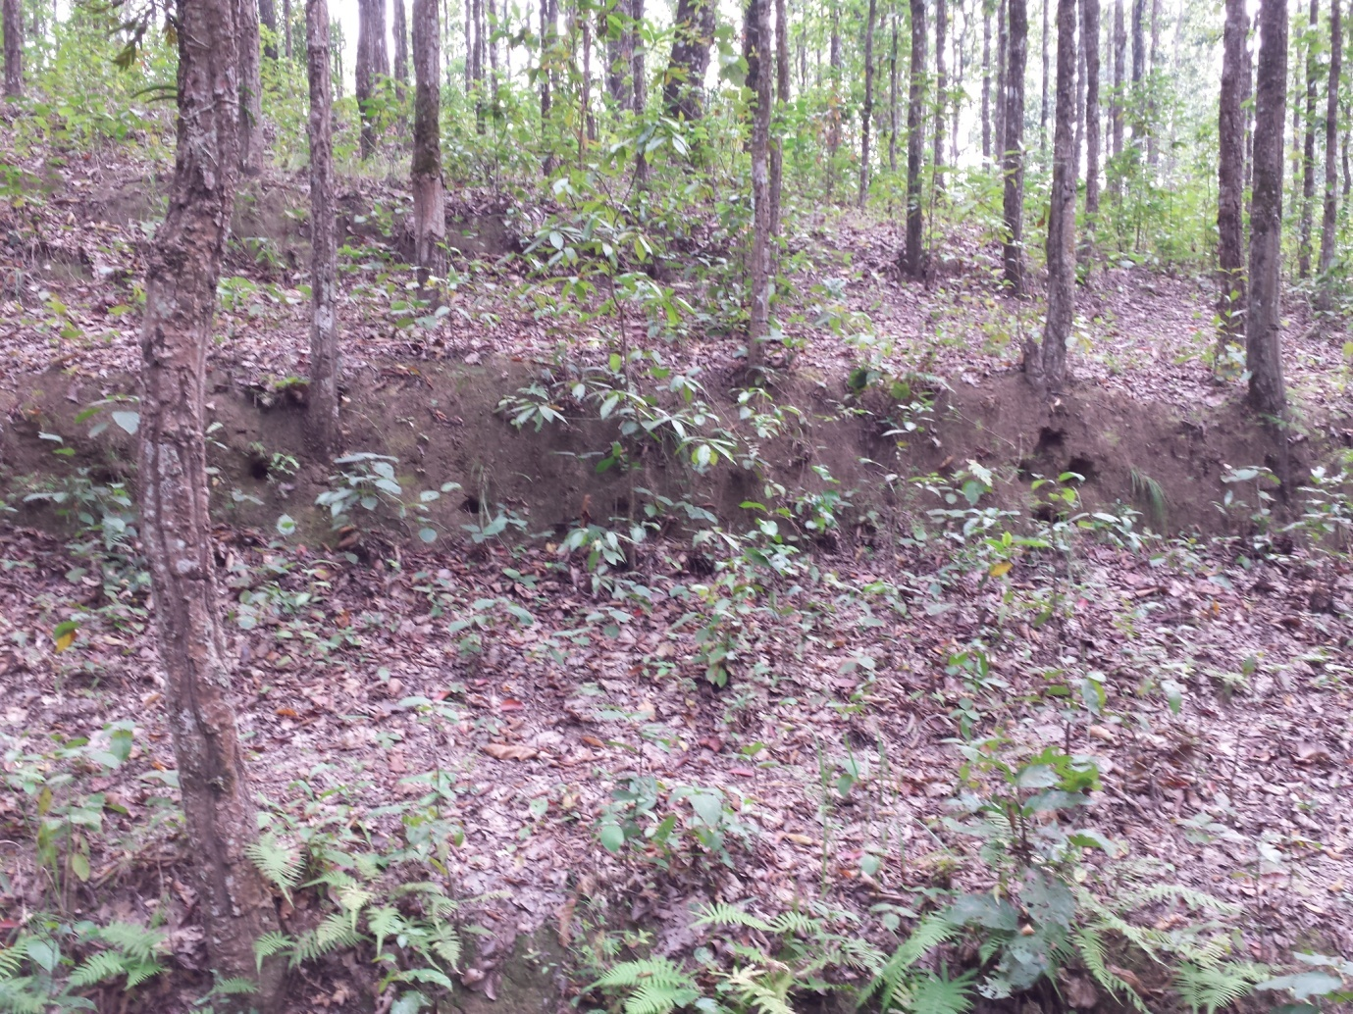
Clumps of burrow
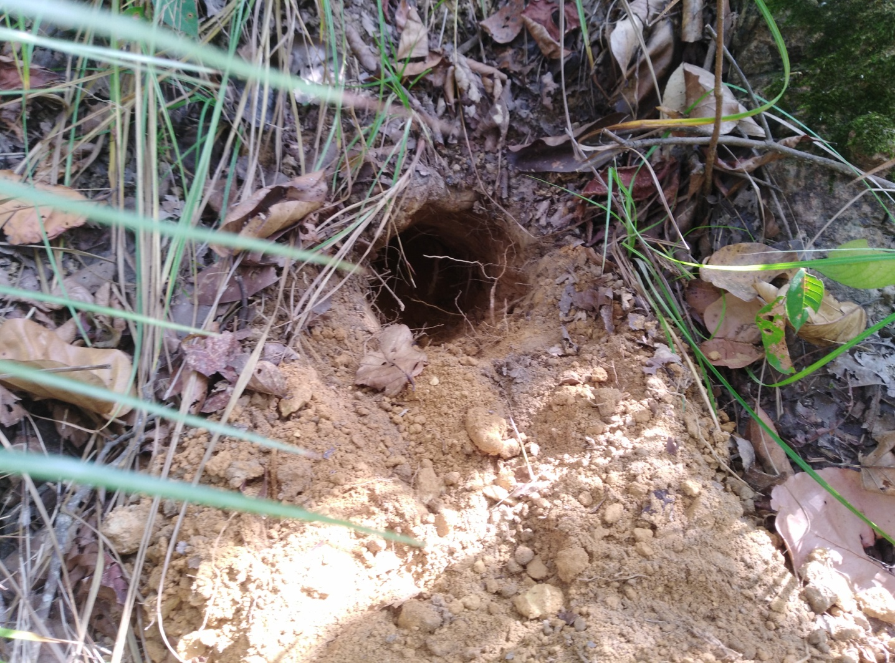
New Burrow
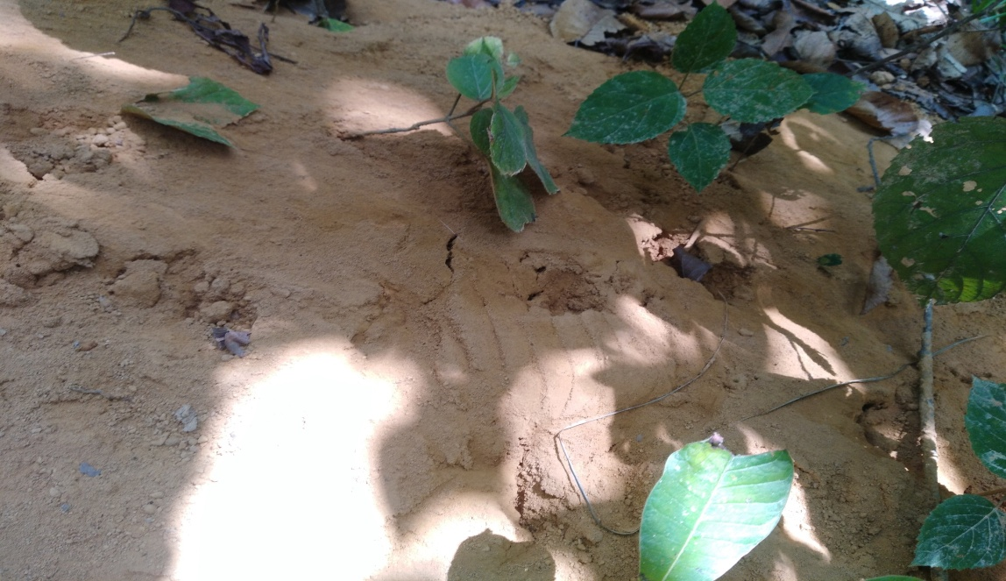
Scale and footprint of pangolin Household Survey

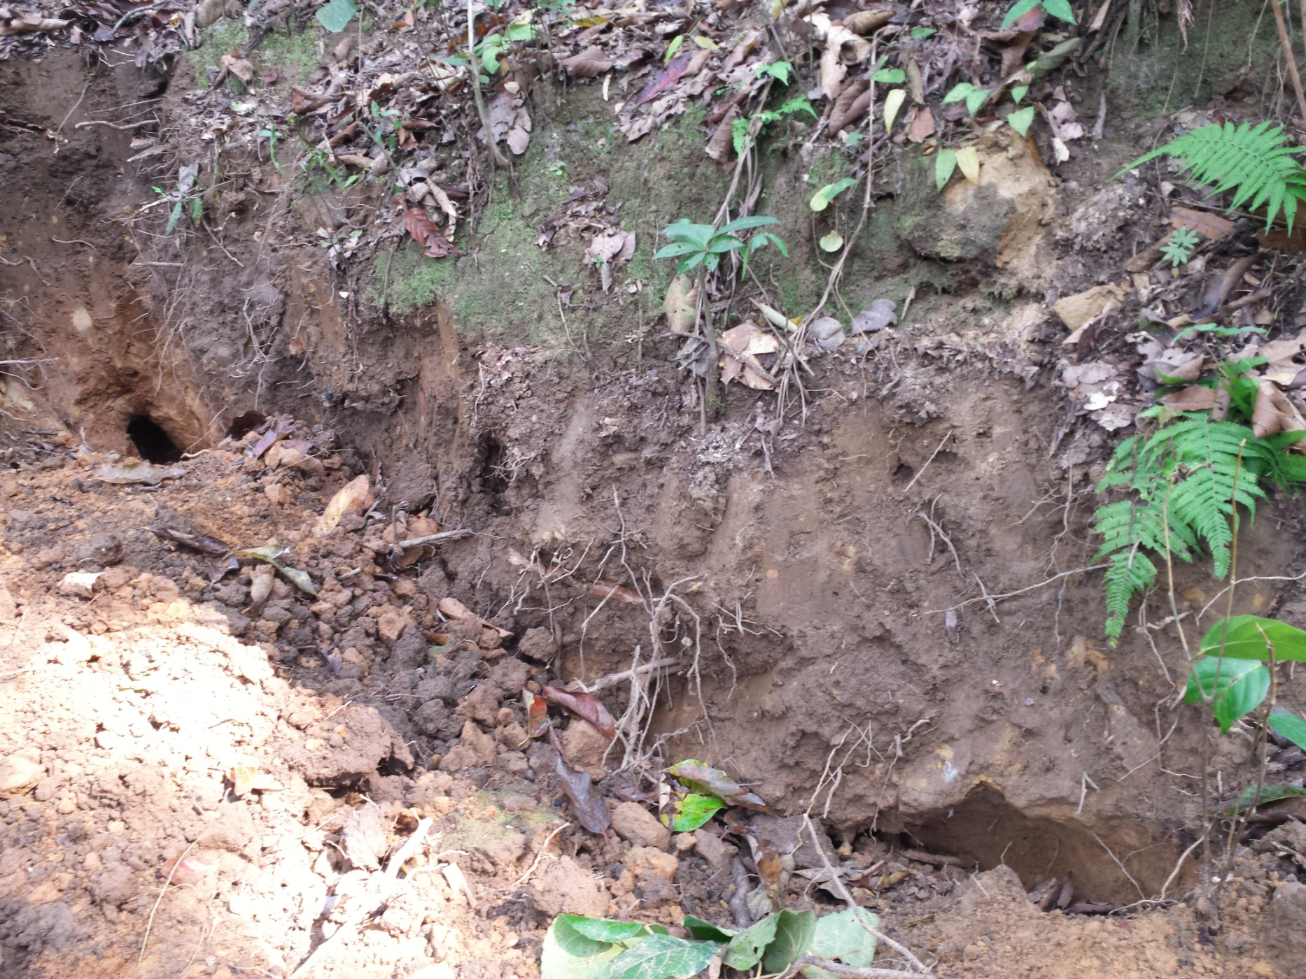

Hole dug to catch pangolin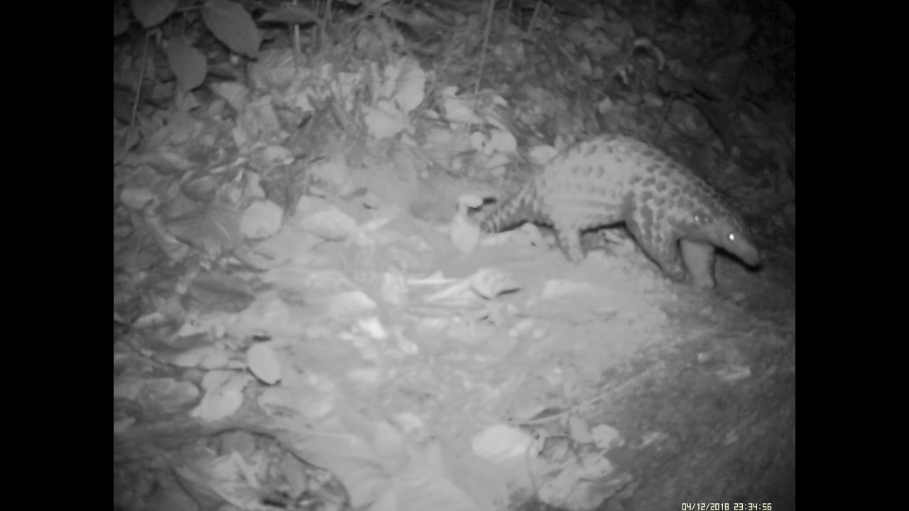
Camera trap picture of pangolin
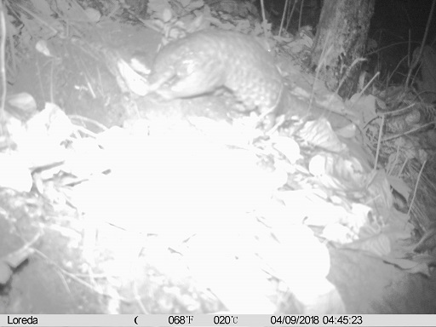
Camera trap picture of pangolin

