NUTRITIONAL STATUS AND ASSOCIATED FACTORS OF ADOLESCENT STUDENTS STUDYING AT GOVERNMENT SCHOOLS OF DHANKUTA MUNICIPALITY, DHANKUTA

by
Gehendra Ghimire

Department of Nutrition and Dietetics
Central Campus of Technology
Institute of Science and Technology
Tribhuvan University, Nepal
2025

Nutritional Status and Associated Factors of Adolescent Students Studying at Government Schools of Dhankuta Municipality, Dhankuta

A dissertation submitted to the Department of Nutrition & Dietetics, Central Campus of Technology, Tribhuvan University, in partial fulfilment of the requirements for the degree of B.Sc. in Nutrition and Dietetics

by
Gehendra Ghimire

Department of Nutrition and Dietetics
Central Campus of Technology, Dharan
Institute of Science and Technology
Tribhuvan University, Nepal
August, 2025
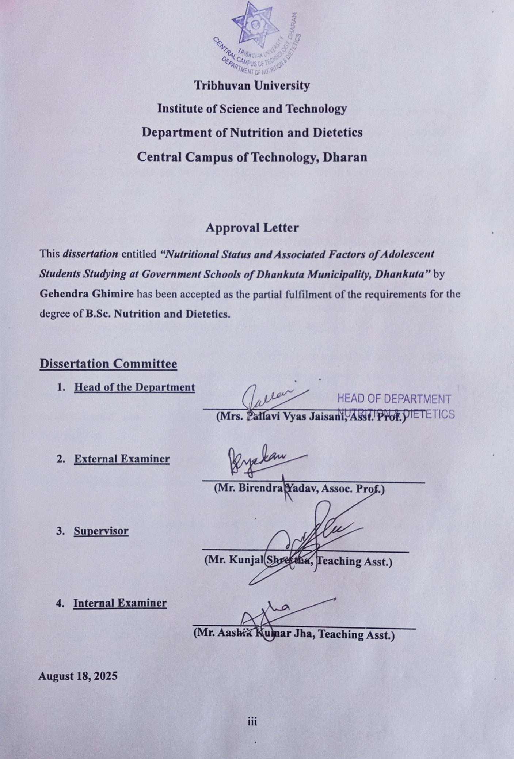

Acknowledgements
First of all, I would like to express my gratitude to Teaching Asst. Kunjal Shrestha, my supervisor, for his continuous support, encouragement and guidance throughout my dissertation. I'd like to express my gratitude to Asst. Prof. Pallavi Vyas Jaisani, Head of the Department of Nutrition and Dietetics, for providing me with all the facilities necessary to complete my dissertation.
I'm thankful to Campus Chief Prof. Basanta Kumar Rai and the Central Campus of Technology for giving me the opportunity to work on my thesis. Their technical and administrative support during the research period is something I deeply appreciate.
I'm grateful to my batch mates who made entire Bachelor life wonderful. I want to take this opportunity to express my gratitude to all the respected teachers for guiding me, offering encouragement and support throughout my entire bachelor's degree.
I am grateful to Mr. Dasharath Rai, chief administrative officer and Dhankuta municipality for providing permission to collect data across government schools of Dhankuta municipality. I would also like to express my gratitude towards Mr. Bhojraj Bhandari, Public health Inspector (Dhankuta municipality) and Health section of Dhankuta municipality for their support.
Also, I take this opportunity to express my deepest gratitude towards the Principals of Gokundeshwar secondary school and Gokundeshwar Balmandir secondary school, Mr. Yagya Prasad Chapagain and Mr. Damador Mishra, respectively for providing me opportunity to conduct my survey. I want to thank all the students for their positive responses during the data collection. Without their cooperation, this study wouldn't have been possible.

Date of submission: August 18, 2025

Gehendra Ghimire

Abstract
A cross-sectional study was carried out among 250 school-going adolescents of government school, Dhankuta district to examine their nutrition status and dietary intake pattern. The students were selected by convenience sampling method from two government schools based on their population size. A well-prepared and tested questionnaire was used to gather details about their family background, physical activity, eating habits, and hygiene practices. Their weight and height were measured using a digital weighing scale and stadiometer. Information about their food intake was collected through a 24-hour food recall and a food frequency questionnaire. The data was analyzed using WHO AnthroPlus (version 1.0.4), SPSS (version 25), and Microsoft Excel. Chi-square and Fisher’s exact tests were used to find out what factors were linked to their nutritional status.
The study found that 12.8% of adolescents were shorter than normal for their age (stunted), 11.6% were thin, and 19.2% were either overweight or obese. Taking part in physical activity during school breaks also made a difference. Father education was statically associated with stunting. Similarly, birth order, number of sibling, family income, feeling about figure and school break activity statically associated with thinness and obesity.

Contents
Approval letter iii
Acknowledgements iv
Abstract v
List of tables xii
List of figures xiv
List of abbreviations xv
1. Introduction 1-5
1.1 Background of study 1
1.2 Problem statement and justification 1
1.3 Objectives 3
1.3.1 General objective 3
1.3.2 Specific objectives 3
1.4 Research questions 3
1.5 Significance of study 3
1.6 Limitations 4
1.7 Conceptual framework 5
2. Literature review 6-24
2.1 Nutrition 6
2.2 Nutrition status 6
2.3 Adolescence 6
2.3.1 Early adolescence 6
2.3.2 Middle adolescence 6
2.3.3 Late adolescence 7
2.4 Changes during adolescence 7
2.4.1 Physical changes 7
3. Cognitive changes 8
2.4.2 Psycho-Social changes 8
2.5 Malnutrition 8
2.6 Assessment of nutrition status 9
2.7 Factors affecting nutritional status of adolescents 9
2.7.1 Dietary adequacy 10
2.7.2 Physiological condition and lifestyle 10
2.7.3 Psycho-social factors 10
2.7.4 Food security 11
2.7.5 Health, water and sanitation 11
2.7.6 Socio-economic and political condition 11
2.8 Nutritional requirement 12
2.9 Nutritional problems in adolescence 14
2.9.1 Under-nutrition (thinness and stunting) 14
2.9.2 Iron deficiency anemia 15
2.9.3 Vitamin A deficiency disorder 16
2.9.4 Iodine deficiency disorders 16
2.9.5 Other micronutrient deficiencies 16
2.9.6 Overweight / Obesity 17
2.10 Dietary intakes and behaviors of adolescents 18
2.11 Nutritional assessment 18
2.11.1 Direct method 19
2.11.2 Indirect method 21
2.12 Dietary assessment 21
2.13 Methods for household dietary assessment 21
2.14 Methods for individual dietary assessment 21
1. 24 hours dietary recall 21
2. Estimated food recall 22
3. Weighed food records 22
4. Dietary history 22
5. Food frequency questionnaire 22
6. Dietary diversity score 22
2.15 Physical activity for adolescents 23
2.16 Cut off point of physical activity for adolescents 24
3. Material and methods 25-29
3.1 Research method 25
3.2 Study location 25
3.3 Target population 25
3.4 Sampling 25
3.5. Sample size calculation: 25
3.6 Criteria for sample selection 26
3.6.1 Inclusion criteria 26
3.6.2 Exclusion criteria 26
3.7 Research instruments 26
3.8 Data collection 27
3.8.1 Height 27
3.8.2 Weight 27
3.8.3 Food frequency and dietary recall 28
3.9 Data analysis 28
3.10 Research variables 28
3.11 Pre-testing 29
3.12 Ethical consideration 29
4. Results and discussion 30-64
4.1 Adolescents characteristics 30
4.2 Demographic characteristics 32
4.3 Socioeconomic characteristics 34
4.4 Environmental condition 37
4.5 Physical activity level 38
4.6 Dietary habits and behavior 38
4.7 Food frequency questionnaire 42
4.8 Dietary diversity score 44
4.9 Dietary intakes 44
4.10 Adequacy of nutrient intake 46
4.11 Prevalence and distribution of malnutrition 47
4.11.1 Stunting (Height for age) 48
4.11.2 Thinness (BMI for age) 52
4.12 Factors associated with malnutrition 55
4.12.1 Socio-econimic and demographic factor associated with stunting 55
4.12.2 Physical activity factors associated with stunning 56
4.12.3 Environmental factors associated with stunning 58
4.12.4 Socio-economic and demographic factor associated with thinness and obesity 59
4.12.5 Dietary behavioral factors associated with thinness and obesity 61
4.12.6 Physical activity associated with malnutrition thinness and obesity 63
5. Conclusions and recommendations 64-65
5.1. Conclusions 64
5.2. Recommendations 65
6. Summary 66
References 67
Appendices 76

List of Tables
Table No. | Title | Page No.
2.1 | RDA of nutrients for boys | 12
2.2 | RDA of nutrients for girls | 13
2.3 | Anthropometric indicators of nutritional status for adolescents | 20
4.1 | Frequency distribution of age group and gender of study population | 30
4.2 | Frequency distribution of adolescent characteristics | 31
4.3 | Frequency distribution of demographic characters of study population | 33
4.4 | Frequency distribution of education level of parents | 34
4.5 | Frequency distribution of economic characteristics of studies families | 35
4.6 | Frequency distribution of environmental character of studies families | 37
4.7 | Frequency distribution of physical activity level of studied adolescents | 38
4.8 | Behavior of meal pattern of adolescents | 39
4.9 | Frequency distribution of diet related behavior of study population | 40
4.10 | Frequency distribution of behaviors related to other food habits and body weight | 41
4.11 | Frequency distribution of weekly consumption of different food group | 42
4.12 | Mean nutrient intake of surveyed adolescents | 44
4.13 | Mean nutrient intake of boys | 45
4.14 | Mean nutrient intake of girls | 45
4.15 | Adequacy of nutrient intake | 46
4.16 | Z-score value for height for age (HAZ) of studied population | 49
4.17 | HAZ for male adolescents | 49
4.18 | HAZ for female adolescents | 50
4.19 | Z-score value for BMI for age | 52
4.20 | BAZ of male adolescents | 53
4.21 | BAZ of female adolescents | 53
4.22 | Socio-economic and demographic factors associated with stunning | 55
4.23 | Physical activity associated with stunning | 56
4.24 | Environmental factors associated with stunning | 58
4.25 | Socio-economic and demographic factors associated with thinness and obesity | 59
4.26 | Dietary behavioral factors associated with thinness and obesity | 61
4.27 | Physical activity associated with thinness and obesity | 63

List of Figures
Figure No. | Title | Page No.
1.1 | UNICEF theoretical framework on the causes of malnutrition | 5
4.1 | Prevalence of malnutrition based on gender | 48
4.2 | Distribution of HAZ curve with reference to WHO standard | 51
4.3 | Gender wise distribution of HAZ | 52
4.4 | Distribution of BAZ curve with reference to WHO standard | 55
4.5 | Gender wise distribution of BAZ | 56

List of Abbreviations
Abbreviations | Full forms
BMI | Body Mass Index
BAZ | Z score value for BMI for age
HAZ | Z score value for height for age
BNF | British Nutrition Foundation
FAO | Food and Agriculture Organization of United Nations
GoN | Government of Nepal
gm | Gram
HDI | Human Development Index
ICMR | Indian Council of Medical Research
IOM | Institute of Medicine of National Academies
Kcal | Kilo calorie
mg | Milligram
NCD | Non-communicable disease
NDHS | Nepal Demographic and Health Survey
NLM | National Library of Medicine
SEAR | South East Asian Region
UNICEF | United Nations Children's Emergency Fund
USA | Unites States of America
USAID | United States Agency for International Development
WHO | World Health Organization
ZnD | Zinc Deficiency

Part I

Introduction

1.1 Background of study
Adolescence, spanning the ages of 10 to 19, is a transitional phase between childhood and adulthood. It is a distinct and critical period of human development that lays the foundation for long-term health and well-being. During this time, adolescents undergo rapid physical, cognitive, and psychological changes. Moreover, key behavioral patterns related to nutrition, physical activity, substance use, and sexual behavior are established during this stage (WHO, 2025a).
Nutrition is the consumption of food in proportion to the nutritional requirements of the body. A healthy diet is crucial to overall well-being. Impaired physical and mental development, heightened vulnerability to illness, decreased immunity, and decreased output. At every stage of life, from conception to death, nutrition affects development (WHO, 2025d). A person's nutritional status is determined by the balance between their dietary intake and needs, and it should permit them to use nutrients to replenish stores and make up for losses (Fernández-Lázaro and Seco-Calvo, 2023)
Teenagers in many impoverished countries frequently suffer from stunting, underweight, and micronutrient deficiencies as a result of inadequate nutrition and early childhood illnesses, which are exacerbated by a diet that does not meet the significant nutritional needs during the adolescence's fast growth phase (Cusick and Kuch, 2012). According to a 2021 study on the Kathmandu metropolitan area, 9.1% of people are underweight, and 23.7% are overweight or obese (Singh et al., 2021). A study carried out in a semi-urban part of the Pokhara metropolitan metropolis found that among school-age adolescents aged 9 to 17, the percentages of obesity, overweight, underweight, and stunting were 4%, 12%, 7%, and 17%, respectively (Hamann et al., 2023).

1.2 Problem statement and justification
Despite the widespread belief that adolescence is a healthy stage of life, there are a significant number of deaths, illnesses, and injuries throughout this time (WHO, 2025a). According to a study on the eating patterns and variables influencing the food preferences of teenagers in rural areas Adolescents' food choices have been found to be influenced by a number of factors, including body image issues, dieting, food education, parental control, maternal education level, and dining with family and peers (Bargiota et al., 2013).
Protein-energy malnutrition is one of the top 10 causes of death for children and adolescents, accounting for 225,906 fatalities in 2013, according to data from the worldwide burden of illnesses and injuries among children and adolescents. Malnutrition causes about 34 fatalities per 100,000 children and adolescents worldwide, with a notable difference between developing (38.5 per 100,000) and developed (0.2 per 100,000) nations (Kyu et al., 2016). Teenagers frequently use energy sources deficient in important vitamins or minerals, according to research. Given that dietary behaviors developed throughout adolescence often carry over into adulthood, intervention during this time is essential (Ross et al., 2020).
Many teenagers in the South East Asian (SEA) Region experience chronic anemia and malnutrition, which has a negative effect on their development and health. In addition to raising morbidity and mortality, girls' high rates of malnutrition linked to the chance of giving birth to low-birthweight kids as well as pregnancy and delivery. This adds to the cycle of malnutrition that spans generations (WHO, 2006). Underweight, stunting, and wasting in children and adolescents now coexist alongside overnutrition indicators including overweight and obesity. The "double burden of malnutrition" refers to the discrepancy of these two borders (Marriott et al., 2012; Wells, 2012).
Nutrition programs in many developing countries, including Nepal, have mostly focused on women and children, ignoring the nutritional needs of teenagers (Cusick and Kuch, 2012). There are more young people in the current generation. More so than before, but many of them aren't getting the help they need to completely exercise their rights. Three teenagers' well-being is at risk due to issues like poverty, inequality, prejudice, climate change, economic disruptions, conflict, and displacement. Regretfully, legislators usually ignore adolescents or, in certain situations, view them as problems or threats (UNICEF, 2021).
Limited studies have explored the factors contributing to malnutrition among adolescents in Nepal. Since no study on assessment of nutritional status and dietary intake of adolescents on Dhankuta municipality has been conducted till date, this study was done to assess the nutritional status and its associated factors among adolescents attending schools in the Dhankuta Municipality of Dhankuta district, Nepal. The study can aid for policy makers at both local and national level.

1.3 Objectives

1.3.1 General objective
The general objective of this survey is to assess nutritional status and dietary intake of adolescents studying in government schools of Dhankuta municipality, Dhankuta.

1.3.2 Specific objectives
- To assess the nutritional status of the adolescents by anthropometric method and dietary assessment of government school of Dhankuta municipality, Dhankuta.
- To assess the dietary intake and dietary habits of adolescents in Dhankuta municipality, Dhankuta.
- To assess the relation of nutritional status with socioeconomic and dietary factor.

1.4 Research questions
- What is the nutritional status of adolescents studying in government schools of Dhankuta municipality, Dhankuta?
- How is the dietary intake and dietary habits of adolescents of Dhankuta municipality, Dhankuta?
- What are the different factors which directly and indirectly influence the nutritional status of the adolescents?

1.5 Significance of study
This study highlights the extent and distribution of malnutrition among adolescents studying in government schools of Dhankuta municipality. By identifying patterns and trends within this specific population, the findings offer valuable insights that could reflect the broader nutritional challenges faced by adolescents at the national level. The research helps pinpoint the individuals or groups most at risk of malnutrition, paving the way for more effective intervention strategies.
In addition to determining the prevalence of malnutrition, the study explores the various contributing factors, including dietary behaviors and nutrient intake. It sheds light on how these behaviors influence adolescents' nutritional status and examines the role of other variables such as gender, caste, and family economic background. This comprehensive analysis allows for a clearer understanding of the underlying causes of malnutrition in this age group.
Based on these findings, the study can recommend specific and targeted corrective measures to address adolescent malnutrition. These recommendations may guide governmental and non-governmental organizations in designing and implementing relevant nutrition programs. Moreover, the study serves as a useful reference for policymakers, helping them develop informed plans and policies aimed at improving adolescent health and reducing malnutrition nationwide.

1.6 Limitations
- Biochemical and clinical assessment were not performed due to limitations of facilities.
- Seasonal variation could not be accounted because it is cross-sectional survey.
- Data cannot be generalized to other population.

1.7 Conceptual framework

Food insecurity

Inadequate care
Inadequate prevention and control of disease
Control and management of resources (human, economic, organizational)

Disease
Malnutrition
Inadequate dietary intake

Immediate cause

Potential resources

Underlying cause

Fig. 1.1 UNICEF theoretical framework on the causes of malnutrition
Source: UNICEF (2021)

Part II

Literature review

2.1 Nutrition
The study of nutrition focuses on how food may support human health and wellness at all age groups while also being essential to children's and teenagers' growth and development. Numerous dietary components are included in the relationship between nutrition and health (Contentto, 2008).

2.2 Nutrition status
The state of the body brought about by food intake, absorption, and use is known as nutritional status (Sangroula and Uprety, 2020). Anthropometric metrics, such as the arm muscle mass, triceps skin-fold thickness, and weight-for-height index Measurements of circumference and circulating proteins including albumin, transferrin, and prealbumin are used to determine nutritional status. When developing dietary intake guidelines, this evaluation is crucial (Elmadfa and Meyer, 2014).

2.3 Adolescence
Adolescence is the stage of life between childhood and adulthood, usually from ages 10 to 19. It is an important time for growth and for building the foundation for good health (WHO, 2025a). This foundation for healthy growth and development begins before birth and continues through childhood and the teenage years (WHO, 2006).

2.3.1 Early adolescence
The normal age range for early adolescence is 10 to 15 years old. Secondary sexual traits appear during this time, people start using concrete thinking, and they frequently don't grasp how their present behavior will affect their future. Arguments, defiant conduct, and frequent mood swings are characteristics of this period (WHO, 2010b).

2.3.2 Middle adolescence
The ages of 14 to 17 are included in the category of middle adolescence. People usually attain around 95% of their adult height during this age, and secondary sexual traits continue to emerge. During this time, people consider impractical dreams, an increase in self-confidence, the development of sexual urges, and the formation of stronger interpersonal bonds (WHO, 2010b).

2.3.3 Late adolescence
The 16–19 age range is referred to as late adolescence. During this stage, people acquire their ability to think abstractly, mature physically, and start making plans for the future. Furthermore, they begin to learn morals and ethics, improving their comprehension of good and evil (WHO, 2010b).

2.4 Changes during adolescence
Adolescence is a time of accelerated physical, biological, and emotional development.
Hormones affect both the body and the psyche, bringing about a variety of changes. The final growth spurt, which causes increases in height and weight, occurs at this period. During their development spurt, boys develop more slowly than girls (Srilakshmi, 2014). Rapid changes in the body can be confusing, thrilling, or scary. Both circumstances may exacerbate the stress of standing out from the crowd, even though some teenagers may mature earlier and others later. This can be extremely distressing because adolescent is the key developmental stage for the desire to fit in with others (Rathus, 2016).

2.4.1 Physical changes
The growth experienced during adolescence in terms of physical size is second only to the development in infancy. The maximum growth velocity occurs in the 10–13 age range for girls and 12–15 years for boys. Between the ages of 18 and 20, they reach adult height, but until they are 25 years old, their bone mass keeps growing (Srilakshmi, 2014). Some physical changes during teenage are as below:

1. Body composition
Prior to puberty, males and girls have roughly equal quantities of muscle, lean body mass, and fat (19% and 15%, respectively). By the age of 20, girls' body fat percentage rises to 23%, while boys' lowers to 12% (Delisle, 2005).

2. Sexual maturity
The development surge is accompanied by sexual maturity. Girls go through menarche, pubic and auxiliary hair growth, and breast development. They get smaller waists and rounder hips.
The development of pubic and auxiliary hair, wider shoulders, a deeper voice, and in boys, pubertal changes are indicated by the development of the penis and testicles. In order to evaluate sexual maturation, pubertal development is examined by looking at secondary sex traits such testicular and penile growth and the appearance of pubic hair in boys, as well as breast development and pubic hair appearance in girls. Tanner stage rating is a typical name for this evaluation (Stonge et al., 2014).

3. Cognitive changes
Teens' perceptions of the world change as they become aware of their increased mental capacity. The cognitive changes in teenagers affect how they view themselves, their families, and their friends as well as how they handle broader social and moral concerns. Which take place throughout adolescence (Rathus, 2016).

2.4.2 Psycho-Social changes
The development of a sexual and personal identity, the emergence of abstract thought, the rising ability to absorb and process the opinions of others, the formation of a system of values, the growing independence and autonomy from family, the growing. The most important psychological and psychosocial changes that take place in the early years of adolescence are the importance of occasionally subcultural peer interactions, as well as the development of coping strategies and problem-solving abilities (Remschmidt, 1994). Adolescents who begin to differentiate themselves from others and undergo bodily changes often struggle with self-esteem issues. Teenagers' struggles with self-esteem can be complex. Although they might be highly regarded by their family, they might not be as well-regarded by their peers or by their academic achievement (Robert, 2008).

2.5 Malnutrition
Deficits or excesses in food intake, an imbalance of vital nutrients, or poor nutrient use are all considered forms of malnutrition. The double burden of malnutrition, which also includes diet-related noncommunicable illnesses, includes undernutrition, obesity, and overweight (WHO, 2025d).
According to (WHO, 2025d):
- Wasting is defined as low weight-for-height.
- Stunting is defined as low height-for-age. It is the result of chronic or recurrent undernutrition.
- Underweight is defined as low weight-for-age.
- Micronutrient deficiencies are a lack of vitamins and minerals that are essential for body functions such as producing enzymes, hormones and other substances needed for growth and development.

2.6 Assessment of nutrition status
Analyzing information from dietary, laboratory, anthropometric, and clinical research is part of nutritional evaluation. By taking into account the effects of nutrient intake and use, this procedure seeks to assess the nutritional status of individuals or populations. Following a conference held in 1932 by the League of Nations' Health Organizations, the techniques for nutritional assessment were initially described (Lee, 2010).
The assessment of nutritional status of adolescents can be done by;
- Height for age
- BMI for age

2.7 Factors affecting nutritional status of adolescents
The nutritional status of adolescents in Nepal is intricately linked to a complex interplay of educational, socio-economic, cultural, and environmental factors. Economic disparities and poverty impact access to quality food and healthcare, with a significant population engaged in agriculture. Cultural beliefs shape dietary habits and health practices. Limited healthcare infrastructure, early marriage and pregnancies contribute to increased nutritional demands. Challenges in sanitation, hygiene, and climate change further affect food security. Some of the major factors affecting nutritional status of adolescents are given below:

2.7.1 Dietary adequacy
In developing countries, the majority of rural households' diets are made up of seasonal fruits and vegetables, locally grown starchy staples, and little to no animal products. Boresome diets with a relatively small range of foods lead to under-nutrition, particularly in children from households with poor food resources. Gender disparities in access to the availability of food and other resources can lead to under-nutrition, especially when the female child is still seen as less important than the male child (Maziya, 2014). Adolescent growth and health are impacted by diet, which extends throughout adulthood. Poor calorie, macronutrient, or micronutrient intake during adolescence may have detrimental long-term effects. Adolescent malnutrition can also lead to disordered eating patterns, including restriction or dieting, negative body image, or a tense relationship with food, which may so in a diet that is significantly worse (Evans and Docter, 2020). Even when there is an adequate supply of food, the average calorie intake of each family member may be below the suggested limits. As a result, the most impacted groups are children under two and adolescents (WHO, 2006).

2.7.2 Physiological condition and lifestyle
According to Christian and Smith (2018), food intake, physical activity, infection, and early pregnancy are the physiological determinants of adolescent health and nutrition. Frequent exercise has a significant impact on energy expenditure and long-term weight control (Wier et al., 2001). Physical inactivity is currently the fourth most significant risk factor for death 12 globally. The rising rates of physical inactivity have a substantial effect on the general health of the world's population. Frequent exercise has been shown to reduce the risk of coronary heart disease, stroke, diabetes, depression, breast and colon cancer, and high blood pressure. Additionally, physical activity is vital for maintaining energy balance and regulating weight since it plays a critical role in determining energy expenditure (WHO, 2010a).

2.7.3 Psycho-social factors
The American Psychological Association (APA) defines psycho-social factors as social, cultural, and environmental influences and phenomena that have an impact on behavior and mental health. During adolescence and the early years of adulthood, eating patterns frequently change. This is because of social changes that occur when a person grows from school age to adolescence, such as the transition from eating mostly at home to dining with friends or on campus, as well as the period of time spent exploring one's identity (Bhattarai and Bhusal, 2019). Although poverty is thought to be the main factor influencing food intake, other studies contend that cultural factors rather than socioeconomic conditions have a greater influence allocation of food and nutritional adequacy (WHO, 2006).

2.7.4 Food security
An increased risk of stunting and underweight in children and adolescents appears to be associated with household food insecurity. Additionally, the intensity of food insecurity and the advancing ages of children may increase the risk of stunting or underweight in households experiencing food insecurity (Moradi et al., 2019). People who suffer from long-term food insecurity are probably also deficient in macro and micronutrients. Even when people eat enough food, they may still have nutritional imbalances (UNICEF, 1991).

2.7.5 Health, water and sanitation
The quality of the accessible healthcare facilities, medical expertise and practices, water quality, and hygiene practices are all associated with malnutrition (Danjin et al., 2021). Because stunting and a higher prevalence of poverty are often associated with higher rates of open defecation in low- and middle-income nations. In order to reduce malnutrition, water, sanitation, and hygiene are essential (Soulichanh, 2019). When sick or infected, the body requires more nutrients, and malnutrition makes it more difficult for the body to absorb and use nutrients. A vicious circle of disease, malnutrition, and sometimes even death results from this. Recurrent infections and illnesses have a detrimental effect on children's mental and physical development, and malnutrition is more likely to affect those with compromised immune systems (Maziya, 2014).

2.7.6 Socio-economic and political condition
Due to a variety of significant underlying factors, such as poverty, low literacy rates, big families, food insecurity, food safety, and women's education, children from lower socioeconomic groups typically have worse health results. In addition to personal development through educational opportunities, political, social, and economic reforms are required to enhance nutritional status (Babar et al., 2010). Based on gender, parents probably give boys and girls varying amounts of food and other resources. As demonstrated, for instance, in Nepal, adolescent girls and women may be disadvantaged when it comes to the distribution of food in households (Delisle, 2005).

2.8 Nutritional requirement
The age and sex of an individual determine their nutritional needs. While newborns, kids, and adolescents need nutrients for both development and maintenance, adults need them for maintenance. The amount of nutrients a child needs during childhood is correlated with their rate of growth. Even people of the same age, sex, and body weight have distinct variances in their nutritional needs (Srilakshmi, 2006). Table 2.1 and 2.2 shows the RDA for adolescent boys and girls, respectively.
Table 2.1 RDA of nutrients for boys
Nutrients | Age in years
Nutrients | 10 -12 years | 13 -15 years | 16 -18 years
Energy (Kcal) | 2200 | 2860 | 3320
Protein (g) | 32 | 45 | 55
Fat (g) | 35 | 45 | 50
Calcium (mg) | 850 | 1000 | 1050
Iron (mg) | 16 | 22 | 26
Vitamin A (µg) | 770 | 930 | 1000
Thiamine (mg) | 1.5 | 1.9 | 2.2
Riboflavin (mg) | 2.1 | 2.7 | 3.1
Niacin (mg) | 15 | 19 | 22
Pyridoxine (mg) | 2.0 | 2.6 | 3.0
Ascorbic Acid (mg) | 55 | 70 | 85
Dietary folate (µg) | 220 | 285 | 340
Vitamin B12 (µg) | 2.2 | 2.2 | 2.2
Magnesium (µg) | 240 | 345 | 440
Zinc (mg) | 8.5 | 14.3 | 17.6
Source: ICMR (2020)

Table 2.2 RDA of nutrients for girls
Nutrients | Age in years
Nutrients | 10 -12 years | 13 -15 years | 16 -18 years
Energy (Kcal) | 2060 | 2400 | 2500
Protein (g) | 35 | 45 | 46
Fat (g) | 35 | 40 | 35
Calcium (mg) | 850 | 1000 | 1050
Iron (mg) | 28 | 22 | 32
Vitamin A (µg) | 790 | 930 | 860
Thiamine (mg) | 1.4 | 1.9 | 1.7
Riboflavin (mg) | 1.9 | 2.7 | 2.3
Niacin (mg) | 14 | 19 | 17
Pyridoxine (mg) | 1.9 | 2.6 | 2.3
Ascorbic Acid (mg) | 50 | 70 | 70
Dietary folate (µg) | 225 | 285 | 270
Vitamin B12 (µg) | 2.2 | 2.2 | 2.2
Magnesium (µg) | 250 | 345 | 380
Zinc (mg) | 8.5 | 14.3 | 14.2
Source: ICMR (2020)

2.9 Nutritional problems in adolescence

2.9.1 Under-nutrition (thinness and stunting)
Short stature and low body mass in adolescents may be linked to concurrent functional impairment. Teenagers with small statures who have previously experienced chronic undernutrition are associated with reduced lean body mass, weakened muscles, and diminished functional ability. Under-nutrition throughout adolescence may affect a girl's capacity to procreate as an adult (WHO, 1995). Although it is often known that genetics has a big influence on stature, there is growing evidence that environmental factors, such as poverty and a high prevalence of diseases, also have a big influence on final stature. It has been suggested that in unfavorable situations, environmental variables impact size more than genetics (Amigo et al., 1994; Merchant et al., 2003).
The NDHS 2022 report states that 5.2% of girls and 13.6% of boys between the ages of 15 and 19 months were extremely thin (Z-score value <-2) (MoHP. et al., 2023). 47.3% of school-age adolescents in the eastern region of Nepal have low BMIs for their age, per a study (Kafle et al., 2020). A study of teenage girls aged 9 to 16 in the Kavreplanchok area found that the general prevalence of underweight, stunting, and thinness was 31.98%, 21.08%, and 14.94%, respectively. According to Mansur et al. (2015), girls aged 9 had the highest rates of stunting and thinness (37.34% and 24.2%, respectively), while girls aged 11 had a significantly higher likelihood of being underweight (49.5%).

2.9.2 Iron deficiency anemia
Under physiological settings, iron transit, storage, and absorption all occur in balance within the human body. However, iron deficiency anemia (IDA) and ID may result from the interaction of three distinct risk factors: increased blood loss, decreased external supply, and higher iron requirements (Hersko, 2006).
Iron deficiency and iron deficiency anemia account for the bulk of disability-adjusted life years (DALYs) associated with micronutrient deficiencies (>2,500 DALYs per 100,000 adolescents). Iron deficiency anemia and iron insufficiency are more common in countries with lower social development indices (SDIs) and affect adolescent girls more often than boys. Iodine deficiency, which is more common in female teenagers, considerably raises the burden of micronutrient deficits. According to Akseer et al. (2017), the prevalence is 4.6% among older female adolescents (15–19 years old) and 3.4% among young adolescent girls in low SDI countries.
Research in Morang found that iron deficiency anemia afflicted 65.6% of adolescents overall, with a distribution of 78.3% among females, 62.4% among men, and 70.0% among urban regions (Baral and Onta, 2009). Overall, 31% of teenagers in Nepal had anemia, 38% of female adolescents had it, and 24% of male adolescents had it, according to results from a nationally representative cross-sectional study (Chalise et al., 2018).

2.9.3 Vitamin A deficiency disorder
Vitamin A deficiency in children is the leading cause of preventable blindness and severe visual impairment in developing countries. It also contributes significantly to severe diseases and deaths, particularly those brought on by diarrhea and measles. Poor maternal performance during pregnancy and lactation, as well as growth limitations in children, may also be significantly influenced by vitamin A deficiency. Additionally, it might increase the risk of other illnesses, like iron-deficiency anemia, for both moms and kids (Underwood and Arthur, 1996). Studies conducted in a variety of settings have shown that adolescents in Bangladesh suffer from subclinical vitamin A insufficiency at a considerable rate (WHO, 2006).

2.9.4 Iodine deficiency disorders
Iodine deficiency has several detrimental consequences on development and growth. These illnesses, which are referred to as iodine-deficiency disorders, are brought on by inadequate thyroid hormone production. Iodine deficiency is the leading preventable cause of mental harm worldwide. Goiter, or enlarged thyroid, is the typical sign of iodine insufficiency and is a physiologic reaction to chronic iodine deficit (Zimmermann and colleagues, 2008).

2.9.5 Other micronutrient deficiencies
Growth retardation, immunological dysfunction, reduced cognitive function, developmental delay, and metabolic abnormalities that increase the risk of obesity and hypertension later in life are all consequences of micronutrient deficiencies in childhood and adolescence. Developing nations typically have diets that are high in 18 phytate and low in micronutrient density, which impairs vitamin absorption and raises the risk of micronutrient shortages (Ferrari and Branca, 2002).
Compared to childhood or early adulthood, adolescence appears to require much more calcium for skeletal development. Since adolescence is when the greatest quantity of bone mass is formed, the amount of calcium deposited at this time determines the risk of osteoporosis in adulthood.
Rickets in newborns or adolescents or osteomalacia and muscle weakness in older children or adolescents can result from a vitamin D deficiency, whether or not it is coupled with a calcium deficiency (Lips and van Schoor, 2011). A person's peak bone mass may also be adversely affected by a vitamin D deficiency, which could lead to osteoporosis in later life and low bone mineral density in childhood and adolescence (Golden and Abrams, 2014).
Zinc is a multipurpose metal that supports general health and growth (Chasapis et al., 2012). Its ability to regulate neurological development, immunity, and growth is well known. This can affect the development of the kidneys, heart, brain, lungs, bones, and other organs. Iron and vitamin A are two of the several micronutrients with which it interacts (Maggini et al., 2010). Coexisting with CKD and ZnD aggravates renal issues. Furthermore, Li et al. (2017) found that oxidative stress is connected to the negative consequences of ZnD.

2.9.6 Overweight / Obesity
The prevalence of overweight and obesity in children and teenagers is increasing globally, making it a widespread and persistent health issue in this age group that often continues into adulthood (Lissau et al., 2004). The effects of childhood and adolescent obesity, such as altered metabolism and physiology, frequently persist into adulthood, potentially increasing an individual's risk of disease, disability, and death (Wang et al., 2010).
Teenagers who were growth-retarded at birth also tend to put on more weight during their teenage growth spurt. Teens have delicate body image concerns and are especially vulnerable to social discrimination regarding their bodies. Adolescent obesity is frequently associated with negative body image and low self-esteem. The two primary long-term health consequences of adolescent obesity are its persistence into adulthood and its association with an increased risk of cardiovascular disease in later life (Must and Strauss, 1999). Overweight and obesity in adolescents were also significantly influenced by their eating habits and degree of physical activity (Kadim et al., 2023).
Overweight and obesity were prevalent among school-age adolescents aged 16 to 17 (58.6%), with the majority of these individuals being male (56.4%) and attending public schools (86.7%), per a cross-sectional study conducted in a developing nation. 28.8% of the sample's children were overweight, and 14.4% of them were obese. Boys are more likely to be overweight or obese than girls. According to Kadim et al. (2023), 43% of youths enrolled in public schools were overweight or obese. The prevalence of overweight and obesity among teenagers aged 15 to 19 is 4.0% and 2.5% for males and 5.2% and 0.6% for females, respectively, according to the NDHS 2022 study (MoHP. et al., 2023).

2.10 Dietary intakes and behaviors of adolescents
The types of foods, calories, and quantities of each that are ingested are all included in a person's dietary intake. Many circumstances, including early pregnancy, prejudice, dieting, and consuming less energy than boys, may make teenage girls much more susceptible to inadequate intakes. However, women are more likely than men to eat properly, and when given the choice, they are more concerned with eating well as long as dieting doesn't interfere with their lifestyle (WHO, 2005).
According to a study done in Ethiopia, there is a serious problem with vitamin A consumption, and both macro and micronutrient intake are insufficient. Additionally, it has been found that the problem is caused by teens' inadequate daily intake of body-building nutrients like milk and pulses as well as protective foods like fruits, green vegetables, and other vegetables (Semegn et al., 2024).
According to a study done on teenage girls in a rural part of Puducherry, India, their intake of fruits, vegetables, and foods high in calcium and iron was inadequate. However, the amount of grains and pulses consumed was sufficient and satisfactory (Chandar et al., 2020).

2.11 Nutritional assessment
Nutritional status is the current body status of a person or a population group, related to their state of nourishment (the consumption and utilization of nutrients). The principal aim of assessing the nutritional status of a community is, to map out the magnitude and 20 geographical distribution of malnutrition as a public health problem, to discover and analyze the ecological factors that are directly or indirectly responsible, and, where possible to suggest appropriate corrective measures, preferably capable of being applied with continuing community participation (Jelliffe, 1966).
Poor nutritional status refers to an inadequate or even excessive intake or poor utilization of the nutrients to meet the body‘s requirement (Joshi, 2015).
Assessment of nutritional status involves two methods (Joshi, 2015):
- Direct Method
  - Anthropometric method
  - Biochemical methods
  - Clinical examination methods
  - Dietary procedures
- Indirect Method
  - Vital statistics
  - Ecological factors

2.11.1 Direct method

1. Anthropometric measurement
Anthropometric measurements include height, weight, skin-fold thickness, and circumference etc. it could detect the change of body composition to assess the nutritional status in specific population groups, including newborn, children under age of five and adults (Shrivastava et al., 2014).
Advantages of anthropometry (Benjamin, 2014):
- To get information about growth patterns.
- To get information about fat composition and lean body mass.
- To predict index of morbidity and mortality concerning malnutrition.
- To evaluate the effect of nutrition therapy.

Table 2.3 Anthropometric indicators of nutritional status for adolescents
Z score | Cut off | Indicators
Z score | Cut off | Height for age | BMI for age
Z score | Below -3 SD | Severely stunted | Severely thin
Z score | -3 SD to -2 SD | Moderately Stunted | Moderately thin
Z score | -2 SD to 1 SD | Normal | Normal
Z score | +1 SD to +2 SD | Normal | Overweight
Z score | +2 SD to +3 SD | Normal | Obese
Z score | Above +3 SD | May be abnormal | Severely Obese
Source: WHO (2025c)

2. Biochemical assessment
Biochemical assessment involves measurement of status of bodily secretions, fluids etc. against certain standard parameter. For instance, measurement of albumin, creatinine, immune function tests etc. (Benjamin, 2014).

3. Clinical examination
Clinical examination seeks out the symptoms of specific nutritional deficiency. Presence of two or more clinical signs increases the diagnostic significance (Shrivastava et al., 2014).

4. Dietary intake assessment
Dietary intake assessment is done to assess the nutritional intake, questionnaire, recall or record method can be implied for performing intake assessment (Shrivastava et al., 2014).

2.11.2 Indirect method

1. Vital statistics
Vitals statistics such as records related to birth and death of infants, death of mother etc. might be used to evaluate the prevalence rate, sort out the risk groups and has higher public health importance (WHO, 2025c).

2. Ecological factors
Ecological factors like socio-economic factors, health care facilities etc. are related to the occurrence of malnutrition. It is necessary assessment to find out which factor is affecting the nutritional status of the society (Shrivastava et al., 2014).

2.12 Dietary assessment
Dietary assessment involves the collection of information on foods and drinks consumed over a specified time that is coded and processed to compute intakes of energy, nutrients and other dietary constituents using food composition tables. A wide variety of dietary assessment methods are available to collect dietary information. Dietary assessment can be done in different levels, from national to individual level (Dao et al., 2019).

2.13 Methods for household dietary assessment
A household dietary survey is a type of research methodology that evaluates the nutritional intake and food consumption habits of members of a family. This kind of survey gathers information on the kinds and amounts of food that members of the family consume over a given time frame, usually a few days to a few weeks. Dietary surveys conducted among households yield important insights on a population's eating patterns, nutritional inadequacies, and general health. In order to improve nutritional quality and encourage better lifestyles, researchers frequently use this data to advise public health policy, create nutrition programs, and pinpoint areas that need to be addressed (Hoddinott and Yohannes, 2002).

2.14 Methods for individual dietary assessment

1. 24 Hours dietary recall
A 24 hours dietary recall is a means to assess an individual’s intake over the previous 24 hours. Ideally, multiple 24 HRs on non-consecutive, random days would be collected (Casey et al., 1999). It is relatively brief to administer (about 20 min) and can provide detailed information on specific foods, brand names, etc. (Block, 1989).

2. Estimated food recall
An estimated record is a list of all foods eaten by an individual during a specified period (usually three to five days), given in terms of household measures or compared in size to food models (Hartog et al., 2006).

3. Weighed food records
The weighing method assesses the cooked weights of the total portions of the meal served, the portion for each individual, and leftovers. Often the ingredients and amounts used in the preparation of dishes is also measured. Weighed intakes may be used as the comparison method with other dietary methods (Hartog et al., 2006).

4. Dietary history
This method does not refer to the assessment of diet at some time in the past, but to the assessment of an individual’s intake over an extended period of current time such as the past year. The technique is based on the premise that people have a constant daily pattern in their food habits (Block, 1989).

5. Food frequency questionnaire
FFQs assess usual intake over a specified period of time, generally a longer reference period, and query how frequently a person consumes food items, often combining multiple food items with similar nutrient profiles into a category. FFQs offer a more cost-effective alternative to the 24HR because the subject usually self-completes the tool and are generally used in research studies with for large sample sizes. FFQs do not assess the amount of food that is eaten, only the frequency; the most commonly consumed portion sizes are assumed, 24 reducing the quality of the data but this strategy also reduces participant burden (Heady, 1961).

6. Dietary diversity score
The total of the various food categories ingested, or the dietary diversity score, can be used to evaluate the data obtained from the dietary diversity questionnaire. A straightforward tally of the food types that a family or an individual has ingested over the last 24 hours makes up the dietary variety scores (Kennedy et al., 2011). Condiments, sugar and sugary meals, beverages, and other products that require family resources to obtain are included in the score of the household dietary diversity score (HDDS), which is intended to show the economic access of a household to food (Kennedy et al., 2011).
The individual dietary diversity score (IDDS), gauges how adequate a diet is in terms of nutrients. The purpose of each score is to represent the diet's nutritional quality. The measuring of dietary variety is governed by rules established by the FAO (Kennedy et al., 2011).
The seven food groups given (WHO, 2025b) by includes:
- Grains, roots and tubers
- Legumes and nuts
- Dairy products (milk, yogurt, cheese)
- Flesh foods (meat, fish, poultry and liver/organ meats)
- Eggs
- Vitamin-A rich fruits and vegetables
- Other fruits and vegetables

Using these food groups, the minimum dietary diversity indicator is calculated by using formula below:
$$\frac{No. of subjects consuming minimum 4 food groups× 100 }{Number of total subject}$$
Source: WHO (2025b)

2.15 Physical activity for adolescents
Physical exercise is defined as any skeletal muscle-driven movement that involves the use of energy. Any movement, whether it be for recreation, transportation to and from locations, or employment, is considered physical exercise. Physical activity, whether at a moderate or high intensity, is beneficial to health (WHO, 2022). The study suggested that, engaging in physical activity can improve cardiovascular and respiratory fitness, avoid obesity, improve metabolic and cardiovascular health, build muscle and bone strength, and generally increase general well-being (FSEM., 2022).

2.16 Cut off point of physical activity for adolescents
It is advised that adolescents engage in moderate-to-intense physical exercise for at least 60 minutes a day, with at least five to ten minutes of intense physical activity thrown in. Brisk walking, which is 140 beats per minute or 70% of HRmax, is about comparable to moderate physical activity, while jogging, which is 160 beats per minute or 80% of HRmax, is roughly equivalent to vigorous physical activity (WHO, 2025e). The similar recommendation was provided by FSEM (2022) and (Benítez-Porres et al., 2016).
Part III

Material and methods

3.1 Research method
A cross sectional descriptive study was conducted among the students studying at government schools of Dhankuta municipality. The study involved collection of data within a short period of time from date 2082/02/25 to 2082/02/30 B.S to determine the current status with respect to dietary intake and nutritional status of that population. This was followed by anthropometric measurements, and interview schedule based on the prepared questionnaire.

3.2 Study location
The study was conducted at government schools of Dhankuta Municipality, Dhankuta, Koshi Province, Nepal.

3.3 Target population
The target population consisted adolescent students studying at government schools of Dhankuta municipality, Dhankuta.

3.4 Sampling
Convenient random sampling method was used for sampling. First, two government schools of secondary level were selected from ward no. 5 and 6 of Dhankuta municipality. Then units of sample were selected according the population proportions of schools.

3.5. Sample size calculation:
The calculation of sample size was done by using the statistical formula:
Sample size (n_{o}) = $\frac{Z²pq}{e²}$
Source: Kothari (2004); Singh (2005)
Where,
z = confidence interval at 95 % (standard value of 1.96)
p = estimated prevalence of malnutrition in project area,
q = 1-p
e = margin of error (6 %)
Here, as the prevalence rate of malnutrition is taken as 34.7 ≈ 35 % (Pandey, 2018)
i.e. p = 0.35 and (1-p) = 0.65
Now,
n_{o =} $\frac{Z²p×q}{e²}$
or, n_{o =} $\frac{(1.96)²×0.35×0.65}{(0.06)²}$
or, n_{o} = 234.70
$≈$ 235
Adjust for Non-response 10%
Adjusted sample size = 235/ (1-0.1)
= 246.75
≈ 250
So, Sample size was 250.

3.6 Criteria for sample selection

3.6.1 Inclusion criteria
Adolescent of age 10–19 years within the chosen government schools of Dhankuta Municipality.

3.6.2 Exclusion criteria
The participants who were:
- Seriously ill
- Absent during the time of survey
- Reluctant to give consent for the study

3.7 Research instruments
The following instruments will be used during the research:
- Stadiometer: Stadiometer with least count of 0.1 cm and measuring up to 200 cm to assess the height.
- Digital weighing balance: A digital weighing balance with least count of 0.1 kg.
- Questionnaire: Well designed and pretested set of questionnaires to collect information on demographic variables, socio-economic condition, dietary practices and related habits, environmental conditions (Singh, 2021).
- Food frequency questionnaire and 24-hour dietary recall data sheet: Food frequency table along with 24-hour dietary recall sheet to study the food consumption pattern and nutrient intake of the adolescents (Singh, 2021).
- Standardized utensils (glass and bowls) and photos of different foods.

3.8 Data collection
Primary data were collected using semi-structured questionnaire and anthropometric measurement. Interview was done with the children to fill the questionnaire. Height and weight were measured by using stadiometer and digital weighing balance as below:

3.8.1 Height
In order to measure height subject was first asked to stand straight without shoes on horizontal platform with heels together and hanging the arms loose. Head was made at Frankfurt plane, buttocks and shoulder blades in contact with vertical surface of stadiometer. He was asked to take deep breath and stand tall to aid the straightening of the spine and shoulders relaxed. Movable headboard was lowered until it touches crown of head. Height measurement was taken at maximum inspiration, with examiner’s eyes in level with headboard to avoid parallax error. Reading was taken to nearest millimeter. For reading falling between two values, lower reading was recorded. The same process was repeated for 3 time for more accurate observations (WHO, 2019).

3.8.2 Weight
After emptying the bladder and wearing very little clothing, the measurement was made. The scale was set to zero and the balance was set down on a firm, level surface. The subject was instructed to stand alone in the middle of the platform, look straight ahead while remaining calm and motionless. Weight was measured to the closest 0.1 kg. The same process was repeated for 3 time for more accurate observations (WHO, 2019).

3.8.3 Food frequency and dietary recall
Data on dietary intake was gathered using the 24-hour recall method and a food frequency questionnaire. The types of foods and frequency of consumption of those foods by the respondents were ascertained through the use of the food frequency questionnaire. In the 24-hour recall, participants were asked to list every meal and beverage they had had throughout the preceding 24 hours, or the day before, starting with their first meal of the day and ending with their last meal before bed. Pictures of standardized amount of different foods items and locally used equipment like bowl, spoon, glass etc. were used to obtain the information about the amount of foods.

3.9 Data analysis
Data were analyzed by using SPSS ver. 27 and WHO Anthro plus ver. 1.0.4. Verified test parameters were used for relationship between the variables and nutritional status.

3.10 Research variables
The different variables of the study are shortly described as below.
- Dependent variable:
- Stunting
- Thinness
- Independent variables:
  - Socio-economic and demographic variables: Caste, family size, family type, income, occupation, birth order, number of siblings, number of adolescents in family, parent’s occupation, family income, literacy of parents, source of food (WHO, 2008; Nieman, 2019)
  - Individual/sample characteristics: Age, education, sleeping pattern, physical activity.
  - Anthropometric characteristics: Height, weight, BMI for age, Height for age.
  - Hygiene and Sanitation practices: Source and treatment of drinking water, use of toilet facilities.
  - Dietary practices: Food frequency, food habit related variables (vegetarian/non-vegetarian, skipping of meal, fast food consumption, food choices etc.), nutrient intake.

3.11 Pre-testing
The tools used in the study were pre-tested among mentioned age group children from a selected area under sampling procedure. The pre-testing was conducted to establish accuracy of questions and clarity and to check for consistency in the interpretation of questions and to identify ambiguous items. After review of instruments all suggested revisions was made before being administered in the actual study.

3.12 Ethical consideration
The research was proceeded after receiving approval from Dhankuta municipality committee. Respondents were asked for their consent, and the study's purpose was explained to them. I assured that any data collected will be kept confidential and won't be shared with unauthorized individuals outside the study team.

Part IV

Results and discussion
Our research investigates the nutritional status and dietary intake of adolescents in government schools of Dhankuta. The study analyzes various factors such as socioeconomic and demographic variables, adolescent characteristics, dietary behaviors, and environmental conditions associated with nutritional status. The data collection took place from 25th Jestha to 30th Jestha and the results are outlined below:

4.1 Adolescents characteristics
Table 4.1 Percentage distribution of age group and gender of study population
Age group | Sex |  | Total
Age group | Male | Female | Total
10-12 | 40 (16 %) | 34 (13.6 %) | 74 (29.6 %)
13-15 | 91 (36.4 %) | 73 (29.6%) | 164 (66 %)
16-18 | 7 (2.4 %) | 5 (2 %) | 12 (4.4 %)
Total | 138 (54.8 %) 112 (45.2 %) |  | 250 (100%)
*Note: Values in the parentheses represent frequency distribution of sample
Out of total 250 adolescents, 45.2 % (112) were females, 54.8 % (138) were males as shown in table 4.1. Similarly, 29.6 % (74) were at early adolescence, (66 %) 164 were at middle adolescence and (4.4 %) 12 were at late adolescence.

Table 4.2 Frequency distribution of adolescent characteristics
Variables | Frequency | Percentage
Numbers of siblings
0 | 25 | 10%
1 | 149 | 59.6%
2 | 53 | 21.2%
3 | 19 | 7.06%
4 or more | 4 | 1.6%
Number of adolescent in family
0 | 2 | 0.008%
1 | 108 | 43.2%
2 | 118 | 47.2%
3 | 19 | 7.6%
4 or more | 3 | 1.2%
Birth order of student
1 | 141 | 56.4%
2 | 69 | 27.6%
3 | 27 | 10.8%
4 | 10 | 4%
More than 4 | 3 | 1.2%

As shown in table 4.2, 149 (59.6%) of adolescents had one sibling, followed by adolescents with two siblings 53 (21.2%). 19 (7.6%) of them had than 3 siblings and 25 (10 %) didn’t had any sibling. 4 (1.6 %) of them had 4 or more than 4 Siblings. There are two adolescents in maximum of the families (48 %), followed by one adolescent (43.40 %) and three adolescents (8.08 %). Four or more adolescents made up the families of 43.2 % of the individuals. 56.4% of the adolescents surveyed were the eldest among their siblings, while 27.6% were the second child, with 10.8 % being the third and 4% the fourth. Those with a birth order beyond the fourth child constituted 1.2% of the total.

4.2 Demographic characteristics
Table 4.3 illustrates that the sample, accounting for 35.74%, comprised adolescents belonging to Brahmin/ Chhetri group. Among the total adolescents, 27.23% were identified as Rai, 17.87% as others, 7.2% as Limbu, 5.95% as Magar, 4.68% as Tamang and Dalit constituted 1.27%. Similarly, 68.51% of students belonged to Hindu religion, 24.25% represented Kirat, 3.82% of the adolescents belonged to Buddhist religion,2.97% of them were Christians, while remaining 0.428% of them were Muslim religion. 68.51% adolescents in the sample were from joint family and 31.48% from nuclear family. The family size of 23.4 % students was below national average (4.33), while that of 76.6 % was above the average as shown below in table 4.3.

Table 4.3 Frequency distribution of demographic characters of study population
Characteristics | Frequency | Percentage
Caste/ Ethnicity
Brahmin / Chhetri | 90 | 36%
Rai | 68 | 27.2%
Others | 45 | 18%
Limbu | 19 | 7.6%
Magar | 14 | 5.6%
Tamang | 11 | 4.6%
Dalit | 3 | 1.2%
Religion
Hindu | 167 | 66.8%
Kirat | 61 | 24.4%
Buddhist | 12 | 4.8%
Christian | 9 | 3.6%
Muslim | 1 | 0.4%
Family type
Nuclear | 79 | 31.6%
Joint | 171 | 68.4%

4.3 Socioeconomic characteristics
Table 4.4 Frequency distribution of education level of parents
Education level | Frequency | Percentage
Education of father
Higher secondary | 80 | 32%
Secondary | 22 | 8.8%
Basic | 87 | 34.8%
Informal | 55 | 22%
Illiterate | 6 | 2.4%
Education of mother
Higher secondary | 80 | 32%
Secondary | 86 | 34.4%
Basic | 53 | 21.2%
Informal | 19 | 7.6%
Illiterate | 12 | 4.8%

From the table 4.5, it can be seen that fathers of 32% students had got higher level education (bachelor and above). Similarly, 8.8% of them were educated up to secondary level (class 9 to 12), 34.8% had got basic level of education (up to class 8). Of total, 22% were informally educated, 2.4 % were illiterate. While taking about mother’s education level, 86 highest number (34.4%) of mothers was educated up to Secondary only, whereas only 32% of mothers had got university level education. Of total, 21.2% of mothers were educated up to Basic school, and 7.6% had got informal education and 4.8% were illiterate as shown in table 4.5.
Table 4.5 Frequency distribution of economic characteristics of studied families
Variables | Frequency | Percentage
Family income
Less than 30,000 | 119 | 47.6%
More than 30,000 | 131 | 52.4%
Occupation of father
Agriculture | 70 | 28%
Service | 35 | 14%
Labour | 26 | 10.4%
Business | 19 | 7.6%
Foreign Employment | 62 | 24.8%
Dead or other | 38 | 15.2%
Occupation of mother
Agriculture | 70 | 28%
Service | 25 | 10%
Business | 11 | 4.4%
Foreign Employment | 30 | 12%
Housewife | 102 | 40.8%
Labour or other | 12 | 4.8%

According to Table 4.6, 52.4% of families of surveyed adolescent children had a monthly income exceeding Rs. 30,000 and 47.6% had monthly income below Rs. 30,000. Based on Table 4.7, the primary occupations of fathers were agriculture (28%), foreign employment (24.8%), Dead or others (15.2%), social service (14%), and Laborer roles (10.4%). fathers of (7.6%) of respondents were business or trade. Conversely, the majority of mothers were homemakers (40.8%), followed by those engaged in farming (28%), foreign employment (12%), service occupations (10%), labour or other (4.8%) and 4.4% were involve in business.

4.4 Environmental condition
Table 4.6 Frequency distribution of environmental characters of studied families
Variables | Frequency | Percentage
Source of drinking water
Tap water | 179 | 71.6%
River | 7 | 2.8%
Pond | 64 | 25.6%
Purification of drinking water
Yes | 219 | 87.6%
No | 31 | 12.4%
Toilet facility
Yes | 250 | 100%
No | 0

According to Table 4.7, Tap water was the main source of water in 71.6% of the adolescent sample's homes. Overall, 25.6% of families got their primary drinking water from ponds, 7 and 2.8% got water from rivers. According to the surveyed adolescents 87.6% of them use water without purifying and 12.4% of them use purified water. All of the respondents have toilet facilities at their home.

4.5 Physical activity level
WHO (2010) recommended for at least 60 minutes of moderate- to vigorous intensity daily physical activity for adolescents but among the study subjects, more than 70 % of them had not achieved the required physical activity level.
Table 4.7 Frequency distribution of physical activity level of studied adolescents
Activity level | Frequency | Percentage
Below recommendation | 77 | 30.8%
Equal to or above recommendation | 173 | 69.2%

4.6 Dietary habits and behavior
177 (70.8%) of adolescents were found to skip meal. Of the 169 participants who skipped meals, 62.13% generally skipped breakfast, 20.71% usually skipped midday, and 36.68% of the adolescents skipped dinner. Additionally, among those who skip meals, 62.13% did so once or twice a week, 20.18% did so five or more times a week, and 17.75% did so two or three times a week as shown below in table 4.9.
Table 4.8 Behavior of meal pattern of adolescents
Behavioral factors | Frequency | Percentage
Skipping of meal
Yes | 177 | 70.8%
No | 73 | 29.2%
Meal skipped (n=169)
Breakfast | 72 | 42.60%
Lunch | 35 | 20.71%
Dinner | 62 | 36.68%
Frequency of meal skipped weekly (n=169)
1-2 times | 105 | 62.13%
2-3 times | 30 | 17.75%
More than five | 34 | 20.18%

Variables | Frequency | Percentage
Eating place of student
Kitchen | 215 | 86%
In front of tv | 9 | 3.6%
Bedroom or other | 26 | 10.4%
Eating nature of student
Vegetarian | 21 | 8.4%
Non-vegetarian | 219 | 87.6%
Vegan Vegetarian | 10 | 4.1%
Consumption of water per day
One glass | 41 | 16.4%
2 to 4 glass | 127 | 50.8%
5 to 7 glass | 79 | 31.6%
8 or more glass | 3 | 1.2%
Days of Pocket money available per week
7 days | 144 | 57.6%
5 – 6 days | 18 | 7.2%
3 – 4 days | 22 | 8.8%
Less than 2 days | 66 | 26.4%
Table 4.9 Frequency distribution of diet related behaviours of study population

86% of the adolescents eat their meal in kitchen and 10.4% were in Bedroom or other place, while 3.6% of them consume meals watching TV. None of the adolescents were ovo-vegetarians and lacto-vegetarian. 4.1% were vegan vegetarian, 87.6% of them were non-vegetarian and 8.4% of them were vegetarians. 57.6% of adolescents have pocket money every day, 7.2% have it five to six days a week, 8.8% have it three to four times a week, and 26.4% have it less than twice a week as shown below.
Table 4.10 Frequency of behaviors related to other food habits and body weight
Variables | Frequency | Percentage
Food brought during school hours
Biscuit | 58 | 23.2%
Chatpate | 110 | 44%
Noodles | 46 | 18.4%
Others | 36 | 14.4%
Perception about body weight
Overweight | 49 | 19.6%
Right weight | 162 | 64.8%
Thin | 39 | 15.6%
Monitor weight
Yes | 11 | 4.4%
No | 239 | 95.6%
Tried weight gain
Yes | 46 | 18.4%
No | 204 | 81.6%
Tried weight loss
Yes | 98 | 39.2%
No | 152 | 60.8%

According to table 4.11, all of the respondents rely on canteen/shops near schools for snacks. 44 % of adolescents mostly buy chatpate, 23.2 % of them mostly biscuit, 18.4% of them mostly buy noodles and 14.4 % of them buys other foods. 64.8 % of the adolescents feel having right weight but 15.6 % of them feel they were thin and 19.6 % of them feel they were overweight. 95.6 % of adolescents doesn’t monitor their weight regularly and only 4.4 % of them monitor their weight regularly. 60.8 % of the adolescents have never tried losing weight, and 81.6 % of them have never tried gaining weight.

4.7 Food frequency questionnaire
Table 4.11 Frequency of weekly consumption of different food groups
Food groups | Daily | 4-5 times a week | 2-3 times a week | Once a week | Once in 15 days or less | Never
Cereals | 100% | - | - | - | - | -
Pulses and legumes | 63.82% | 20.42% | 11.06% | 4.68% | - | -
Milk and milk products | 45.53% | 14.89% | 16.59% | - | 15.31% | 7.65%
Green leafy vegetables | 53.61% | 20.85% | 18.723% | 5.53% | - | 1.276%
Other vegetables | 42.970% | 27.234% | 8.510% | 17.02% | 1.702% | 2.55%
Fruits | 25.53% | 33.61% | 28.085% | - | 11.48% | 1.27%
Egg, meat, fishes | 15.31% | 21.27% | 34.89% | 22.127% | - | 6.382%
Tea / coffee | 58.72% | 12.34% | 11.91% | - | 10.63% | 6.38%
Processed food | 48.07% | 20.85% | 18.29% | 10.21% | 0.85% | 1.27%

It was observed that all adolescents used to consume cereals and their products daily. Only 63.82 % of them told they consume pulses or legumes daily. Only 45.53% of the study subjects were found to consume milk or its products on daily basis and this may result deficit of calcium in diet of others who do not consume milk products daily because milk and milk products are major source of calcium. Among them, only 15.31 % told that they consume meat, fish or poultry products daily. Table 4.12 shows that 53.61 % of participants consume green leafy vegetables on daily basis and 20.85 % of them said that they consume it four to five times a week. Also, 18.72% of them were consuming green leafy vegetables 2-3 times a week. Other vegetables were consumed by 42.98% of adolescents in daily basis and 57.02% of them consume it frequently. Just 25.53% of the adolescents reported that they consume fruits on daily basis. 33.61% of them consume fruits four to five times a week, 28.08% of them consume fruits two to three times and 11.4 % consume fruits in 15 days or less. Production of fruits and vegetables at home is the primary source of consumption. Therefore, seasonal variations could impact consumption.
58.72%, 12.34%, 11.91 % and 10.63% of the adolescents reported that they drink tea or coffee on daily basis, 4-5 times a week, 2-3 times a week and once a 15 days or less respectively. 48.51% of the adolescents consume processed foods daily while 50.2% of them frequently consumed fast foods and 1.27% never consumed fast foods. According to a study conducted on schoolchildren in Nepal, over twothirds of adolescents chose fast food (chips, ready-to-eat snacks, etc.); advertising had an impact on these adolescents' preferences (WHO, 2006).

4.8 Dietary diversity score
The mean dietary diversity score of the adolescents was found to be 3.15 ± 0.67 with minimum of 2 and maximum 5 out of 7 food groups. Thus, participants were consuming more than 3 different types of food on average each day. Furthermore, it was found that 13.61 % (32) of the adolescents had only consumed meals from 2 dietary groups.

4.9 Dietary intakes
According to the survey, the mean calorie intake of adolescents was found to be 1935.6 ± 370.2 kcal. The mean intake of carbohydrate, protein, fat and added fat was found to be 281.3 ± 64.5gm, 60.2 ±13.8 gm, 51.6 ± 11.4 gm and 22.7± 5.1 gm respectively. The following table shows the average nutrient intake of studied population based on their age group.
Table 4.12 Mean nutrient intake of surveyed adolescents
Age group | Calorie (g) | CHO (g) | Protein (g) | Visible fat (g)
10-12 | 1885.2±410.3 | 279.8±68.5 | 60.1±14.8 | 24.7±4.8
13-15 | 1925.6±389.2 | 296.1±65.2 | 59.0±13.5 | 23.9±4.7
16-18 | 1855.7±335.6 | 291.2±61.3 | 58.2±12.1 | 22.8±14.9

The average nutrient intake of adolescent based on the gender is presented below:

Table 4.13 Mean nutrient intake of boys
Age group | Calorie (g) | CHO (g) | Protein (g) | Visible fat (g)
10-12 | 2030.5±395.0 | 309.3±66.0 | 63.0±14.5 | 25.0±4.1
13-15 | 1942.7±432.0 | 297.8±70.2 | 60.1±13.9 | 24.1±4.5
16-18 | 2010.6±255.3 | 318.7±53.2 | 62.0±10.0 | 23.1±5.2

Table 4.14 Mean nutrient intake of girls
Age group | Calorie (g) | CHO (g) | Protein (g) | Visible fat (g)
10-12 | 1795.3±345.0 | 256.7±62.5 | 56.0±13.9 | 25.3±5.0
13-15 | 1868.9±318.7 | 288.4±54.2 | 56.6±12.7 | 24.0±4.6
16-18 | 1759.4±336.2 | 272.9±56.5 | 53.6±13.0 | 23.6±5.3
According to the study, the average intake of calorie and protein was found to be higher in boys and the average intake of visible fat was found to be higher in girls. According to a British study, median energy consumption of adolescent females was 1662 kcal (Whitton et al., 2011), which is slightly lower than the results from our study.

4.10 Adequacy of nutrient intake
Table 4.15 Adequacy of nutrient intake
Variables | Frequency | Percentage
Adequacy of Energy intake
Below RDA | 217 | 86.8%
Above RDA | 33 | 13.2%
Adequacy of protein intake
Below RDA | 47 | 18.8%
Above RDA | 203 | 82.2%
Adequacy of added fat intake
Below RDA | 230 | 92%
Above RDA | 20 | 8%

Table 4.16 shows the results of the comparison between the participants' dietary intakes and the recommended daily allowances (RDAs) supplied by NIN and ICMR (2020). According to this survey, the majority of adolescents did not consume enough nutrients. Among the adolescents, just 13.2 % consumed sufficient energy for their age and sex. The lower intake of nutrients might be due to lower socioeconomic status of According to (Ochola and Masibo, 2014), the majority of school-age children and adolescents in developing nations did not consume enough calories from their diets. Table 4.13 revealed that around 82.2% of research participants had insufficient protein intake. According to report by (Ochola and Masibo, 2014) the majority of study participants found that protein was sufficient. According to our study, 92 % of adolescents were not consuming enough added fat from their diet. Ochola and Masibo (2014) discovered that adolescents living in urban environments consumed more fat than was necessary, but our study found that adolescents living in rural areas consumed less fat.

4.11 Prevalence and distribution of malnutrition
According to the study, the prevalence of thinness, stunting and overweight among adolescents was 11.6%, 12.8% and 19.2%, respectively. The prevalence of malnutrition among the adolescents is presented in the figure below:

Fig. 4.1 Prevalence of malnutrition based on gender
According to the similar study conducted stunting among adolescents in Nepal was 29.9%, thinness was 10.2% and overweight/obesity was 5.76% (Tuijl et al., 2021). Study conducted at semi-urban area of Nepal showed the prevalence of obesity, overweight, underweight, and stunting among school going adolescents was 4%, 12%, 7%, and 17%, respectively (Hamann et al., 2023).
According to study conducted in Sinamangal area, 14.3 % of the adolescents were found to be underweight, 22.9 % of them were overweight and 14.2 % were stunted (K C et al., 2021). According to study conducted at Gorkha, 31.9% were underweight, 51.9% were stunted, and 2.9% were wasted (Semegn et al., 2024).
The prevalence of malnutrition among adolescents in Nepal varies significantly across different regions, as evidenced by the findings of several studies. While one study conducted in a semi-urban area reported relatively low rates of obesity (4%) and overweight (12%), another study in Sinamangal found a higher prevalence of overweight (22.9%) but a lower prevalence of underweight (14.3%). These variations may be attributed to factors such as differences in socio-economic status, access to healthcare, and dietary habits among the study populations. Additionally, temporal trends in the prevalence of malnutrition indicators are evident, with some studies showing increases over time.
For example, while a study conducted in 2021 reported a stunting prevalence of 29.9%, a more recent study in 2024 found a higher prevalence of stunting at 51.9% in a different region. These trends highlight the dynamic nature of nutritional status among adolescents and underscore the need for ongoing monitoring and targeted interventions. From a public health perspective, these findings emphasize the importance of tailored interventions to address the specific nutritional needs of adolescents in different regions of Nepal. Regions with high prevalence of stunting may require interventions focused on improving access to nutritious foods and healthcare services, while areas with high prevalence of overweight may benefit from programs promoting healthy eating habits and physical activity. However, it is important to acknowledge the limitations of the studies reviewed, such as limitations in data collection methods. Future research should focus on longitudinal studies to track changes in nutritional status over time and qualitative studies to explore the socio-cultural factors influencing dietary behaviors among adolescents in Nepal. By addressing these gaps in knowledge, policymakers and public health practitioners can develop more effective strategies to combat malnutrition and improve the overall health and well-being of adolescents in Nepal.

4.11.1 Stunting (Height for age)
According to our study, the prevalence of stunting was found to be 36.6% were mildly stunted and 12.8 % were moderately stunted. Demographic Health surveys of Nepal had shown that prevalence of stunting among under five children was 57%, 49%, 41%, 36% and 25% respectively in 2001, 2006,2011, 2016 and 2022 (MoHP. et al., 2023). The result obtained from the study was quite higher than the result obtained in NDHS report. This might be due to lack of awareness about diet and nutrition among people of Dhankuta municipality and lower calorie intake among adolescents due to different socioeconomic and demographic factors.
Table 4.16 Z score value for height for age (HAZ) of studied population
Category | HAZ | Frequency | Percentage
Severely stunted | < -3 | 0 | 0
Moderately stunted | -2 to - 3 | 32 | 12.8%
Mildly stunted | - 2 to -1 | 84 | 33.6%
Normal | > -1 | 134 | 53.6%

Table 4.18 and 4.19 represents the gender wise distribution of Z score value of height for age of adolescents.
Table 4.17 HAZ of male adolescents
Category | HAZ | Frequency | Percentage
Severely stunted | < -3 | 0 | 0
Moderately stunted | -3 to - 2 | 17 | 12.31%
Mildly stunted | 2 to - 1 | 45 | 32.6%
Normal | > -1 | 76 | 55.09%

Table 4.18 HAZ of female adolescents
Category | HAZ | Frequency | Percentage
Severely stunted | < -3 | 0 | 0
Moderately stunted | -3 to - 2 | 14 | 12.5%
Mildly stunted | 2 to - 1 | 39 | 34.82%
Normal | > -1 | 59 | 52.68%

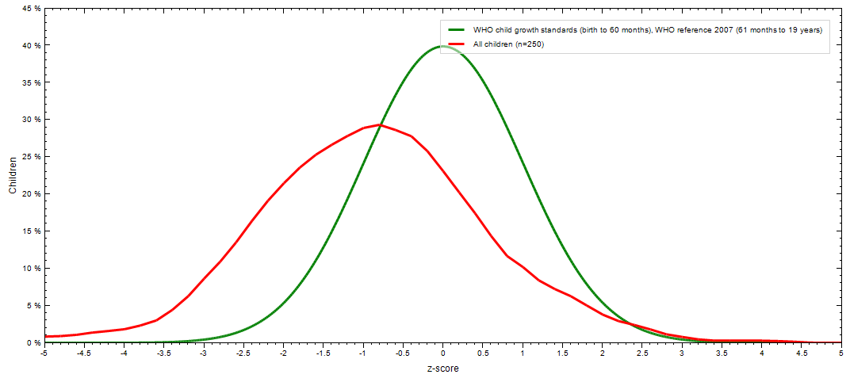

Fig. 4.2 Distribution of HAZ curve with reference to WHO standard.
The figure compares the Z-score distribution of a sample of 250 children (red line) with the WHO child growth standards (green line). The green curve follows a normal distribution centered on a Z-score of 0, representing the expected growth pattern in healthy children. In contrast, the red curve is noticeably shifted to the left, with its peak around -1.0 Z-score. This leftward shift indicates that a large number of children in the sample fall below the WHO standard, suggesting that many are experiencing growth issues such as stunting or under-nutrition. Additionally, a greater proportion of children in the sample have Z-scores below -2, which is typically used to define moderate to severe malnutrition. The divergence between the two curves highlights a significant nutritional gap in the study population and suggests the need for public health interventions focused on improving child nutrition and overall well-being.
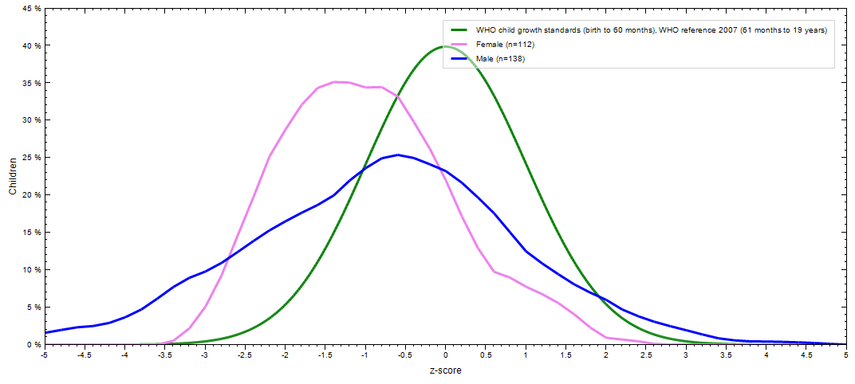
Fig. 4.3 Gender wise distribution of HAZ
The figure presents a comparison of Z-score distributions among male and female children in relation to WHO child growth standards. The green line represents the WHO growth standard, showing a symmetrical, bell-shaped distribution centered at a Z-score of 0, indicating normal growth in healthy children. The pink curve represents female children (n=112), and the blue curve represents male children (n=138). Both male and female distributions are shifted to the left of the WHO standard, indicating that many of the children in the study fall below expected growth levels. The leftward shift is more pronounced among females, whose curve peaks closer to a Z-score of around -1.5, suggesting higher levels of under-nutrition or stunting in girls compared to boys. The male distribution is also left-shifted but to a lesser extent, peaking closer to -1.0. This visual comparison highlights a gender disparity in growth patterns, with females showing a greater deviation from the WHO standard. It indicates that female children in the sample may be more vulnerable to under-nutrition or related health issues, underscoring the need for targeted nutritional and health interventions to address these inequalities.

4.11.2 Thinness (BMI for age)
Table 4.19 Z score value for BMI for age (BAZ) of studied population
Category | BAZ | Frequency | Percentage
Severely thin | < -3 | 11 | 4.4%
Moderately thin | -3 to - 2 | 18 | 7.2%
Normal | -2 to +1 | 139 | 55.6%
Over weight | +1 to +2 | 34 | 13.6%
Obese | +2 to +3 | 19 | 7.6%
Severely obese | >+3 | 29 | 11.6%

According to similar study conducted at Malangwa municipality, Sarlahi, the prevalence of underweight and obesity was found to be 37.6% and 2.5% (Dhobi and Giri, 2022). According to similar study conducted at Solukhumbu, the rate of underweight and overweight was found to be 27.6 % and 7.3 % (Sherpa et al., 2019).

Table 4.20 BAZ of male adolescents
Category | BAZ | Frequency | Percentage
Severely thin | < -3 | 5 | 3.62%
Moderately thin | -3 to - 2 | 11 | 7.97%
Normal | -2 to +1 | 85 | 61.59%
Over weight | +1 to +2 | 14 | 10.14%
Obese | +2 to +3 | 6 | 4.34%
Severely obese | >+3 | 17 | 12.31%
Table 4.21 BAZ of female adolescents
Category | BAZ | Frequency | Percentage
Severely thin | < -3 | 6 | 5.35
Moderately thin | -3 to - 2 | 7 | 6.25
Normal | -2 to +1 | 54 | 48.21
Over weight | +1 to +2 | 20 | 17.85
Obese | +2 to +3 | 13 | 11.60
Severely obese | >+3 | 12 | 10.71

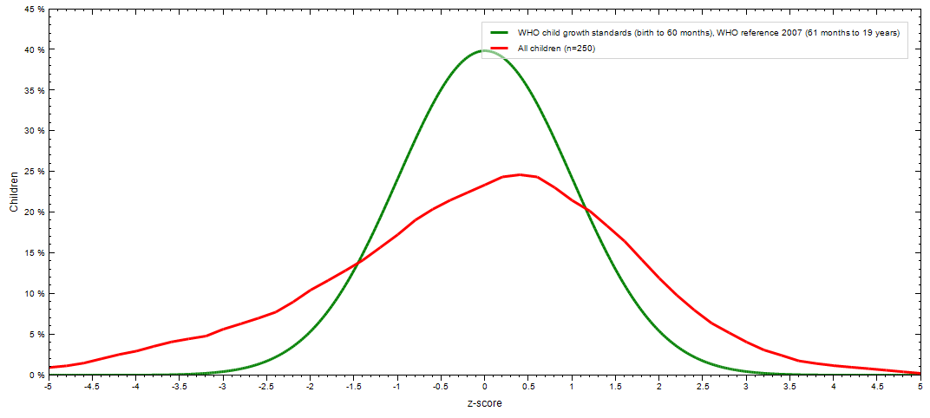
Fig. 4.4 Distribution of BAZ curve with reference to WHO standard
The figure compares the Z-score distribution of a sample group of children (red line, n = 250) with the WHO child growth standards (green line). The green curve represents the expected normal distribution of children's growth according to WHO standards, which peaks at a Z-score of 0, meaning most children are within a healthy weight and height range for their age. In contrast, the red curve representing the study sample shows a noticeable shift to the left and is flatter compared to the WHO standard. This shift indicates that a significant portion of the children in the sample fall below the expected growth norms, with many having lower Z-scores. This suggests a higher prevalence of under-nutrition, obesity, or thinness among the sampled children. Additionally, the broader and flatter shape of the red curve implies more variability and potential disparities in nutritional status compared to the healthy population represented by the WHO curve. Overall, the figure highlights that the nutritional and growth status of the children in the sample does not align with global health standards, pointing toward potential issues of under-nutrition or growth retardation in the population studied.
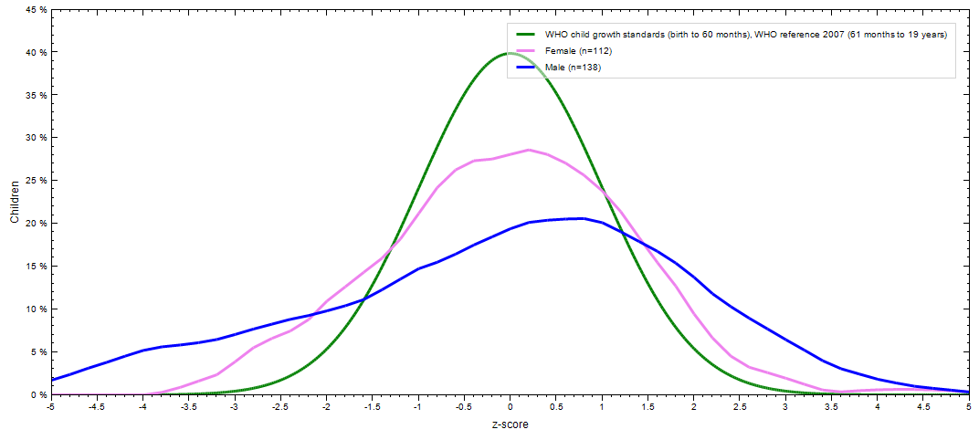
Fig. 4.5 Gender wise distribution of BAZ
This graph compares the growth of children (measured by z-scores) to the WHO child growth standards. The green line represents the WHO standard, while the pink and blue lines show the growth patterns of 112 females and 138 males, respectively. The WHO curve is tall and narrow, indicating that most healthy children fall near the average. In contrast, the pink and blue curves are wider and shorter, suggesting that the children's growth in this group is more varied and does not perfectly match the WHO standard. Overall, females appear slightly closer to the WHO pattern than males.

4.12 Factors associated with malnutrition

4.12.1 Socio-economic and demographic factor associated with stunting
Table 4.22 Socio-economic and demographic factors associated with stunning
Factor | Stunted | Normal | χ2– square | P-value | df
Father Education
Primary/ Secondary | 48 (19.2%) | 61 (24.4%) | 1.175 | 0.556 | 2
Higher Secondary | 39 (15.6%) | 41 (16.4%) | 1.175 | 0.556 | 2
Informal | 32 (12.8%) | 29 (11.6%) | 1.175 | 0.556 | 2

There is a significant association between the father's education level and stunting. The p-value of 0.556 indicates that lower levels of father’s education are linked to a higher prevalence of stunting. A study conducted in Ethiopia, India, Peru, and Vietnam found that children whose fathers had lower educational levels were more likely to be stunted (Melaku et al., 2015). Educated fathers tend to have better access to knowledge about nutrition, health care, and resources, which can contribute to improved child growth outcomes.
Research indicates that a father's education level significantly influences the likelihood of stunting in children. In Nepal, a comprehensive study analyzing data from 2001 to 2016 identified parental education as a primary factor in reducing child stunting. The study found that improvements in both maternal and paternal education were associated with better HAZ in children, suggesting that educated fathers contribute to improved child nutrition and health outcomes (Conway et al., 2020).

4.12.2 Physical activity factors associated with stunning
Table 4.23 Physical activity associated with stunning
Factor | Stunted | Normal | χ2– square | P-value | df
Tried to lose weight
Yes | 43 (17.2%) | 55 (22%) | 0.895 | 0.344 | 1
No | 76 (30.4%) | 76 (30.4%) | 0.895 | 0.344 | 1
Weight monitoring
Yes | 113 (45.6%) | 126 (50.4%) | 0.223 | 0.637 | 1
No | 6 (2.4%) | 5 (2%) | 0.223 | 0.637 | 1
Skip meal
Yes | 84 (33.6%) | 93 (37.2%) | 0.05 | 0.944 | 1
No | 35 (14%) | 38 (15.2%) | 0.05 | 0.944 | 1

The association between trying to lose weight and nutritional status (stunted vs. normal) was examined using a Chi-square test. Among adolescents who reported trying to lose weight, 17.2% were stunted and 22% had normal nutritional status. Those who did not attempt to lose weight had an equal distribution of stunting and normal status (30.4% each). The Chi-square value was 0.895 with a p-value of 0.344, indicating no statistically significant association between weight-loss attempts and stunting. Thus, trying to lose weight does not appear to be related to nutritional status in this group. Weight monitoring was also evaluated in relation to stunting. Of those who monitored their weight, 45.6% were stunted and 50.4% were normal, while among those who did not monitor their weight, 2.4% were stunted and 2% were normal. The Chi-square value for this factor was 0.223 with a p-value of 0.637. Again, the result is not statistically significant, suggesting no meaningful association between weight monitoring behavior and stunting. This implies that monitoring weight, though potentially health-conscious behavior, may not influence or reflect nutritional status significantly.
This finding suggests that adolescents who paid more attention to their body weight might have taken better care of their diet, which could lower their chances of being stunted. A study by Harnois-Leblanc (2024) looked at weight loss efforts and weight checking among adolescents. It found that those who often tried to lose weight or regularly checked their weight were more likely to feel stressed about their body, which could affect how they eat and grow. Although the study didn’t directly link these habits to stunting, it pointed out that such behaviors might lead to poor nutrition, which could harm growth and development.
Skipping meals was the third behavior assessed for its relation to nutritional status. Among adolescents who skipped meals, 33.6% were stunted and 37.2% were normal, while those who did not skip meals showed 14% stunted and 15.2% normal. The Chi-square test yielded a very small value of 0.05 with a p-value of 0.944, clearly indicating no significant association between skipping meals and stunting. Despite the common perception that meal skipping might lead to poor nutrition, this data shows no clear link in this population.

4.12.3 Environmental factors associated with stunning
Table 4.24 Environmental factors associated with stunning
Factor | Stunted | Normal | χ2– square | P-value | df
Water Purification
Yes | 105 (42%) | 114 (45.6%) | 0.392 | 0.530 | 1
No | 13 (5.2%) | 18 (7.2%) | 0.392 | 0.530 | 1

The table 4.26 examines the relationship between water purification practices and nutritional status (stunted vs. normal) among adolescents. Among those who used water purification methods, 42% were stunted and 45.6% were normal. In contrast, among those who did not purify their water, 5.2% were stunted and 7.2% were normal. The Chi-square value for this association is 0.392, with a p-value of 0.530. Since the p-value is greater than 0.05, the result is not statistically significant, meaning there is no strong evidence of a relationship between water purification behavior and stunting in this group. Although purifying drinking water is important for preventing infections and ensuring safe consumption, the data from this study does not show a clear link between purification practices and better nutritional outcomes. Other environmental or dietary factors may have a stronger influence on the adolescents’ growth and nutritional status. The study found that stunting was mainly caused by drinking water from contaminated hand pumps and water tanks. Children who drank from these unsafe sources were more likely to get infections, especially stomach-related illnesses, which affected their ability to absorb nutrients and led to malnutrition (Batool et al., 2023). Another study showed that children from families who purified their drinking water had better height-for-age scores than those who didn’t, highlighting the importance of clean water for healthy growth (Shrestha et al., 2020).

4.12.4 Socio-economic and demographic factor associated with thinness and obesity
Table 4.25 Socio-economic and demographic factor associated with thinness and obesity
Factor | Thinness | Normal | Obesity | χ2– square | p-value | df
No. of adolescent
Only 1 | 16 (6.4%) | 60 (24%) | 32 (12.8%)
Above 1 | 20 (8%) | 84 (33.6%) | 36 (14.4%) | 1.237 | 0.872 | 4
None | - | 1 (0.4) | 1 (0.4)
Birth order
1st | 24 (9.6%) | 73 (29.2%) | 44 (17.6%)
2nd | 8 (3.2 %) | 47 (18.8%) | 14 (5.6%) | 9.018 | 0.173 | 4
3rd | 2 (0.8%) | 20 (8%) | 5 (2%)
4th or more | 2 (0.8%) | 6 (2.4%) | 5 (2%)
No. of sibling
0 | - | 14 (5.6%) | 11 (4.4%)
1 | 28 (11.2%) | 82 (32%) | 41 (16.4%) | 36.397 | <0.001 | 8
2 | 6 (2.4%) | 10 (4%) | 37 (14.8%)
3 | 2 (0.8%) | 11 (4.4%) | 6 (2.4%)
4 or more | 1 (0.4%) | 2 (0.8%) | 1 (0.4%)
Family income
More than 30K | 40 (16%) | 53 (21.2%) | 38 (15.2%) | 302.839 | <0.001 | 6
Less than 30K | 15 (6%) | 74 (29.6%) | 30 (12%)
The table 4.27 presents an analysis of multiple factors affecting adolescent nutritional status using Chi-square tests. Regarding the number of adolescents in a household, the Chi-square value is 1.237 with a p-value of 0.872, indicating no statistically significant relationship. This suggests that whether a family has one or more adolescents does not appear to be associated with the likelihood of thinness, normal weight, or obesity in this sample. A study from India found that children in bigger families were more likely to develop poor eating habits, which could increase their chances of becoming obese during their teenage years (Langford et al., 2022). On the other hand, a study from Japan showed the opposite. It found that children who are the only child or the youngest in the family are more likely to be overweight. In fact, the study revealed that being an only child greatly raised the chances of being overweight compared to those who have siblings (Ochiai et al., 2012).
In the case of birth order, the Chi-square value is 9.018 with a p-value of 0.173, which also does not reach statistical significance (p > 0.05). Although a higher percentage of first-born adolescents are obese or normal compared to later-born ones, the differences are not strong enough to confirm a meaningful association. This implies that birth order may not be a key factor influencing nutritional status in this context. A study from South Korea also supports this trend, indicating that first-borns are more likely to be overweight compared to their siblings (Diao et al., 2024).
However, number of siblings shows a highly significant relationship with nutritional status, as indicated by a Chi-square value of 36.397 and a p-value less than 0.001. This means the number of siblings in a household is significantly associated with whether an adolescent is thin, normal, or obese. A similar significant relationship is observed with family income, where the Chi-square value is 302.839 and the p-value is <0.001, strongly indicating that income levels greatly affect nutritional status. Adolescents from families earning less than 30,000 were more likely to be thin or normal, while higher income groups showed a higher rate of obesity, possibly due to lifestyle and dietary patterns. A study of 800 adolescents in Dharan found that students from private schools, which usually serve higher-income families, had higher rates of being overweight (13.7%) and obese (5.8%). In comparison, students from government schools, who mostly come from lower-income families, had much lower rates—only 3.8% were overweight and 0.8% were obese (Shakya et al., 2023).

4.12.5 Dietary behavioral factors associated with thinness and obesity
Table 4.26 Dietary behavioral factors associated with thinness and obesity
Factors | Thinness | Normal | Obesity | χ2– square | p-value | df
Tried to gain weight
Yes | 3 (1.2%) | 7 (2.8%) | 36 (14.4%) | 2.985 | 0.225 | 2
No | 33 (13.2%) | 32 (12.8%) | 139 (55.6%)
Feeling about figure
Over weight | 3 (1.2%) | 5 (2%) | 41 (16.4%)
Right weight | 29 (11.6%) | 94 (37.6%) | 41 (16.4%) | 60.221 | <0.001 | 4
Thin | 4 (1.6%) | 25 (10%) | 10 (4%)
Tried to lose weight
Yes | 11 (4.4%) | 56 (22.4%) | 31 (12.4%) | 4.059 | 0.131 | 2
No | 25 (10%) | 95 (38%) | 32 (12.8%)
The study examined whether adolescents who tried to gain weight had different nutritional outcomes. Among those who made such efforts, only 1.2% were thin, 2.8% were normal, and 14.4% were obese. In comparison, those who did not try to gain weight had higher rates of thinness (13.2%) and normal weight (12.8%), and a larger portion—55.6%—were obese. The Chi-square value was 2.985 with a p-value of 0.225, indicating that the difference is not statistically significant.This means that trying to gain weight does not appear to be strongly linked with actual nutritional status in this group.
Adolescents’ perception of their body size showed a strong and statistically significant relationship with their nutritional status. Among those who felt overweight, 16.4% were obese. Those who believed they had the right weight had a more balanced distribution: 11.6% thin, 37.6% normal, and 16.4% obese. Adolescents who felt thin showed lower obesity rates (4%). The Chi-square value was 60.221 with a p-value less than 0.001, showing a very strong association between how adolescents feel about their body and their actual weight status. Supporting this, a study in Malaysia on adolescent feeling about body perception found that body shaming is strongly linked to negative emotional well-being, which contributes to obesity through unhealthy behavioural adaptations (Yu et al., 2020).
The table 4.28 also explored whether efforts to lose weight were associated with actual body weight. Among adolescents who tried to lose weight, 4.4% were thin, 22.4% were normal, and 12.4% were obese. Those who didn’t attempt weight loss had slightly higher rates of thinness (10%) and normal weight (38%), with 12.8% being obese. The Chi-square value was 4.059, and the p-value was 0.131, indicating no significant relationship. This suggests that trying to lose weight does not have a strong or clear connection with whether adolescents are thin, normal, or obese. A global study by the World Health Organization (WHO) found that many adolescents around the world have difficulty managing their weight properly. According to a 2020 report, about 13.4% of adolescents aged 10 to 19 were either too thin or overweight. This was partly due to unsuccessful weight management efforts. The study pointed out that not having enough nutritional advice and emotional support made these problems worse, which is similar to the trends seen in this study (WHO, 2021).

4.12.6 Physical activity associated with malnutrition thinness and obesity
Table 4.27 Physical activity associated with thinness and obesity
Factors | Thinness | Normal | Obesity | χ2– square | p-value | df
School break activity
No | 28 (11.2%) | 93 (37.2%) | 52 (20.8%) | 5.002 | 0.08 | 2
Yes | 8 (3.2%) | 53 (21.2%) | 16 (6.4)

The table 4.29 shows the relationship between school break activity and the nutritional status of adolescents in terms of thinness, normal weight, and obesity. Among those who did not engage in any school break activity, 11.2% were thin, 37.2% had normal weight, and 20.8% were obese. In contrast, among those who participated in activities during school breaks, only 3.2% were thin, 21.2% had normal weight, and 6.4% were obese. The chi-square value is 5.002 with a p-value of 0.08 and 2 degrees of freedom, suggesting that the relationship between school break activity and nutritional status is not statistically significant at the 0.05 level, but it does indicate a possible trend where physical activity may help reduce obesity and thinness among adolescents. A study conducted in a semi-urban area of Nepal found that 24% of schoolchildren aged 9-17 were either malnourished (underweight or overweight/obese). The research also highlighted that child who were less likely to participate in physical activities during school breaks, showed higher odds of being malnourished (Hamann et al., 2023).

Part V

Conclusions and recommendations

5.1. Conclusions
Following conclusions were drawn from the study:
- Nutrition status among the government school going adolescent was conducted and prevalence of thinness, stunting and overweight were found to be 11.6%, 12.8% and 19.2%.
- According to HAZ, in total population of 250, 32 were moderately stunted, 84 were mildly stunted and 134 were normal. None of the adolescent was severely stunted. Out of each stunted and normal persons, 17 males and 14 females were moderately stunted, 45 males and 39 females were medley stunted and 76 males and 59 females were normal.
- Similarly, according to BAZ, in total population of 250 adolescents, 11 were severely thin, 18 were moderately thin, 39 were normal, 34 were overweight, 19 were obese and 29 were severely obese. Out of each thin and obese persons, 5 male and female were severely thin, 11 male and 7 female were moderately thin, 85 male and 54 female were normal, 14 male and 20 female were overweight, 6 male and 13 female were obese and 17 male and 12 female were severely obese.
- Total energy intake and fat intake were found to below RDA while protein intake was above RDA.
- Factor like tried to lose weight, weight monitoring, skip meal and water purification had no statistically significantly associated with stunting. Only father education was statistically associated with stunting.
- Similarly, factors like tried to gain weight, tried to lose weight, no. of adolescent did not associated statistically with thinness and obesity. While birth order, number of sibling, family income, feeling about figure and school break activity statistically associated with thinness and obesity.

5.2. Recommendations
Following recommendations can be provided on the basis of the study in order to improve the nutritional status and nutrient intake of the adolescents:
- Adolescents should be suggested to avoid skipping meals and eat more frequently to meet their energy and nutrient needs for healthier weight gain.
- Adolescents should be encouraged to consume a variety of nutrient-rich, energy-dense foods including fruits, vegetables, pulses, legumes, meat, fish, poultry, milk, and dairy products for optimal nutrition.
- The municipality should make plans and carry out programs with schools and families to follow the recommendations mentioned earlier.
- The federal and state governments can conduct similar studies in various localities to assess the overall national and state-wise nutritional status and dietary behaviors of adolescents.

Part IV

Summary
Adolescence is a stage marked by rapid growth and development, second only to infancy in terms of speed. This phase demands increased intake of nutrients and energy. During this time, social and psychological factors begin to shape eating behaviors more than family influence. These changes directly affect an adolescent’s nutritional status. Maintaining good health and nutrition during adolescence is essential, as it sets the foundation for well-being in adulthood and later life.
A cross sectional survey was conducted to assess the nutritional status and dietary intake of adolescents studying in schools of Dhankuta municipality, Dhankuta. Among 10 wards of Dhankuta, ward no.5 and ward no.6 was selected and 250 adolescents were chosen by random selection according to proportion from 2 secondary schools. To gather data on the target population’s nutritional status, dietary habits, socioeconomic status, and sanitation and hygiene conditions, a carefully thought-out and pretested set of questionnaires was created. A computerized weighing balance (measuring up to 180 kg and least count 0.1 kg) was used to measure the subjects’ weight and stadiometer was used to measure the height. Dietary intake was assessed by 24 hours dietary recall and food frequency questionnaire. Data collected was analysed using WHO Anthroplus version 1.0.4, SPSS version 27 and Microsoft excel. Pearson correlation test, independent sample t test and one-way ANOVA was used to analyze the factors associated with nutritional status.

References
Akseer, N., Al-Gashm, S., Mehta, S., Mokdad, A. and Bhutta, Z. A. (2017). Global and regional trends in the nutritional status of young people: a critical and neglected age group. In: “Annals of the New York Academy of Sciences”. Vol. 1393, Issue 1, pp. 3–20. Ann N Y Acad Sci. [doi: 10.1111/nyas.13336]
Babar, N. F., Muzaffar, R., Khan, M. A. and Imdad, S. (2010). Impact of socioeconomic factors on nutritional status in primary school children. J. Ayub Med. Coll. Abbottabad, 22(4), 15–18. Retrieved from https://pubmed.ncbi.nlm.nih.gov/22455252/. Accessed [July 17, 2025]
Baral, K. P. and Onta, S. R. (2009). Prevalence of anemia amongst adolescents in Nepal: a community based study in rural and urban areas of Morang District. Nepal Med. Coll. J. , NMCJ.., 11(3), 179–182.
Bargiota, A., Delizona, M., Tsitouras, A. and Koukoulis, G. N. (2013). Eating habits and factors affecting food choice of adolescents living in rural areas. Hormones, 12(2), 246–253. [doi: 10.14310/horm.2002.1408]
Benítez-Porres, J., Alvero-Cruz, J. R., Sardinha, L. B., López-Fernández, I. and Carnero, E. A. (2016). Valores de corte para clasificar niños y adolescentes activos utilizando el cuestionario de actividad física: PAQ-C y PAQ-A. Nutr. Hosp., 33(5), 1036–1044. [doi: 10.20960/nh.564]
Bhattarai, S. and Bhusal, C. K. (2019). Prevalence and associated factors of malnutrition among school going adolescents of Dang district, Nepal. AIMS Public Heal., 6(3), 291–306. [doi: 10.3934/publichealth.2019.3.291]
Block, G. (1989). Human dietary assessment: Methods and issues. Prev. Med. (Baltim)., 18(5), 653–660. [doi: 10.1016/0091-7435(89)90036-4]
Branca, F. and Ferrari, M. (2002). Impact of micronutrient deficiencies on growth: The stunting syndrome. Ann. Nutr. Metab., 46(SUPPL. 1), 8–17. [doi: 10.1159/000066397]

Casey, P. H., Goolsby, S. L. P., Lensing, S. Y., Perloff, B. P. and Bogle, M. L. (1999). The use of telephone interview methodology to obtain 24-hour dietary recalls. J. Am. Diet. Assoc., 99(11), 1406–1411. [doi: 10.1016/S0002-8223(99)00340-5]
Chalise, B., Aryal, K. K., Mehta, R. K., Dhimal, M., Sapkota, F., Mehata, S., Karki, K. B., Madjdian, D., Patton, G. and Sawyer, S. (2018). Prevalence and correlates of anemia among adolescents in Nepal: Findings from a nationally representative cross-sectional survey. PloS One, 13(12), e0208878. [doi: 10.1371/JOURNAL.PONE.0208878]
Chandar, D., Naik, B. N., Thumati, G. and Sarkar, S. (2020). Assessment of dietary habits and nutritional status among adolescent girls in a rural area of Puducherry: A community-based cross-sectional study. Int. J. Adolesc. Med. Health, 32(5). [doi: 10.1515/IJAMH-2018-0001]
Chasapis, C. T., Spiliopoulou, C. A., Loutsidou, A. C. and Stefanidou, M. E. (2012). Zinc and human health: An update. In: “Archives of Toxicology”. Vol. 86, Issue 4, pp. 521–534. Arch Toxicol. [doi: 10.1007/s00204-011-0775-1]
Contento, I. R. (2008). Nutrition education: linking research, theory, and practice – PubMed. Retrieved from https://pubmed.ncbi.nlm.nih.gov/18296331/. Accessed [July 17, 2025]
Cusick, S. E. and Kuch, A. E. (2012). Determinants of Undernutrition and Overnutrition among Adolescents in Developing Countries. Adolesc. Med. State Art Rev., 23(3), 440. [doi: 10.1542/9781581107838-ch03]
Dao, M. C., Subar, A. F., Warthon-Medina, M., Cade, J. E., Burrows, T., Golley, R. K., Forouhi, N. G., Pearce, M. and Holmes, B. A. (2019). Dietary assessment toolkits: An overview. Public Health Nutr., 22(3), 404–418. [doi: 10.1017/S1368980018002951]
Dhobi, S. and Giri, M. (2021). Food Habits and Nutritional Status of Adolescents in Malangwa Municipality, Sarlahi, Nepal: A Cross-sectional Study. MedS Alliance J. Med. Med. Sci., 1(1), 20–24. [doi: 10.3126/mjmms.v1i1.42997]

Dirghayu, K. C., Ulak, N., Poudyal, A., Shrestha, N., Gautam, N., Ghimire, L. and Paudel, U. (2021). Household Food Security Access and Nutritional Status among Early Adolescents in a Poor Neighborhood of Sinamangal, Nepal. Curr. Dev. Nutr., 5(11). [doi: 10.1093/cdn/nzab127]
Elmadfa, I. and Meyer, A. L. (2014). Developing suitable methods of nutritional status assessment: A continuous challenge. Adv. Nutr., 5(5), 590S-598S. [doi: 10.3945/an.113.005330]
Evans, Y. N. and Docter, A. D. (2020). Adolescent Nutrition: Assuring the Needs of Emerging Adults. In: “Adolescent Nutrition: Assuring the Needs of Emerging Adults”. Springer International Publishing. [doi: 10.1007/978-3-030-45103-5]
FANTA. (2002). NUTRITION TECHNICAL Dietary Diversity as a Household Food Security Indicator : Technical Appendix John Hoddinott Indicator : Technical Appendix. Yohannes, Yisehac Hoddinott, J., 136(May), 4. Retrieved from http://www.fantaproject.org/research/dietary-diversity-household-food-security
FAO. (2010). Guidelines for measuring household and individual dietary diversity. In: “Fao”. [doi: 613.2KEN]
Fernández-Lázaro, D. and Seco-Calvo, J. (2023). Nutrition, Nutritional Status and Functionality. In: “Nutrients”. Vol. 15, Issue 8, p. 1944. Multidisciplinary Digital Publishing Institute. [doi: 10.3390/nu15081944]
Golden, N. H., Abrams, S. A., Daniels, S. R., Corkins, M. R., De Ferranti, S. D., Magge, S. N. and Schwarzenberg, S. J. (2014). Optimizing bone health in children and adolescents. In: “Pediatrics”. Vol. 134, Issue 4, pp. e1229–e1243. American Academy of Pediatrics. [doi: 10.1542/peds.2014-2173]
Hamann, S. A., Thorup, L., Patsche, C. B., Hohwü, L., Hjortdal, V. E., Gyawali, B., Neupane, D. and Kallestrup, P. (2023). Association between nutritional status and socio-economic status among school children aged 9–17 years in a semi-urban area of Nepal. J. Heal. Popul. Nutr., 42(1). [doi: 10.1186/s41043-023-00392-4]

Hartog, A. P., van Staveren, W. A. and Brouwer, I. D. (2006). Food habits and consumption in developing countries manual for field studies. In: “Food Habits and Consumption in Developing Countries Manual for Field Studies”. Wageningen Academic Publishers. [doi: 10.3920/978-90-8686-667-0]
Jelliffe, D. B. (1966). The assessment of the nutritional status of the community (with special reference to field surveys in developing regions of the world). Monogr. Ser. World Health Organ., 53, 3–271. Retrieved from https://pubmed.ncbi.nlm.nih.gov/4960818/. Accessed [July 17, 2025]
Jessri, M., Rashidkhani, B., Hajizadeh, B., Jessri, M. and Gotay, C. (2011). Macronutrients, vitamins and minerals intake and risk of esophageal squamous cell carcinoma: A case-control study in Iran. Nutr. J., 10(1), 137. [doi: 10.1186/1475-2891-10-137]
Li, M. S., Adesina, S. E., Ellis, C. L., Gooch, J. L., Hoover, R. S. and Williams, C. R. (2017). NADPH oxidase-2 mediates zinc deficiency-induced oxidative stress and kidney damage. Am. J. Physiol. – Cell Physiol., 312(1), C47–C55. [doi: 10.1152/ajpcell.00208.2016]
Lips, P. and Van Schoor, N. M. (2011). The effect of vitamin D on bone and osteoporosis. In: “Best Practice and Research: Clinical Endocrinology and Metabolism”. Vol. 25, Issue 4, pp. 585–591. Best Pract Res Clin Endocrinol Metab. [doi: 10.1016/j.beem.2011.05.002]
Lissau, I., Overpeck, M. D., Ruan, W. J., Due, P., Holstein, B. E. and Hediger, M. L. (2004). Body Mass Index and Overweight in Adolescents in 13 European Countries, Israel, and the United States. Arch. Pediatr. Adolesc. Med., 158(1), 27–33. [doi: 10.1001/archpedi.158.1.27]
Maggini, S., Wenzlaff, S. and Hornig, D. (2010). Essential role of vitamin c and zinc in child immunity and health. In: “Journal of International Medical Research”. Vol. 38, Issue 2, pp. 386–414. Field House Publishing LLP. [doi: 10.1177/147323001003800203]
Mansur, D. I., Haque, M. K., Sharma, K., Mehta, D. K. and Shakya, R. (2015). Prevalence of underweight, stunting and thinness among adolescent girls in Kavre District. J. Nepal Paediatr. Soc., 35(2), 129–135. [doi: 10.3126/jnps.v35i2.12794]
Marriott, B. P., White, A., Hadden, L., Davies, J. C. and Wallingford, J. C. (2012). World Health Organization (WHO) infant and young child feeding indicators: Associations with growth measures in 14 low-income countries. Matern. Child Nutr., 8(3), 354–370. [doi: 10.1111/j.1740-8709.2011.00380.x]
Maziya, N. (2014). Adolescent Nutritional Status and its Association with Village-level Factors in Tanzania. Sch. Amherst, February, 1–76. Retrieved from https://www.researchgate.net/publication/266787609_Adolescent_nutritional_status_and_its_association_with_village-level_factors_in_Tanzania. Accessed [July 17, 2025]
Mela Danjin, Henry O. Sawyerr and Solomon O. Adewoye. (2021). Association between malnutrition and some water, sanitation and hygiene (WASH) factors among school children in Gombe State, Nigeria. World J. Biol. Pharm. Heal. Sci., 5(1), 055–065. [doi: 10.30574/WJBPHS.2021.5.1.0006]
Merchant, A. T., Jones, C., Kiure, A., Kupka, R., Fitzmaurice, G., Herrera, M. G. and Fawzi, W. W. (2003). Water and sanitation associated with improved child growth. Eur. J. Clin. Nutr., 57(12), 1562–1568. [doi.org/10.1038/sj.ejcn.1601725]
Moradi, S., Mirzababaei, A., Mohammadi, H., Moosavian, S. P., Arab, A., Jannat, B. and Mirzaei, K. (2019). Food insecurity and the risk of undernutrition complications among children and adolescents: A systematic review and meta-analysis. In: “Nutrition”. Vol. 62, pp. 52–60. Elsevier Inc. [doi: 10.1016/j.nut.2018.11.029]
Must, A. and Strauss, R. S. (1999). Risks and consequences of childhood and adolescent obesity. Int. J. Obes., 23, S2–S11. [doi: 10.1038/sj.ijo.0800852]
Ochola, S. and Masibo, P. K. iny. (2014). Dietary intake of schoolchildren and adolescents in developing countries. In: “Annals of nutrition & metabolism”. Vol. 64, pp. 24–40. Ann Nutr Metab. [doi: 10.1159/000365125]
Remschmidt, H. (1994). Psychosocial milestones in normal puberty and adolescence. Horm. Res., 41(SUPPL. 2), 19–29. [doi: 10.1159/000183955]

Sangroula, R. K. and Uprety, S. (2020). Factors associated with nutritional status of under five children among Satar Community of Bhadrapur Municipality, Jhapa, Nepal. Int. J. Community Med. Public Heal., 7(6), 2059. [doi: 10.18203/2394-6040.ijcmph20202452]
Shrestha, A., Bhusal, C. K., Shrestha, B. and Bhattarai, K. D. (2020). Nutritional Status of Children and Its Associated Factors in Selected Earthquake-Affected VDCs of Gorkha District, Nepal. Int. J. Pediatr. (United Kingdom), 2020. [doi: 10.1155/2020/5849548]
Shrivastava, S. R. B. L., Shrivastava, P. S. and Ramasamy, J. (2014). Assessment of nutritional status in the community and clinical settings. J. Med. Sci., 34(5), 211–213. [doi: 10.4103/1011-4564.143648]
Singh, D. R., Sunuwar, D. R., Dahal, B. and Sah, R. K. (2021). The association of sleep problem, dietary habits and physical activity with weight status of adolescents in Nepal. BMC Public Health, 21(1). [doi: 10.1186/s12889-021-10985-5]
Sitaula, D., Dhakal, A., Lageju, N., Silwal, A., Basnet, S. K., Shrestha, N., Anup Bikram, B. C. and Phoju, N. (2023). Prevalence and Associated Factors of Adolescent Obesity among Rural School Adolescents in Nepal: A Cross-Sectional Study. Glob. Heal. Epidemiol. Genomics, 2023, 2957278. [doi: 10.1155/2023/2957278]
Tamiru, Y., Ayelign, A., Mulugeta, A., Reda, Z. and Gebremedhin, S. (2024). Dietary quality and nutrient intake assessment in school adolescents: A study in Addis Ababa, Ethiopia. Clin. Nutr. Open Sci., 55, 36–47. [doi: 10.1016/j.nutos.2024.03.001]
UNICEF. (2021). Adolescent development and participation | UNICEF India. Unicef. Retrieved from https://www.unicef.org/adolescence. Accessed [July 18, 2025]
van Tuijl, C. J. W., Madjdian, D. S., Bras, H. and Chalise, B. (2021). Sociocultural and economic determinants of stunting and thinness among adolescent boys and girls in Nepal. J. Biosoc. Sci., 53(4), 531–556. [doi: 10.1017/S0021932020000358]

Vos, T., Kyu, H. H., Pinho, C., Wagner, J. A., Brown, J. C., Bertozzi-Villa, A., Charlson, F. J., Coffeng, L. E., Dandona, L., Erskine, H. E., Ferrari, A. J., Fitzmaurice, C., Fleming, T. D., Forouzanfar, M. H., Graetz, N., Guinovart, C., Haagsma, J., Higashi, H., Kassebaum, N. J., … Murray, C. J. L. (2016). Global and national burden of diseases and injuries among children and adolescents between 1990 and 2013 findings from the global burden of disease 2013 study. In: “JAMA Pediatrics”. Vol. 170, Issue 3, pp. 267–287. American Medical Association. [doi: 10.1001/jamapediatrics.2015.4276]
W.H.O. (2005). Nutrition in adolescence Issues and Challenges. Retrieved from http://whqlibdoc.who.int/publications/2005/
Wang, L. Y., Denniston, M., Lee, S., Galuska, D. and Lowry, R. (2010). Long-term Health and Economic Impact of Preventing and Reducing Overweight and Obesity in Adolescence. J. Adolesc. Heal., 46(5), 467–473. [doi: 10.1016/j.jadohealth.2009.11.204]
Wells, J. C. K. (2012). Obesity as malnutrition: The role of capitalism in the obesity global epidemic. In: “American Journal of Human Biology”. Vol. 24, Issue 3, pp. 261–276. Am J Hum Biol. [doi: 10.1002/ajhb.22253]
Whitton, C., Nicholson, S. K., Roberts, C., Prynne, C. J., Pot, G. K., Olson, A., Fitt, E., Cole, D., Teucher, B., Bates, B., Henderson, H., Pigott, S., Deverill, C., Swan, G. and Stephen, A. M. (2011). National Diet and Nutrition Survey: UK food consumption and nutrient intakes from the first year of the rolling programme and comparisons with previous surveys. In: “British Journal of Nutrition”. Vol. 106, Issue 12, pp. 1899–1914. Br J Nutr. [doi: 10.1017/S0007114511002340]
Wier, L. T., Ayers, G. W., Jackson, A. S., Rossum, A. C., Carlos Poston, W. S. and Foreyt, J. P. (2001). Determining the amount of physical activity needed for long-term weight control. Int. J. Obes., 25(5), 613–621. [doi: 10.1038/sj.ijo.0801586]
Wilson, L. (2000). Contemporary Nutrition. Gastroenterol. Nurs., 23(6), 291. [doi: 10.1097/00001610-200011000-00014]

WHO. (2005). Nutrition in adolescence: issues and challenges for the health sector: issues in adolescent health and development [Report]. World health organization. geneva, Switzerland.
W.H.O. (2005). Nutrition in adolescence Issues and Challenges for. Retrieved from http://whqlibdoc.who.int/publications/2005/.
WHO. (2006). Adolescent nutrition: a review of the situation in selected South-East Asian Countries. World Health Organization. Regional Office for South-East Asia. Retrieved from https://iris.who.int/handle/10665/204764. [Accessed 06 June, 2025].
WHO. (2010a). "Global recommendations on physical activity for health". World Health Organization (WHO). [ISBN 9241599979].
WHO. (2010b). Participant manual: IMAI one-day orientation on adolescents living with HIV. Geneva: World Health Organization.
WHO. (2019). Recommendations for data collection, analysis and reporting on anthropometric indicators in children under 5 years old.
WHO. (2022). Physical activity. World health organization. Retrieved from https://www.who.int/news-room/fact-sheets/detail/physical-activity. [Accessed 11,07,2025].
WHO. (2025a). Adolescence health. WHO. Retrieved from https://www.who.int/healthtopics/adolescent-health. [Accessed 06 June, 2025].
WHO. (2025b). Children aged 6-23 months who receive a minimum acceptable diet (%). 2024. Retrieved from https://www.who.int/data/gho/indicator-metadataregistry/imr-details/4738. [Accessed 16 June, 2025].
WHO. (2025c). Growth reference data for 5-19 years. World health organization. Retrieved from https://www.who.int/tools/growth-reference-data-for-5to19-years. [Accessed 11 June, 2025].

WHO. (2025d). Health topics. WHO. Retrieved from https://www.emro.who.int/healthtopics/nutrition/introduction.html#:~:text=Nutrition%20is%20the%20intake%20of ,is%20essential%20to%20good%20health. [Accessed 06 June, 2025].
WHO. (2025e). Physical activity. World health organization. Retrieved from https://www.who.int/news-room/fact-sheets/detail/physical-activity. [Accessed 10 June, 2025].
WHO. (2010). Recomendaciones Mundiales sobre Actividad Física para la Salud. Geneva WHO Libr. Cat., Completo, 1–58. Retrieved from http://scholar.google.com/scholar?hl=en&btnG=Search&q=intitle:Recomendaciones+Mundiales+sobre+actividad+F�sica+para+la+salud#4. Accessed [July 18, 2025]
Zimmermann, M. B., Jooste, P. L. and Pandav, C. S. (2008). Iodine-deficiency disorders. In: “The Lancet”. Vol. 372, Issue 9645, pp. 1251–1262. Elsevier B.V. [doi: 10.1016/S0140-6736(08)61005-3].

Appendices
Appendix A: Approval letter
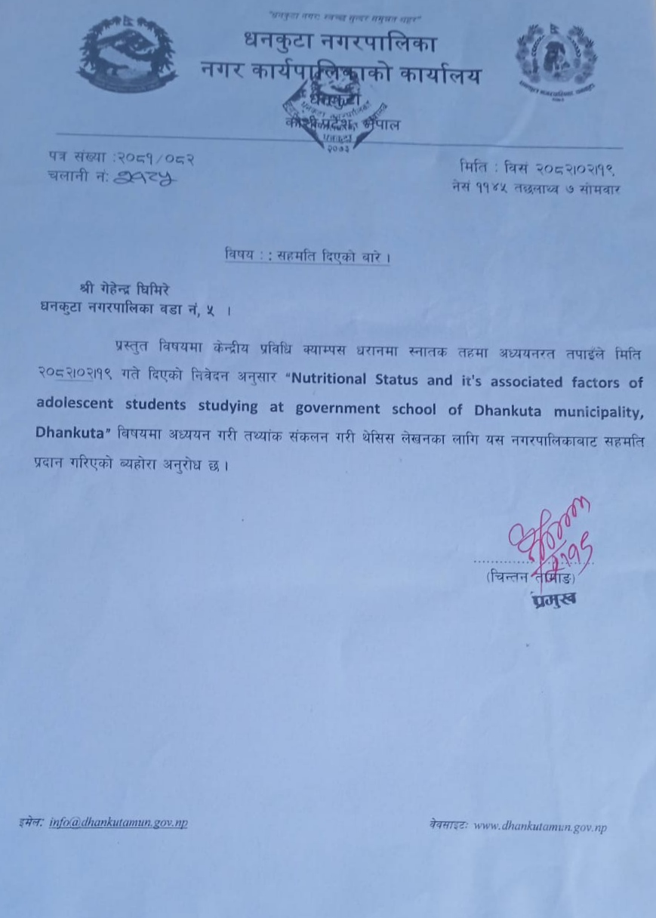
Appendix B
Consent letter
Namaskar! As part of my dissertation research for my Bachelor of Science in Nutrition and Dietetics, I, Mr. Gehendra Ghimire, enrolled in the Central Campus of Technology, Dharan, will be doing my studies in the Dhankuta municipality.
The topic for the study is “NUTRITIONAL STATUS AND ITS’ ASSOCIATED FACTORS OF ADOLESCENT STUDENTS STUDYING AT GOVERNMENT SCHOOLS OF DHANKUTA MUNICIPALITY, DHANKUTA”
The nutritional status, dietary status-influencing factors, and dietary pattern of adolescents between the ages of 10 and 19 will be surveyed as part of this study.
Thank you for being chosen to participate in the survey. A few broad inquiries about your family, financial situation, food habits, level of physical activity, and social condition will be made. We’ll measure your weight and height as well. Certain inquiries may be private. The respondent’s privacy won’t be compromised. It matters that you take part in the study. If any of the questions feel sensitive or personal to you, you are free to leave out any or all of them. I’m hoping you’ll help. Would you like to participate in the study?
Yes, I provide written consent for the participation in the study and permit to ask necessary questions and take necessary measurements required for the study.

Signature of participant: Signature of surveyor:

Date: Date:

Place: Place:
Appendix C
Questionaries’

A. GENERAL INFORMATION
School’s Name: __________________________________ Date (B.S.): ____________________
Student’s Code No: _______________________________ Class: _________________________
1.Name of child:____________________________________________
2.Age (in years): _____________________________ Date of birth
(B.S.):______________________
3. Address: Dhankuta municipality Ward no:______________ Tole:________________
4.Gender:
a) Male b) Female c) Other
5. Caste/Ethnicity:
a) Brahmin b) Chettri c) Rai d) Magar e) Limbu e) Tamang
f) Others:
6.Religion:
a) Hindu b) Christian c) Kirat d) Buddhist e) Others:
B. ANTHROPOMETRIC INFORMATION:
 | Reading 1 | Reading 2 | Reading 3 | Average
Height(cm)
Weight(kg)
C. FAMILY INFORMATION:
1. Type of family:
a) Nuclear b) Joint
2. Number of family members:__________________________
3. Number of male members: __________________ 4. Number of female members: ___________________
5. Number of children (0-10 years): ______________ 6. Number of adolescents (10-19 years):_____________
7. How many siblings do you have (siblings from same parents)?
Total: ______________Brothers: ________________ Sisters:________________
8. Your sequence among siblings (from the eldest):________________________
9. Occupation of father:
a) Agriculture b) Service c) Labor d) Business e) Foreign

employment

f) Others:
10. Occupation (of mother):
a) Agriculture b) Service c) Labor d) Business e) Foreign
employment
f) Others:
11. Family income:
a) Less than Rs. 30000 monthly b) Equal to or more than Rs. 30000 monthly
12. Father’s Education level
a) Higher secondary or above Informal b) Secondary c) primary d) Informal
e) Illiterate
13. Mothers’s Education level
a) Higher secondary or above Informal b) Secondary c) primary d) Informal e) Illiterate
14. Which is your main source of drinking water in your family?
a) water tape b) River c) pond
15. Is the water purified?
a) Yes b) NO
16. Do you have toilet facility in your house?
a) Yes b) NO
17. What is the main source of food for your family?
a) Own production b) Purchased from market c) Both d) Others
D. PHYSICAL ACTIVITIES
1. On an average, how many hours do you sleep in a day?
a) 5 or less hours b) 6 hours c) 7 hours d) 8 or more hours
2. Which form of transport do you normally use when travel to and from school and apart
from your journey to and from school?
a) Private vehicle b) Cycle c) Public/school transport d) Walk
3. How many hours per day do you spend on doing your homework?
a) None b) less than 1 hours c) 1-2 hours d) more than 2 hours
4. What do usually do at school breaks?
a) Sitting down (talking, reading or eating) b) Standing or walking around
c) Running or playing game
5. Do you normally play games or perform physical activities outside school?
a) Yes b) No
If yes, what type?
a) Aerobics/Zumba b) Swimming c) Gym d) Running/jogging e) Walking f)
Yoga g)Other
In a day, how much time do you do such activity? _____________ (Hours/Minutes)
How frequently in a week? ___________________
6. Do you help your parents in doing domestic activities?
a) Yes b) No

If yes, how much time in a day do you involve in domestic
activities?________(Hours/Minutes)
E. DIETARY INTAKE AND FOOD HABITS
1. Is your meal size affected by the presence of friends or family members?
a) Yes b) No
2. Do you skip any meal?
a) Yes b) No
If yes, which meal does you skip?
a) Breakfast b) Lunch c) Dinner
3. How often do you skip this meal?
a) 1 – 2 time a week day b) 3-4 times a week c) 5 or more times
4. At home, where do you usually eat?
a) Dining room/Kitchen b) Bedroom c) In front of the TV d) Other
places.
5. What are you?a) Vegan vegetarian b) Vegetarian c) Non-vegetarian
6. How many glasses (300 ml) of water do you drink/day?
a) 1 b) 2-4 c) 5-7
7. Do you have daily pocket money?
a) Yes b) No c) Sometimes ______________ times a week)
8. Do you buy food from school canteen/shops/vendor?
a) Yes b) No
If yes, what do you usually buy? ________________________
9. How do you feel about your figure?

a) Overweight b) Right weight c) Thin
10. Have you ever tried losing weight?
a) Yes b) No
11) Have you ever been body shamed about your weight or height?
a) Yes b) NO
12) Do you know about malnutrition?
a) Yes b) No
If yes, what is the cause of malnutrition?
a) Inadequate food b) Superstition c) Unhygienic food practices d) Others ____________
13) Do you know about balance diet?
a) yes b) No
If yes, source of information?
a) Social media b) Books /articles/research c) News, newspaper d)
Others
14) Have you ever tried to weight gain?
a) Yes b) No
15) Do you monitor your weight?
a) Yes b) No
16) How frequently does the school conduct a nutrition program?
a) Weekly b) Monthly c) Yearly d) Never

F. FOOD FREQUENCY TABLE
Food groups | Daily | 4-5 times a week | 2-3 times a week | Once a week | Once in 15 days or less | Never
Cereals
Pulses and Legumes
Milk and milk products
Green leafy Vegetable
Other vegetable
Fruits
Eggs, Meat, Fishes
Tea/ Coffee
Fast food

G. 24 HOUR DIETARY RECALL
Timing | Description of food | Serving | Amount
6-9 am
9-11 am
1-5 pm
7-9 pm

Appendix D
Photo gallery

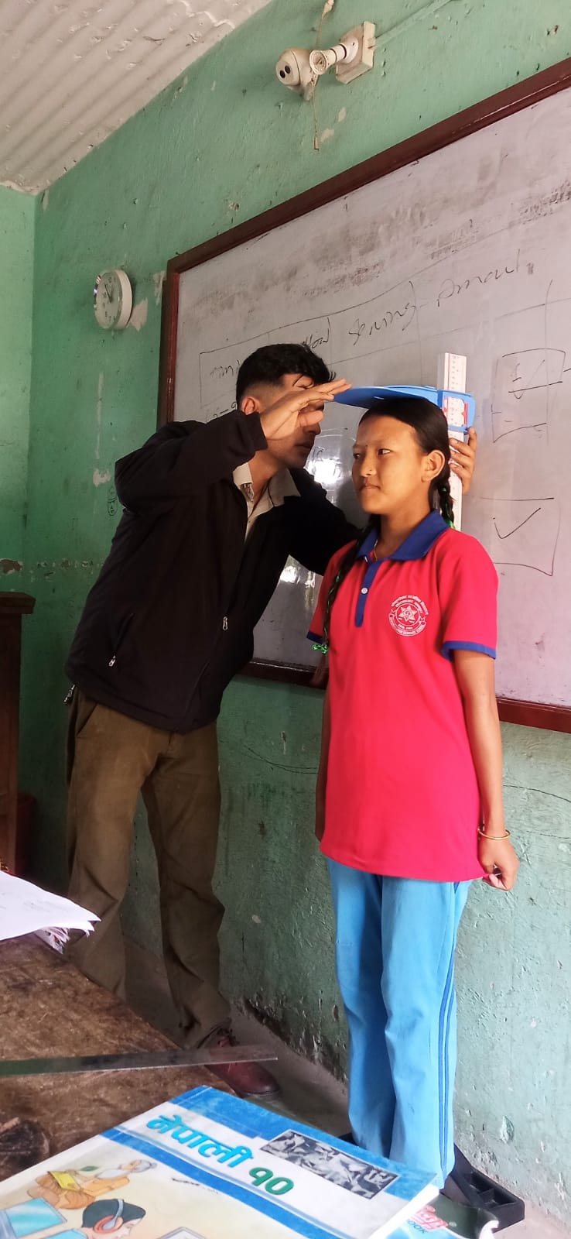 | 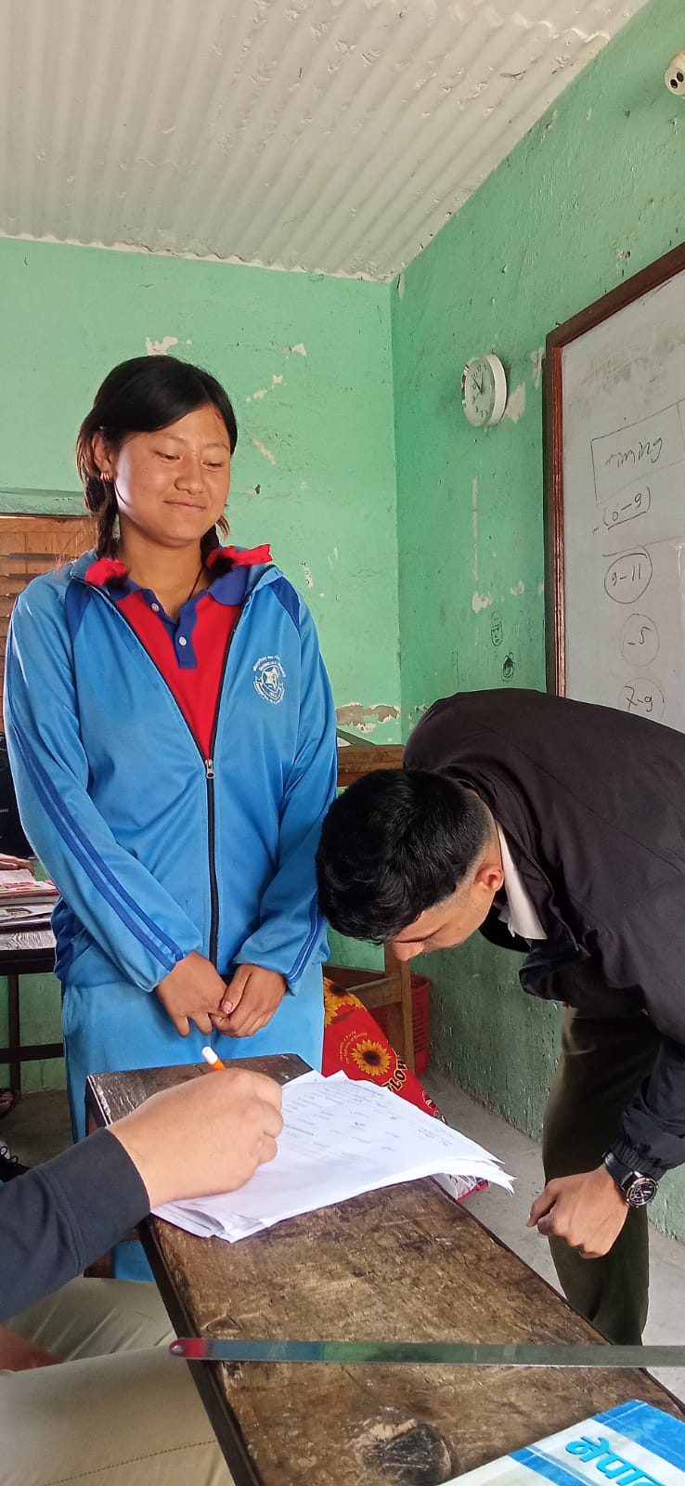

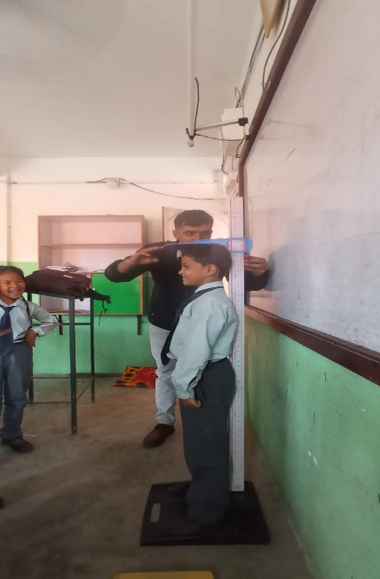 | 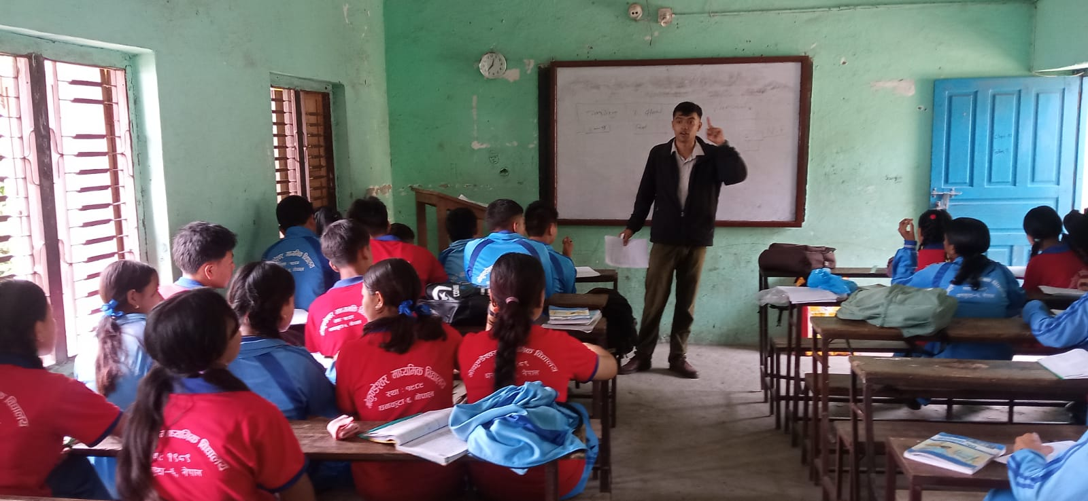
Appendix F
Chi-square test of factors affecting malnutrition
Table F.1 Chi-square test for father education
counts |  | Value | df | Asymptotic Significance (2-sided)
51 | Pearson Chi-Square | .^{b}
51 | N of Valid Cases | 29
32 | Pearson Chi-Square | .^{b}
32 | N of Valid Cases | 32
39 | Pearson Chi-Square | .^{b}
39 | N of Valid Cases | 39
41 | Pearson Chi-Square | .^{b}
41 | N of Valid Cases | 41
48 | Pearson Chi-Square | .^{b}
48 | N of Valid Cases | 48
61 | Pearson Chi-Square | .^{b}
61 | N of Valid Cases | 61
Total | Pearson Chi-Square | 1.175ª | 2 | 0.556
Total | Likelihood Ratio | 1.176 | 2 | 0.556
Total | N of Valid Cases | 250
a. 0 cells (0.0%) have expected count less than 5. The minimum expected count is 29.04.
b. No statistics are computed because Father education and status are constants.

Table F.2 Chi-square test for water purification
Chi-Square Tests
counts |  | Value | df | Asymptotic Significance (2-sided) | Exact Sig. (2-sided) | Exact Sig. (1-sided)
13 | Pearson Chi-Square | .^{c}
13 | N of Valid Cases | 13
18 | Pearson Chi-Square | .^{c}
18 | N of Valid Cases | 18
105 | Pearson Chi-Square | .^{c}
105 | N of Valid Cases | 105
114 | Pearson Chi-Square | .^{c}
114 | N of Valid Cases | 114
Total | Pearson Chi-Square | .394ª | 1 | 0.530
Total | Continuity Correction^{b} | 0.189 | 1 | 0.663
Total | Likelihood Ratio | 0.396 | 1 | 0.529
Total | Fisher's Exact Test |  |  |  | 0.569 | 0.333
Total | N of Valid Cases | 250
a. 0 cells (0.0%) have expected count less than 5. The minimum expected count is 14.63.
b. Computed only for a 2x2 table
c. No statistics are computed because Water purification and status are constants.

Table F.3 Chi-square test for weight monitoring
Chi-Square Tests
counts |  | Value | df | Asymptotic Significance (2-sided) | Exact Sig. (2-sided) | Exact Sig. (1-sided)
5 | Pearson Chi-Square | .^{c}
5 | N of Valid Cases | 5
6 | Pearson Chi-Square | .^{c}
6 | N of Valid Cases | 6
113 | Pearson Chi-Square | .^{c}
113 | N of Valid Cases | 113
126 | Pearson Chi-Square | .^{c}
126 | N of Valid Cases | 126
Total | Pearson Chi-Square | .223ª | 1 | 0.637
Total | Continuity Correction^{b} | 0.027 | 1 | 0.871
Total | Likelihood Ratio | 0.222 | 1 | 0.637
Total | Fisher's Exact Test |  |  |  | 0.761 | 0.434
Total | N of Valid Cases | 250
a. 0 cells (0.0%) have expected count less than 5. The minimum expected count is 5.24.
b. Computed only for a 2x2 table
c. No statistics are computed because weight monitoring and status are constants.

Table F.4 Chi-square test for skip meal
Chi-Square Tests
counts |  | Value | df | Asymptotic Significance (2-sided) | Exact Sig. (2-sided) | Exact Sig. (1-sided)
35 | Pearson Chi-Square | .^{c}
35 | N of Valid Cases | 35
38 | Pearson Chi-Square | .^{c}
38 | N of Valid Cases | 38
84 | Pearson Chi-Square | .^{c}
84 | N of Valid Cases | 84
93 | Pearson Chi-Square | .^{c}
93 | N of Valid Cases | 93
Total | Pearson Chi-Square | .005ª | 1 | 0.944
Total | Continuity Correction^{b} | 0.000 | 1 | 1.000
Total | Likelihood Ratio | 0.005 | 1 | 0.944
Total | Fisher's Exact Test |  |  |  | 1.000 | 0.527
Total | N of Valid Cases | 250
a. 0 cells (0.0%) have expected count less than 5. The minimum expected count is 34.75.
b. Computed only for a 2x2 table
c. No statistics are computed because Skip meal and status are constants.

Table F.5 Chi-square test for number of adolescent
Chi-Square Tests
count |  | Value | df | Asymptotic Significance (2-sided)
1 | Pearson Chi-Square | .^{b}
1 | N of Valid Cases | 2
16 | Pearson Chi-Square | .^{c}
16 | N of Valid Cases | 16
20 | Pearson Chi-Square | .^{c}
20 | N of Valid Cases | 20
32 | Pearson Chi-Square | .^{c}
32 | N of Valid Cases | 32
36 | Pearson Chi-Square | .^{c}
36 | N of Valid Cases | 36
60 | Pearson Chi-Square | .^{c}
60 | N of Valid Cases | 60
84 | Pearson Chi-Square | .^{c}
84 | N of Valid Cases | 84
Total | Pearson Chi-Square | 1.237ª | 4 | 0.872
Total | Likelihood Ratio | 1.456 | 4 | 0.834
Total | N of Valid Cases | 250
a. 3 cells (33.3%) have expected count less than 5. The minimum expected count is .29.
b. No statistics are computed because No. of adolescent is a constant.
c. No statistics are computed because No. of adolescent and status are constants.
Table F.6 Chi-square test for number of sibling
Chi-Square Tests
count |  | Value | df | Asymptotic Significance (2-sided) | Exact Sig. (2-sided) | Exact Sig. (1-sided)
1 | Pearson Chi-Square | .^{b}
1 | N of Valid Cases | 2
2 | Pearson Chi-Square | 4.000^{c} | 1 | 0.046
2 | Continuity Correction^{d} | 1.000 | 1 | 0.317
2 | Likelihood Ratio | 5.545 | 1 | 0.019
2 | Fisher's Exact Test |  |  |  | 0.333 | 0.167
2 | N of Valid Cases | 4
6 | Pearson Chi-Square | 12.000e | 1 | 0.001
6 | Continuity Correction^{d} | 8.333 | 1 | 0.004
6 | Likelihood Ratio | 16.636 | 1 | 0.000
6 | Fisher's Exact Test |  |  |  | 0.002 | 0.001
6 | N of Valid Cases | 12
10 | Pearson Chi-Square | .^{f}
10 | N of Valid Cases | 10
11 | Pearson Chi-Square | 22.000^{g} | 1 | 0.000
11 | Continuity Correction^{d} | 18.182 | 1 | 0.000
11 | Likelihood Ratio | 30.498 | 1 | 0.000
11 | Fisher's Exact Test |  |  |  | 0.000 | 0.000
11 | N of Valid Cases | 22
14 | Pearson Chi-Square | .^{f}
14 | N of Valid Cases | 14
28 | Pearson Chi-Square | .^{f}
28 | N of Valid Cases | 28
37 | Pearson Chi-Square | .^{f}
37 | N of Valid Cases | 37
41 | Pearson Chi-Square | .^{f}
41 | N of Valid Cases | 41
80 | Pearson Chi-Square | .^{f}
80 | N of Valid Cases | 80
Total | Pearson Chi-Square | 36.397ª | 8 | 0.000
Total | Likelihood Ratio | 40.318 | 8 | 0.000
Total | N of Valid Cases | 250
a. 5 cells (33.3%) have expected count less than 5. The minimum expected count is .59.
b. No statistics are computed because No. of sibling is a constant.
c. 4 cells (100.0%) have expected count less than 5. The minimum expected count is 1.00.
d. Computed only for a 2x2 table
e. 4 cells (100.0%) have expected count less than 5. The minimum expected count is 3.00.
f. No statistics are computed because No. of sibling and status are constants.
g. 0 cells (0.0%) have expected count less than 5. The minimum expected count is 5.50.

Table F.7 Chi-square test for family income
Chi-Square Tests
count |  | Value | df | Asymptotic Significance (2-sided)
15 | Pearson Chi-Square | .^{b}
15 | N of Valid Cases | 15
30 | Pearson Chi-Square | .^{b}
30 | N of Valid Cases | 30
38 | Pearson Chi-Square | .^{b}
38 | N of Valid Cases | 38
40 | Pearson Chi-Square | .^{b}
40 | N of Valid Cases | 40
53 | Pearson Chi-Square | .^{b}
53 | N of Valid Cases | 53
74 | Pearson Chi-Square | .^{b}
74 | N of Valid Cases | 74
Total | Pearson Chi-Square | 302.839ª | 6 | 0.000
Total | Likelihood Ratio | 300.531 | 6 | 0.000
Total | N of Valid Cases | 250
a. 0 cells (0.0%) have expected count less than 5. The minimum expected count is 8.36.
b. No statistics are computed because family income and status are constants.
Table F.8 Chi-square test for tried to gain weight
Chi-Square Tests
count |  | Value | df | Asymptotic Significance (2-sided)
11 | Pearson Chi-Square | .^{b}
11 | N of Valid Cases | 11
25 | Pearson Chi-Square | .^{b}
25 | N of Valid Cases | 25
31 | Pearson Chi-Square | .^{b}
31 | N of Valid Cases | 31
32 | Pearson Chi-Square | .^{b}
32 | N of Valid Cases | 32
56 | Pearson Chi-Square | .^{b}
56 | N of Valid Cases | 56
95 | Pearson Chi-Square | .^{b}
95 | N of Valid Cases | 95
Total | Pearson Chi-Square | 4.059ª | 2 | 0.131
Total | Likelihood Ratio | 4.038 | 2 | 0.133
Total | N of Valid Cases | 250
a. 0 cells (0.0%) have expected count less than 5. The minimum expected count is 14.11.
b. No statistics are computed because tried to lose weight and status are constants.
Table F.9 Chi-square test for feeling about figure
Chi-Square Tests
count |  | Value | df | Asymptotic Significance (2-sided)
3 | Pearson Chi-Square | .^{b}
3 | N of Valid Cases | 3
4 | Pearson Chi-Square | .^{b}
4 | N of Valid Cases | 4
5 | Pearson Chi-Square | .^{b}
5 | N of Valid Cases | 5
10 | Pearson Chi-Square | .^{b}
10 | N of Valid Cases | 10
25 | Pearson Chi-Square | .^{b}
25 | N of Valid Cases | 25
29 | Pearson Chi-Square | .^{b}
29 | N of Valid Cases | 29
41 | Pearson Chi-Square | .^{c}
41 | N of Valid Cases | 82
94 | Pearson Chi-Square | .^{b}
94 | N of Valid Cases | 94
Total | Pearson Chi-Square | 60.221ª | 4 | 0.000
Total | Likelihood Ratio | 60.708 | 4 | 0.000
Total | N of Valid Cases | 252
a. 0 cells (0.0%) have expected count less than 5. The minimum expected count is 5.57.
b. No statistics are computed because feeling about figure and status are constants.
c. No statistics are computed because status is a constant.

Table F.10 Chi-square test for tried to lose weight
Chi-Square Tests
count |  | Value | df | Asymptotic Significance (2-sided)
8 | Pearson Chi-Square | .^{b}
8 | N of Valid Cases | 8
16 | Pearson Chi-Square | .^{b}
16 | N of Valid Cases | 16
28 | Pearson Chi-Square | .^{b}
28 | N of Valid Cases | 28
52 | Pearson Chi-Square | .^{b}
52 | N of Valid Cases | 52
53 | Pearson Chi-Square | .^{b}
53 | N of Valid Cases | 53
93 | Pearson Chi-Square | .^{b}
93 | N of Valid Cases | 93
Total | Pearson Chi-Square | 5.002ª | 2 | 0.082
Total | Likelihood Ratio | 5.107 | 2 | 0.078
Total | N of Valid Cases | 250
a. 0 cells (0.0%) have expected count less than 5. The minimum expected count is 11.09.
b. No statistics are computed because activities and status are constants.
Table F.11 Chi-square test for school break activity
Chi-Square Tests
count |  | Value | df | Asymptotic Significance (2-sided)
8 | Pearson Chi-Square | .^{b}
8 | N of Valid Cases | 8
16 | Pearson Chi-Square | .^{b}
16 | N of Valid Cases | 16
28 | Pearson Chi-Square | .^{b}
28 | N of Valid Cases | 28
52 | Pearson Chi-Square | .^{b}
52 | N of Valid Cases | 52
53 | Pearson Chi-Square | .^{b}
53 | N of Valid Cases | 53
93 | Pearson Chi-Square | .^{b}
93 | N of Valid Cases | 93
Total | Pearson Chi-Square | 5.002ª | 2 | 0.082
Total | Likelihood Ratio | 5.107 | 2 | 0.078
Total | N of Valid Cases | 250
a. 0 cells (0.0%) have expected count less than 5. The minimum expected count is 11.09.
b. No statistics are computed because activities and status are constants.

