ASSESSMENT OF NUTRITIONAL STATUS OF 5-10 YEARS AGED CHILDREN IN SUKUMBASI BASTI (SLUMS) OF DHARAN

by
Pradip Khadka
Exam roll no.: 80011
Registration no.: 5-2-0008-0033-2011

Department of Nutrition and Dietetics
Central Campus of Technology
Institute of Science and Technology
Tribhuvan University, Nepal
April, 2017

ASSESSMENT OF NUTRITIONAL STATUS OF 5-10 YEARS AGED CHILDREN IN SUKUMBASI BASTI (SLUMS) OF DHARAN

A dissertation submitted to the Department of Nutrition and Dietetics, Central Campus of Technology, Tribhuvan University, in partial fulfillment of the requirements for the degree of B.Sc. Nutrition and Dietetics

by
Pradip Khadka

Department of Nutrition and Dietetics
Central Campus of Technology
Institute of Science and Technology
Tribhuvan University, Nepal
April, 2017

Tribhuvan University
Institute of Science and Technology
Department of Nutrition and Dietetics
Central Campus of Technology, Dharan

Approval Letter

This dissertation entitled Assessment of nutritional status of 5-10 years aged children in sukumbasi basti (Slums) of Dharan presented by Pradip Khadka has been accepted as the partial fulfillment of the requirement for the B.Sc. degree in Nutrition and Dietetics.

Dissertation Committee
- Head of the Department …………………………………………….
(Mr. Dambar B. Khadka, Teaching Assistant)
- External Examiner ………………………………………………..
(Mr. Pramod Koirala, chief RFTQC)

- Supervisor ………………………………………………..
(Mr. Basanta Kumar Rai, Assoc. Prof.)

- Internal Examiner ………………………………………………….
(Mr. Man Kumar Tamang, Teaching Assistant)

Date

Acknowledgement
Many helping hands were there to help on the way towards completion of my dissertation work. First of all I will like to take the name of my parents and thank them for their support in every steps of my life. Thanks mom and dad for doing everything for me.
I would like to express my gratitude towards my guide teacher Basanta Kumar Rai, who gave me an opportunity to work under his supervision. I would take this opportunity to express my deepest appreciation to all those who provided me the possibility to complete this research and helped me all the way by providing their precious time, support, love, knowledge and guidance.
Also, I would like to thank prof. Dr. Dhan Bahadur Karki, Campus Chief, Central Campus of Technology, for enormous support. I would like to thank the Central Campus of Technology my department committee for their guidance. I feel opportunistic to express my debt of gratitude to my Head of department Mr. Dambar Bahadur Khadka, for giving me permission to do this thesis work, his innovative ideas and giving me a wide exposure of the latest technologies existing in the current topic assigned to me.
I would like to thank my friend Basudev Bhattarai for his support, encouragement, and guidance in completion of my thesis. I would like to thank my other friends Pranaya, Madan, Jivan, Sunita, Sarita, Sandip and Suresh for their motivational suppport. Also I would like to give my thanks to my all juniors who helped me during my thesis.

……………………..

Pradip Khadka

Abstract
Nutritional survey was conducted to assess the contributing factor for nutritional status of 5 to 10 year children in selected Sukumbasi community in Dharan, Sunsari district. A cross-sectional study was done using Anthropometrics measurement and structured questionnaire tools in Sukumbasi community children of 5 – 10 years old to determine their nutritional status. The children were randomly selected and the total numbers of children taken in the study were 165. The data obtained from the survey were analyzed using WHO anthroplus 3.2.2 and SPSS 20.0 and the results were found out.
Analysis of Weight for Age showed that 73.3% of the children were normal and 26.7% were malnourished. 19.4% were found to be moderately underweight and 7.3% were severely underweight. According to Height for Age 65.5% of children were classified as normal, 26.7% of children fall under moderately stunted while 7.9% of children were severely stunted. According to BMI for age z-score, the result showed that 6.1% of children were moderately thinned, 0.6% of children were severely thinned, while 93.3% of children were normal.
Prevalence of thinness was seen higher in male children in comparison with female child. 6.2% of male child were moderately thinned and 1.2% of male child were severely thinned while 5.9% of female child were moderately thinned and there were no any female child in the criteria of severely thinned. In case of prevalence of moderately stunting in male children was found higher than female children but in case of severely stunting female children were more stunted than male children. 30.0% of male children were moderately stunted and 6.2% of male children were moderately stunted while 23.5% of female children were moderately stunted while 9.4% of female children were severely stunted.

Contents
Approval Letter iii
Acknowledgement iv
Abstract v
Contents vii
List of tables viii
List of figure ix
1. Introduction 1-6
1.1 General introduction 1
1.2 Problem statement 3
1.3 Objectives 4
1.3.1 General objective 4
1.3.2 Specific objectives 4
1.4 Significance of study 5
1.5 Limitations of the study 5
2. Literature review 7-26
2.1 Nutrition status 7
2.1.1 Factor affecting the nutritional status 7
2.1.2 Causes of low nutritional status of the 5 to 10 year age group children 12
2.2 Malnutrition 12
2.3 Malnutrition and infection cycle 14
2.3.1 Types of malnutrition problem in children 15
2.4 Assessment of nutritional status 18
2.4.1 Method of Assessment of nutritional status (WHO, 2016) 18
2.4.2 Indirect method of nutritional survey 21
2.4.3 Nutritional status indicators 21
2.5 WHO/NCHS reference for assessing growth in children of 6–10 years 22
2.6 Nutritional status of children in Nepal 23
2.7 Belief, tradition and attitude in Nepal regarding food consumption 25
2.8 Population growth in Nepal 25
2.9 Conceptual framework 25
3. Materials and method 27-30
3.1 Study Variable 27
3.2 Methods 27
3.2.1 Anthropometric measurement 27
3.2.2 Equipment and materials 27
3.3 Sampling procedure 28
3.3.1 Sample size determination 28
3.3.2 Sampling method 28
3.4 Pre-testing 29
3.5 Validity and reliability 29
3.6 Data collection 30
3.7 Data analysis 30
3.8 Logistical and ethical considerations 30
4. Results and discussion 31-45
4.1 Nutritional status 31
4.1.1 Weight for age 32
4.1.2 Height for age 33
4.1.3 Body Mass Index for age 35
4.1.4 Distribution of malnutrition based on sex 36
4.2 Socio-economic and demographic characteristics 37
4.3 Maternal characteristics 39
4.4 Child characteristics 40
4.5 Caring and feeding practice 42
4.6 Environmental characteristics 44
5. Conclusions and recommendations 46-47
5.1 Conclusions 46
5.2 Recommendations 47
6. Summary 48
7. References 49-52
8. APPENDICES 53-62

List of tables

Table No | Title | Page No
4.1 | Prevalence of underweight by age based z-score value of WHO |  | 33
4.2 | Prevalence of stunting by age based z-score value of WHO |  | 34
4.3 | Prevalence of thinness by age based z-score value of WHO |  | 35
4.5 | Distribution of malnutrition based on sex |  | 37
4.4 | Socio-economic and demographic characteristics |  | 38
4.5 | Maternal characteristics |  | 40
4.6 | Child characteristics |  | 41
4.7 | Caring and feeding practice |  | 43
4.8 | Hygiene and sanitation |  | 45

List of figure
Figure No. | Title | Page No.
2.1 | Malnutrition and infection complex cycle | 14
2.2 | UNICEF conceptual framework | 26
4.1 | Prevalence of malnutrition in sukumbasi basti of dharan | 32
4.2 | Distribution of underweight by age based z-score value of WHO | 33
4.3 | Distribution of stunting by age based z-scored value of WHO | 34
4.4 | Distribution of thinness by age based z-scored value of WHO | 36

List of abbreviations
 | Abbreviations | Full form
 | ARI | Acute respiratory infection
 | BAZ | BMI for age
 | BMI | Body mass index
 | CBS | Central bureau of statistics
 | EFA | Essential fatty acid
 | HAZ | Height for age
 | HFA | Health for all
 | IBM SPSS | Statistical package for social science
 | IYCF | Infant young child feeding practice
 | KAP | Knowledge attitude and practice
 | MoHP | Ministry of health and population
 | MUAC | Mid-upper arm circumference
 | NDHS | Nepal demographic health survey
 | PEM | Protein energy malnutrition
 | SD | Standard deviation
 | SEAR | South-east Asia region
 | UNDP | United nation development programme
 | UNFPA | United nation population fund
 | UNICEF | United nation international children emergency fund
 | VAD | Vitamin A deficiency
 | VDC | Village development committee
 | WAZ | Weight for age
 | WFP | World food programme
 | WHO | World health organization

Part I

Introduction

1.1 General introduction
Nutrition is a multidisciplinary subject with community as its practice area. It is a focal point for health and well-being. It has special significance in countries with disadvantages in socioeconomic and hygienic standards. The problems of poverty, safe drinking water, environmental hygiene and poor literacy contribute to the problems of nutrition and public health. Protein Energy Malnutrition (PEM) particularly stunting, has severe functional consequences, including increased vulnerability to disease and increased risk of mortality, lethargy with reduced capability to benefit from stimulation and reduced learning capacity. Adequate nutrition is essential in early childhood for the ensure of healthy growth, proper organ formation and function, a strong immune system, and neurological and cognitive development (UNICEF et al., 2012). Around half of under-five mortality (54 per 1000 live births) in Nepal is associated with malnutrition (UNICEF, 2012).
The burden of malnutrition in Nepal is very high. Malnutrition is not just a stark manifestation of poverty, it is also the non-income face of poverty and it helps perpetuate poverty (WorldBank., 2012). Ignoring this disease malnutrition will lead to heavy loss for the nation. Malnutrition is poor nutrition due to an insufficient, poorly balanced diet, faulty digestion or poor utilization of foods. Malnutrition is not only insufficient intake of nutrients. It can occur when an individual is getting excessive nutrients as well (Ensminger and Ensminger, 1993). Malnutrition in early age causes irreparable damage to the cognitive function of a person (Liang et al., 1967).
Nutritional status is defined as the condition of the body resulting from the intake, absorption and utilization of food. It is determined by a complex interaction between Internal/constitutional factors and external environmental factors: Internal or constitutional factors like: age, sex, nutrition, behavior, physical activity and diseases. External environmental factors like: food safety, cultural, social and economic circumstances. Majority of the ethnic population in Nepal is deprived and lives in condition of extreme poverty and deprivation. Harsh living, poverty and poor socioeconomic condition and infrastructure have increased the health risk of people especially living in rural areas (Ensminger and Ensminger, 1993).
Slums are highly populated urban areas characterized by substandard housing and squalor. Slum households are defined as a group of individuals who have one or more of the following characteristics: poor (structural) housing quality; overcrowding; inadequate access to safe water; inadequate access to sanitation and other infrastructure; and insecure residential status. Squatters (referred to as sukumbasi in Nepal), on the other hand, are slum dwellers settling on land without legal right, neither as tenants nor as owners. These people may live on the land for decades, but have no legal title to it. Technically, sukumbasi are people who do not own land anywhere in the country. In the urban context, sukumbasi are squatters unauthorized to reside where they do, while they may still own land elsewhere in the country (Karki, 2002).
Unlike squatters, residents of slum areas have formal title papers (lalpurja) or may rent their spaces. These communities are characterized by poverty, low income, inadequate living conditions and substandard facilities. Most of these settlements are inhabited by disadvantaged groups such as Khadgi (butchers) and Pode (sweepers). Another characteristic of slums, particularly of squatter settlements, is their location on marginal land. Overcrowding is an apparent characteristic of slums with high occupancy per unit of space, cohabitation, and a high number of single-room units. Many slum dwelling units are home to five or more persons sharing a single room for cooking, sleeping and living. Basic infrastructure such as water and sanitation is poor. Domestic violence, polygamy, child marriage, dowry and other gender discriminatory practices are common in slums, as elsewhere. Alcoholism pulls many back to poverty. School dropout rates are high and child labor is common. Most slum dwellers and squatters are poor (Karki, 2002).
The word Sukumbasi (landless) literally means a person who has no house for shelter, no private land for cultivation and no other opportunities of earning a livelihood. The word ‘Sukhimbasi’ was used to denote any landless people who have no private shelter, land, or other property for the livelihood of their family (Karki, 2002). On the other hand, Sukumbasi from Sukum meaning possessing nothing and basi meaning settlers (Shrestha and Aranya, 2015). He argues that ‘the Sukumbasis’ can be theorised as a group of people who maintain barely a de facto possession over the land they occupy but nonetheless are not simple wage labourers or slaves. (Shrestha and Aranya, 2015)
Generally, Sukumbasi is a name given to an individual or a group of people who occupy public land such as state forest and or land actively unclaimed by other owners.
The landless people of Nepal in the Terai can be categorized in the following four different groups:
- Victims of natural disasters;
- Internal migrants displaced by socio-economic causes;
- Migrants from India
- Some of the indigenous people of Terai and caste discriminated minorities (such as
- Tharus, Satars, Mushahars).
All four kinds of landless people are struggling for land rights in the Terai region, where feudalism and unequal distribution of cultivable land are most developed and a pre-capitalist ‘Kamaiya’, ‘Haruwa’ and ‘Charuwa’ system was predominant after 1950. The very high degree of exploitation of indigenous people such as, Kamaiyas, Haruwas and Charuwas in the region has further increased the numbers of landless people and forced them to organize for land rights (Karki, 2002).

1.2 Problem statement
Malnutrition especially under-nutrition among school going ( 5 to 10) year age group may children lead to the consequences like, falling to grow (underweight, stunted and thinness), reduced learning ability, reduced resistance and immunity against infection and reduced productivity in future (MoHP, 2012). Children are very vulnerable to the malnutrition. Especially of age group 5-10 years, falls to vulnerable group more often. These children from the higher rank family mostly provided optimum nutrient from their parents and they often eat much food and become overweight and obese. The child from the low income family could not able to get optimal nutrient because of they started to do job in child age as child labor, in their family there is too frequency of child and had to distribute the food which lead to manage the food as for survive only. Some of the family of low level also conscious on the nutritious health of child and can provide nutritious diet for their child.
Dharan town is located at the northen part of the Sunsari district, in the foothill of the eastern Mahabharat range, Koshi zone of the eastern development region of Nepal. A dense forest which is a part of famous ”Charkoshejhadi” lies in the south (Karki, 2002). The North West boundary is Sardu river and eastern boundary of municipality is Seuti river. In Dharan there are many sukumbasi people. There are 104 total sukumbasi basti in Dharan. There are 12222 households in sukumbasi basti in Dharan. In these areas many people are poor and illiterate. Poverty and illiteracy are directly related to nutritional status. They are migrated from different places for different reasons. The economic condition is not so good. There is lack of accessibility for foods consumption and health facilities. Though people are a bit literate, they are not much aware of food habits and the nutrition. Their hygiene and sanitation behaviors still to be improved so their children are more susceptible to the various communicable diseases. Nutritional status of people of developing countries is significantly poor. Malnutrition, especially under-nutrition and various forms of under-nutrient deficiencies are wide spread and mostly prevalent in rural areas. Major types of nutritional problems in developing countries are under-nutrition and nutritional disorders which are resulting from inadequate food intake both in quality and quantity, particularly of calories, proteins, vitamins and minerals; and parasitic infection and disease (Karki, 2002).
It is found that none of the research has been conducted to assess the nutritional status of children in sukumbasi basti of Dharan. So this survey is undertaken to assess the nutritional status of children and this will help to improve the nutritional status of children living in these areas.

1.3 Objectives

1.3.1 General objective
The main objective of this work is to assess nutritional status of 5-10 years aged children in Sukumbasi basti (Slums) of Dharan.

1.3.2 Specific objectives
To fulfill the general objective following are the specific objectives which are to be carried out.
- To assess the nutritional status of (5-10) years children of population.
- To assess the group of population who are at risk of malnutrition.
- To know about nutrition knowledge of parents.

1.4 Significance of study
The result of the survey would have following implications:
- Figure out the distribution of the malnutrition condition on 5 to10 years age group children according to their livelihood.
- Reflect sanitary condition, socio-economic variables, degree of malnutrition and condition of 5 to10 year’s age group child.
- Provide information to government as well as voluntary organization to take initial step to tackle the problem.
- Encourage concerned authorities for the proper planning and implementation of nutrition program effectively.
- Encourage government and other stake holders for the development of programs and policies related to nutrition.
- Find out the problems related to nutrition, care practices and feeding behavior of this community.
- Identify individual or group of people who are at risk of being malnourished and who need special care and attention.

1.5 Limitations of the study
- Actual information about family income, food availability & consumption pattern, and their utilization might not be given correctly because of shy nature and this things are related to prestige of family.
- Taking various measurement by a single person might produce personal errors.
- Children might be afraid of injection that would be given during immunization. Thus, problem might arise during measuring height and weight.
- Taking various measurements of girl children might be restricted by their parents and religion.
- Current data about the nutritional status of 5 to 10 year age group children and state of malnutrition of above mention group children in eastern Nepal could not be available for comparison.

Part II

Literature review

2.1 Nutrition status
The nutritional status of any person is his/her health as dictated by the quality of nutrients consumed, and the body’s ability to utilize them for its metabolic needs. Thus, being nutritionally vulnerable, under-5 children’s nutritional status is generally accepted as an indicator of the nutritional status of any particular community (Davidson, 1992). Nutritional status has been defined as the condition of the body resulting from the intake, absorption and utilization of food. It can be measure directly (Burk, 1984). Nutritional status is the condition of health of the individual as influenced by the utilization of nutrient. It can be determine through a careful medical and dietary history, a thorough physical examination, and appropriate laboratory investigation (Robinson, 1972).
A report on the nutrition situation in the world shows that about 2 billion people are affected by malnutrition in one form and the other (Herrador et al., 2014). Nepal is facing the vicious cycle of PEM spiral i.e. Poverty, population explosion, and environmental degradation. However various types of governmental and non-governmental health programs have been launched from time to time but they are still need improvement (MoHP, 2012).
The prevalence of poor nutrition status on developing country is mainly due to the low income, low production of food, low productivity of crops and livestock, unequal distribution of food, low literacy, socio-culture and poor environmental sanitation (Nabarro,1984). The poor nutritional status has both direct and indirect effect on learning skills, mental performance as well as a working capacity (Schmitt, 1979), resistance to disease. Broadly speaking the development of nation depends on the nutritional status of its people (Katwal, 1989).

2.1.1 Factor affecting the nutritional status
Factor contributing to malnutrition are poverty, poor feeding practices, lack of land, insufficient, food production, ignorance on the part of mothers, food losses, exploitation, diarrhea, no portable water, high price of fertilizer, drought, measles, too many children to feed, credit too expensive, health care too far away (Beghin et al., 1988).
A number of factors affect acceptability and utilization of food such as availability, cultural practices, economic condition, familiarity, taste and knowledge about health (Bhatta, 1998)
The factor affecting nutritional status are, mother’s food security, types of food given to the young children, feeding frequency, poverty, illiteracy, ignorance to the child for care and feeding, status of woman and child nutrition and last but not the least who feed the child and how the child eat (NMIS, 1996). Also factor influencing the nutritional status are food availability and its distribution system, consumption, income and purchasing power, price of commodities, illiteracy, family size, socio-culture and religious belief, environmental sanitation, health facility etc.(Bocabo, 1988). Some of them are given in the following paragraphs.
- Conditioning influences: Infectious diseases are important conditioning factor responsible for malnutrition, particularly in small children Diarrhea, Intestinal parasite, Measles, Whooping cough, Malaria, Tuberculosis all contribute to malnutrition. It has been shown that where environmental condition are poor, small children may suffer from some infection or others for almost half of their first three years of life (Amruth et al., 2012).
- Cultural influence: Lack of food is not only cause of malnutrition. Too often there is starvation in the midst of plenty. People choose poor diet when good one is available because of cultural influences which vary wide from country to and from region to region. These may be state as:
I. Food habit, custom, belief, tradition and attitude: Food habits are among the oldest and most deeply entrenched of any culture. They have deeply psychological root and are associated with love, affection, warmth, self-image and social prestige. The family plays an important role in shaping of the food habit, and these habits are passed from one generation to another generation. The crux of the problem is that many customs and belief apply most often the vulnerable group; i.e. in infants, toddlers, expectant and lactating women. Papaya is avoided during pregnancy because it is believed to cause abortion. There is a widespread belief that if the pregnant women eat more, her baby will being and delivery will be difficult. Certain food is “forbidden” as being harmful for the child. Then there are certain belief about hot and cold food, light and heavy food. In some communities men eat first and women eat last and poorly. Consequently, the health of women in these societies may be adversely affected. Chronic alcoholism is another factor which may lead to serious malnutrition (Amruth et al., 2012).
II. Religion: Religion has powerful influences on the food habit of the people. Hindus do not eat beef and Muslim pork. Orthodox Hindu does not eat meat, fish, egg and certain vegetables like onion. These are knows as food taboos which prevent people from consuming nutritious food even these are easily available (Amruth et al., 2012).
III. Food fads: In the selection of foods, personal likes and dislike play on important parts. These are called “food fad”. The food fad may stand in the way of correcting nutritional deficiencies (Amruth et al., 2012).
IV. Cooking practices: Draining away the rice water at the end of cooking, prolonged boiling in open pans, peeling of vegetables all influences the nutritive value widely from region to region and influence the nutritive value of food (Amruth et al., 2012).
V. Child rearing practices: These vary widely from region to region and influence the nutritional status of infants and children. Examples of this situation are premature curtailment of breast feeding, the adoption of bottle feeding and adoption of commercially produced refined food, during eating time the roaming around, active eating and watching television also effect the nutritional status of child (Amruth et al., 2012).
- Socio-economic factor: Malnutrition is largely the byproduct of poverty, ignorance, insufficient education, lack of knowledge regarding the nutritive value of food, inadequate sanitary environment, large family size etc. (Amruth et al., 2012).
- Food production: Increased food production should lead to the increase food consumption. But it will not solve the basic problem of hunger and malnutrition in much of the developing world. Scarcity of food, as a factor responsible for malnutrition may be true at the family level, but it is not true at global basis nor is it true for most of the countries when malnutrition is still a serious problem. It is a problem of uneven distribution between the countries and within the countries (Amruth et al., 2012)
- Health education: It is opined that by appropriate educational action, 50 percent of nutritional problem can be solved. Health education and nutrition education programme in nutrition is often a week component. Its reinforcement is a key element in all health service development (Amruth et al., 2012).
- Occupation: Occupation is the major factor that enhances to introduce the malnutrition in many habitats. As family is more engaged to earn by implying the occupational activities more chances of having the food intake by purchasing from marked or self-production. Among the group of different occupation mostly wage earner earn by daily purpose they spend all of money on food or daily commodities (Amruth et al., 2012).
- Inadequate dietary intake: This can mean both macro nutrients (fat, protein, carbohydrate) and micro nutrients (vitamins and minerals). Though insufficient macro nutrient intake has serious implications for health and well-being, micro nutrients also play large role in immune function (Bhatta, 1998).
- Impact on immune function: Insufficient macro nutrient intake can result in growth stunting (in children) as well as weight loss. Micro nutrients such as vitamin A, zinc and a large number of others are essential to a number of immune responses, and deficiency can lead to suppressed immunity, which in term increases risk of acquiring infection. In addition, in adequate dietary intake can also weaken immune response through changes in mucus membranes of the body (Bhatta, 1998).
- Infection: Once immune function is lowered, it may lead to infectious disease. Malnutrition not only affects the occurrences infectious diseases, it can also increase the severity of illness, and the length of time they are experienced (Bhatta, 1998).
- Poverty: At a micro-level, child malnutrition is related to poverty, but at the macro community level poverty does not appear to be strongly related to child malnutrition in many cases. Other actors are equally important. One of these is related to the intra-household use of resources such as the time management and knowledge of the main caregiver, who is usually the mother (Bocabo, 1988). For example, how much time is allocated to feeding, caring and ensuring a healthy environment for children?
2.1.2 Food availability and nutritional status
Good health depends on the adequate food supply and consumption. This is turn, on a sound agriculture policy and good system of food distribution. The food distribution determines the state of health and the incidence of disease among population. If the food supply is inadequate than the physiological needs, malnutrition and under nutrition could result (Yadav, 1994).
Increased production of food groups making the national diet balance is one of the most important measures of achieving, nutritional adequacy. Where the national diet are deficient in nutrient, adverse consequences manifest themselves, for example, there is high prevalence of anemia due to iron deficiency ,blindness among children due to vitamin A deficiency etc. Thus, the real solution to overcome the deficiencies disease is to consume diet rich in these nutrients (Katwal., 1992).
For a desirable nutrient balance, cereal contributes about 70-80% of the total dietary energy in the diet of people in developing countries. All other food commodities contribute only from 15 to 30% of total dietary energy. The diets in general are bulky, monotonous and imbalance, nutritionally(Yadav, 1994). Household food insecurity can negatively affect food consumption, including reduced dietary variety, nutrient intake, and nutritional status of household members (Yadav, 1994).
Household food insecurity and the prevalence rates of stunting, underweight, wasting, and anemia among children 6 to 23 months in study district were high. However, there was no significant association between household food insecurity and measures of under-nutrition among children in this age group. On the other hand, lower household socioeconomic status was associated with both household food insecurity and childhood stunting, underweight, and anemia. Maternal education, height, and hemoglobin concentration were inversely related to young child nutritional status indicators such as stunting, underweight, and anemia. Thus, improving only household food security may be necessary but not sufficient to improve the nutritional status of young children. An integrated strategy that improves the overall socio-economic well-being of families, maternal education, and knowledge of improved IYCF practices and ensures optimal maternal nutrition will probably be more effective in improving the nutritional status of children aged 6 to 23 month (Osei A et al., 2010).

2.1.2 Causes of low nutritional status of the 5 to 10 year age group children
Main causes of the low nutritional status in seemly developed city are market cycle, food habits, agricultural season or seasonality in food availability, religious cycle, low income, spacing in child birth, food habit, and child birth frequency, food accessibility and economic level (Den Hartag et al., 1990).

2.2 Malnutrition
Malnutrition is regarded as a pathological condition of varying degree of security and disease clinical manifestation, resulting from the deficient assimilation of component of nutrient complex. The disease affect the physiological patterns of tissue, reduce the defensive capabilities to withstand different environmental condition and lower both the efficiency and ability in work shortens life (Gomez, 1955).
Malnutrition has been defined as “a pathological state resulting from a relative or absolute deficiencies or excess of one or more essentials nutrients‟‟, it comprises four forms of under nutrition, imbalance and the specific deficiency (Park, 2011). Malnutrition has been defined in different ways. Some believe that it is the result of an imbalance in the intake of nutrient; whereas other says that it is the result of nutrients. There are still others who say it is depending on the type of nutrients responsible for the diseases. Nevertheless, both over-nutrition and under-nutrition are considered malnutrition (Jelliffe, 1966). Since the diet consumed by large of low income groups of the population in most of the developing countries are inadequate both in quality and quantity, malnutrition, particularly under-nutrition is widely prevalent among the vulnerable group of the people (Swaminathan and Bhagavan, 1976)
“The classical theory of malnutrition holds that kwashiorkor results from a deficiency of protein with a relative adequate supply of calories whereas marasmus is caused by overall deficiency of both protein and calories.”(Waterlow, 1972) on the other hand, Gopalan and his co-workers produced evidence that there are no difference in the diet of children as the clinical picture reflects not a difference in diet difference in the capacity of the child to adopts.
- Under-nutrition: This is the condition which results when insufficient food is eaten overall extended period of time. In extreme cases, it is called starvation.
- Over nutrition: This is the pathological state resulting from the consumption of excessive quantity of food over an extended period of time. The high incidence of obesity, atheroma and diabetes in western societies is attributed to over nutrition.
- Imbalance: It is the pathological state resulting from a disproportion among essential nutrient with or without the absolute deficiency of any nutrient.
- Specific deficiency: It is the pathological state resulting from a relative or absolute lack of an individual nutrient.
The effect of malnutrition on the community is both direct and indirect. Direct effects are the occurrence of frank and subclinical nutrition deficiency disease such as kwashiorkor, marasmus and vitamins and minerals deficiency disease. Indirect are, high morbidity and mortality among young children (nearly 50 percent of total death in the developing countries occur among children five years of age as compare to less than 5 percent in developed countries), retarded physical and mental growth and development (which may be permanent), lowered vitality of the people leading to lowered productivity and reduced life expectancy (Amruth et al., 2012).
Malnutrition and infection are interrelated. Malnutrition encourages infection and infected children cause poor nutritional intake as well absorption ultimately lead towards Malnutrition. The morbidity arising where from as a result of complication from such infection diseases as tuberculosis and gastroenteritis is not in considerable. The high rate of maternal mortality, stillbirth and low birth–weight are all associated with malnutrition (Park, 2011).
Malnutrition, a widespread problem with devastating consequences, weakens immune systems and worsens illnesses. It is a factor in about half the deaths for children under 5; malnourished children who survive have diminished learning capacity and lower productivity in adulthood. Malnutrition reduces the quality of life and financially drains families, communities, and countries (WHO and Fund, 2009).
Malnutrition prevents children from reaching their full physical and mental potential. Health and physical consequences of prolonged states of malnourishment among children are: delay in their physical growth and motor development; lower intellectual quotient (IQ). According to the World Health Organization (WHO), malnutrition has three commonly used comprehensive types named stunting, wasting and underweight measures by height for age, weight for height and weight for age indexes respectively.

2.3 Malnutrition and infection cycle
The vicious cycle of malnutrition, impaired immune response, increased infection and diseased food intake is well recognized (Caballero, 2003) (Fig. 2.1). Malnutrition (both micro & micronutrients) affect epithelial mucosal integrity, mucociliary clearance, immunoglobulin synthesis, lymphocyte differentiation and thus lead to impaired immunity which leads to recurrent infection (Chandra, 1994).

Fig. 2.1 Malnutrition and infection complex cycle (www.foodsec.com)
Non availability of food seems to be the major cause of malnutrition. Protein energy malnutrition (PEM) and micronutrient deficiencies are major contributors to higher mortality rates from illness and diseases such as pneumonia, malaria, diarrhea and measles in the developing world (Caballero, 2003).
Micronutrient malnutrition refers to a group of condition caused by deficiencies of essential vitamin and minerals such as vitamin A, calcium, iodine, iron and zinc. It is estimated that about 2 million people are affected by this type of malnutrition. Vitamin A deficiency is still the most common cause of preventable childhood blindness worldwide; iodine deficiency causes goiter, cretinism and brain damage; and anemia result from insufficient iron intake (Park, 2011).

2.3.1 Types of malnutrition problem in children
The major types in the developing countries like Nepal are protein energy malnutrition, vitamin A deficiency, and Anemia and Iodine deficiency disorder. This problems are briefly described in following paragraphs.
A. Protein energy malnutrition (PEM): Protein energy malnutrition is classified as primary when an individual is not able to offer an adequate intake of energy and other nutrients. PEM is classified as secondary when the major cause is disease or abnormality (Viteri, 1991). Severe malnutrition may be manifested as Marasmus and Kwashiorkor or Marasmic Kwashiorkor. Protein energy malnutrition is a broad term that encompasses kwashiorkor and Marasmus together with milder stages of these social diseases. According to studies conducted. Millions of infants and young children are the victims of these diseases in Asia, Africa, Central America, West Indies and South America. Many of the children who survive are unable to achieve their full physical growth and development (Margo, 1996).
I. Kwashiorkor: Kwashiorkor is a Ghanaian word, which means the illness that an older baby contracts when he is weaned as a result of the mother falling pregnant again (Williams, 1935) a pediatrician who observed this syndrome in infants, and pre-school children introduced this term. Children who were weaned and fed on a diet high in carbohydrates, but low in protein typical of a diet of staple food, such as maize, were usually the victims of kwashiorkor (Davidson, 1992). Growth is retarded and although the muscles are wasted and flabby, there is usually more subcutaneous fat than marasmic children. There is also edema, the child appears moon faced and the hair often turns red brown or grey (Cameron, 1993; Jelliffe, 1966; Swaminathan, 1991). According to literature kwashiorkor is far more common among poor communities and the depressed social classes than among privileged people. No one has recorded a contrary view (Bengoa, 1998). Even those who have doubted whether kwashiorkor was a nutritional disease have not found cases in wealthy families, unless the feeding was exceptional poor.
II. Marasmus: It is usually occurs in the children under 1 year of age when the quantity of mother’s breast milk is insufficient to provide adequate amount of protein and calories for a Symptoms include (Cameron, 1993).
- Presence of little or no subcutaneous fat, so the skin is loose and seems to be too big for the body. growing child and when the supplementary feeding is inadequate (Cameron, 1993). A child suffering from marasmus is less than 60% of normal weight for its age (Shrestha., 1996).
- The infant looks an old manor has a monkey face. The muscles are markedly wasted. They are flabby; this can be easily felt on the thigh and buttocks where the muscles should be thick and strong.
- There is no edema and no change in hair colour.
III. Marasmic-kwashiorkor: When the incidence of PEM is high, a large number of cases some of the feature of both Marasmus and Kwashiorkor (Swaminathan, 1997).
IV. Nutritional dwarfing: Retardation of growth is observed in the children who are deprived of food for prolonged period of time. Weight and height are both reduced resembling children a year and more younger (Srilakshmi, 2011).
V. Underweight child: These children ate growing up smaller than their genetic potential and of greater importance as they are at risk of gastroenteritis, respiratory and other infections, which can precipitate frank malnutrition (Srilakshmi, 2011).
B. Runche: Runche is the primary state of the malnutrition in Nepal (UMN, 1996). The restricted food intake of Marasmic child is sometime the result of maternally imposed restriction rather than result of poor appetite and the child is cry baby, crying all the time for food, but shows the symptoms such as diarrhea caused by under nutrition, the mother is afraid to give him enough food. In Nepal it is known as „Runche lageko‟(UMN, 1995).
C. Vitamin A deficiency: Vitamin A deficiency is one of the most serious nutritional disorders among young children in developing countries. Vitamin A deficiency is prevalent among large segments of society in many countries. The deficiency of Vitamin A weakens the immune systems of a large proportion of under-fives in poor countries, increasing their vulnerability to disease. A deficiency in vitamin A, for example, increases the risk of dying from diarrhea, measles and malaria by 20-24 percent (UNICEF, 2010). The implication of such vitamin A deficiency, however, varies in the group at risk. In pre-school children vitamin A deficiency can lead to increased risk of morbidity or mortality and to blindness in pregnant and lactating women. It can also lead to night blindness and appear to have implications for material mortality and morbidity, while the immediate health consequences for schoolchildren and adolescents are yet to be studied (Westcott, 1979). Deficiency of vitamin A leads to softening and ulceration of the cornea of the eye and sometimes to blindness. It usually affects young children and is often combined with kwashiorkor and marasmus. According to OMNI report (1996), VAD is related to the death of 14,000-20,000 Nepalese children annually. One percent of children aged 24-36 months and 0.5% of children aged 0-36 months had night blindness (NMIS, 1996).
D. Iron deficiency anemia: Anemia in children results in lack of energy, fatigue and reduced power of concentration and, although not confirmed by research in Nepal, lightly affects children’s level of participation in school and recreation. It is possible that children with iron deficiency are most susceptible to infections, since impairment in the production of antibodies is observed when this deficiency is present (UNICEF, 1996). In Nepal, 78% women are anemic due to iron deficiency of which 50% of women are in childbearing age. In total 78% any anemia, mild, moderate and sever are 34.7, 28.7%, and 5.6% and 0.3% respectively. And in children anemic condition data shows 46.2%, 27.2%, 18.5 and 0.5% as any anemia, mild, moderate and severe respectively (MoHP, 2011).
E. Iodine deficiency disorder: Iodine deficiency disorders is a more precise term than "goiter" because the latter only refers to the size of the thyroid gland .The former on the other hand, also includes a condition associated with iodine deficiency. Among this are still births, abortions and congenital anomalies, endemic cretinism, characterized most commonly by mental deficiency deaf mutism and spastic diplegia .For a lesser degree of neurological defects related to fetal iodine deficiency, and impaired mental function in children and adults with goiter and decreased circulating thyroxin. Correcting iodine deficiency in the mother before pregnancy prevents iodine deficiency disorders in infants and children (Westcott, 1997). The iodine deficiency disease, goiter, occurs in those areas where iodine content is low that insufficient iodine is obtained through food and water. Iodized water can thus prevent goiter in districts where this disease is common.
F. Vitamin D deficiency: Both inadequate and excessive vitamin D intakes are found in the United State and in Canada, even though the vitamin has been known for decades to be essential for growth and tonic in excess. Worldwide, vitamin D deficiency leads to rickets, which still afflicts large number of children. The main symptoms of an inadequate intake of vitamin D are those of calcium deficiency. The bones fail to calcify normally and may be so weak that they become bent when they have to support the body's weight (Griesel, 1986).

2.4 Assessment of nutritional status
In making an assessment of nutritional status of an individual or a group, various indices give us some idea. These include body build, physical stature, general appearance, feeling of health and well-being, the level of activity etc. A well-built body, a bounce in the step, sparkling eyes, clear skin and ready smile generally associated with good health (Ramchandran, 1987). The nutritional assessment may require encompassing nations, communities, and vulnerable segments of communities or individuals. It may be done as a part of an exercise to document current status as compared with post status or as specific attempt to evaluate the impact of an intervention programme (Ramchandran, 1987).

2.4.1 Method of Assessment of nutritional status (WHO, 2016)
- Direct method: Deals with the individual and measures objective criteria.eg. Anthropometric, clinical examination, biochemical and bio- physical parameters.
- Indirect method: Use community indices that reflect the community nutritional status or need. e.g. dietary intake, morbidity and mortality rates, as specific mortality and vital statistics.
- Ecological factors: e.g. Socio-economic status, housing and environmental hygiene, health and education services, conditioning infection.

2.4.1 .1 Direct method of nutritional survey
The method is summarized as ABCD steps as:
I. Anthropometric method (Jelliffe, 1966): Anthropometry is the measurement of body weight and proportion. It is an essential part of clinical examination of infant, children and pregnant woman. It is used to evaluate both under and over nutrition. Measured values reflect current nutritional status. Recommended anthropometric measurements for 5 to 10 year age group are height, weight and triceps skin fold thickness.
Accurate measurement of height and weight is necessary to evaluate the physical growth of a child. Height for age is a measure of long term nutritional status or stunting. Height is measured using wall mounting tape or Stadiometer for children. Height of the index children compared with the expected height of a healthy child of the same age, weight for the age is measures of wasting. Weight is measured using bathroom weighting scale or digital scale. Triceps skin fold thickness measured using harpenden’s skin fold callipers.
Body mass index: Although the calculations for adult and child BMI are the same, BMI for children is interpreted differently using BMI for age reference charts. This is because the amount of body fat in children changes according to different stage of a child’s development and growth. Body mass index is computed using the following formula:
BMI = Weight / Height (m)²

2.4.1.2 Anthropometrics tools to assess nutritional status
Height: For children 2 years and above a vertical rod can be employed. After removing the shoes the subject stand on a flat surface by the scale with feet parallel with heels, shoulders and back of head touching the upright. The head should be held comfortably erect, with the lower border of the orbit of the eye in the same horizontal planes as the external canal of the ear. The measuring scale should be 175 cm high and capable of measuring to an accuracy of 0.1 (WHO, 1993).
Weight: For children 5 to 10 year a bathroom scale on which the child is made to stand. The apparatus usually reads to maximum of 100 kg with increment of 100 g. (WHO, 1993).
Weight for height: Weight and height of child is measured using standard Secadigital balance and Stadiometer respectively and index is expressed in standard deviation units from the median of WHO child growth standards adopted in 2006. Children whose weight-for-height is below minus one standard deviations is considered mildly wasted similarly below minus 2 and 3 standard deviations are considered moderately and severely wasted respectively (De Onis and Blössner, 2003)
Weight for age: Children whose weight-for-age is below minus two standard deviations from the median of the reference population are considered underweight. The measure reflects the effects of both acute and chronic under nutrition (De Onis and Blössner, 2003).
Height for age: Children whose height-for-age is below minus two standard deviations from the median of the reference population are considered stunted or short for their age. Stunting is the outcome of failure to receive adequate nutrition over an extended period and is also affected by recurrent or chronic illness (De Onis and Blössner, 2003).
Mid-upper-arm circumference: Muscle and fat constitute the soft tissues that vary with a deficiency of protein and calories. Measurement of the mid-upper-arm circumference is the most useful method for assessing muscle mass and is also useful for rapid screening of children for severe malnutrition (RAPA, 1988/11), as this region is easily accessible and measurement requires only a flexible fiber glass tape (Gopaldas, 1987).
Advantages of anthropometry
- Simple, non-invasive,
- Most of the equipment are inexpensive, portable,
- Relatively unskilled personnel can perform measurements,
- Methods are reproducible,
- Measures with long term nutritional history,
- Quickly identifies mild to moderate malnutrition,
- Measure many variable of nutritional significance like height, weight, skin fold thickness, head circumference waist-hip ratio and BMI,
Limitation of Anthropometry
- Relative insensitive to short term nutritional status,
- Cannot identifies specific nutrient deficiencies,
- Measurements like skin-fold are difficult to carry out in obese people,
- There may be ethnic differences in fat deposition

2.4.1.3 Biochemical and laboratory method
Biochemical test is used primarily to detect subclinical deficiency states or to confirm a clinical diagnosis. Some of its examples are hemoglobin estimation, serum protein, urine creatinine, serum retinol etc.

2.4.1.4 Clinical examinations
We can also assess ones nutritional status by observing certain signs and symptoms which are associated with various nutrient deficiencies in various organs of body like skin, hair, mouth, tongue etc.

2.4.1.5 Dietary evaluation method
Dietary assessment protocol is designed to assess nutrient intakes after implying questionnaire, records, and recall methods (Ferruzzi et al., 2013).

2.4.2 Indirect method of nutritional survey
- Ecological variables including agricultural crop production, food balance, health and educational services.
- Socio economic factors e.g. Family size, occupation, per capita income, population density, education, customs and social habits.
- Vital health statistics particularly infant (under 5) mortality and morbidity related to PEM, school age child stunting and wasting, anemia, goiter, diarrhea, measles and parasitic infestation.

2.4.3 Nutritional status indicators
Several of indicators can be used for the purpose of assessing nutritional status, which are currently available. From possible indicators only few are suitable for the evaluation of field program. The only indicator of nutritional status that are applicable in a large scale and for which a suitable experience if available are those based on anthropometric indicators are best applicable in the evaluation of nutritional status (Keller, 1982).
WHO, listed nutritional status lowering indicators based on body dimensions, birth weight, weight for height, height for age, weight for age, arm circumference, reported in 1976. The measurement of weight and height is relatively simple and reliable and their changes and distribution over ages are well documented for healthy well-nourished reference populations. The simplest of these indicators are weight for age (Keller, 1982; RAPA, 1988/11). It is widely used for both the assessment of child population and the monitoring of individual development.
Weight is the measure of total body mass but gives no indication of its structure, a tall thin child may have same mass as a short, well-proportioned one, a fact that introduces considerable error in to the classification of malnutrition by weight for age particularly in the categories of “mild” and “moderate” malnutrition. Therefore, a refinement that has long been used by anthropologist was introduced into the nutritional anthropometry of children (Scoane and Lathan, 1971). By relating the weight to the attained height, a distinction was made between chronic and acute malnutrition (Scoane and Lathan, 1971) or between stunting and wasting (J. Waterlow and Ruthishause, 1974). Three indicators weight-for-age, height-for-age, and weight-for-height have since found wide acceptance and application and probably more known today about these indicators in different population and different health situations than any of other indicators that have been prepared in the past (Keller, 1982).
An essential component of these indicators and their use is the reference population. It provide the indicator value of the population that are considered normal i.e., healthy and without significant deficiencies, and against which measured indicator value are compared while the indicator weight-for-height is apparently independent of age during childhood (J. Waterlow and Ruthishause, 1974). In the case of dependent indicators weight-for-age and height-for age, it has been argued the major difference in growth potential between ethnic groups would require local reference population. It has however, been shown (Bandal, 1969; Habieht et al, 1974; Eveleth and Tanner, 1976) that with few exception (Hiernaux, 1964) growth of different ethnic groups under favorable conditions is almost identical.

2.5 WHO/NCHS reference for assessing growth in children of 6–10 years
The WHO reference 2007 provides a smooth transition from the child growth standard for 0-5 years to the older age group. The data tables and charts cover the 1st to the 99th percentile and from -3 to +3 standard deviation (SD). The 2006 WHO growth standard should be used for the assessment of children 0-60 months and the 2007 WHO growth reference should be used in the assessment of children 5-14 years. There are no global standard or reference populations for adult or older people of this time. WHO anthro plus is software for use on desktop personal computer or laptops using Microsoft windows. It was developed to facilitate the application of the WHO reference 2007 for 5-14 years to monitor the growth of school-age children and adolescent. To show the continuity with the WHO child growth standard for 0-5 years, these are included in anthroplus for the three indicators that apply, i.e., weight-for-age, height-for-age and BMI-for-age. This software enables monitoring growth in individual and population of children from birth to 18 years of age.

Indicator Age ranges
Height-for-age 5-14 year
Weight-for-age 5-14 year
BMI-for-age 5-14 year

The most widely used system is world health organization (WHO) classification based on z-scores.
Category of Malnutrition
Malnutrition | Z-score
Moderate | <-2 to > -3
Severe | <-3

The commonly used under-nutrition indicators, i.e. underweight, stunting and thinness are used to evaluate the nutritional status of the subject.

Underweight | <-2 WAZ (z-score for weight.-for-age).
Stunting | <-2 | HAZ (z-score for height-for age).
Thinness | <-2 | BMIZ (z-score for BMI-for-age).

2.6 Nutritional status of children in Nepal
In terms of nutrition, breast feeding is universal in Nepal. Over 70% of children in Nepal are exclusively breastfed up to 6 months. Exclusive breast feeding is necessary and sufficient to meet the nutritional needs of infants up to the age of 4-6 months. It protects the child from diarrhea and acute respiratory infections (ARI) and other diseases. Over 70% of children in Nepal are exclusively breastfed up to 6 months. Mostly children are provided solid food in addition to breast feeding after five to six months. In most communities this is observed as the important day for the child known as 'pasnee', the rice feeding day. It is mostly performed in the fifth month for girl child and six month for the male child. The child's share of milk is gradually reduced with the rice feeding time. But majority of mothers continue to breastfeed their children up to two years (MoHP, 2011).
The nutritional condition of mother and child is very poor in the country and this problem mostly concentrated among the disadvantaged poor. It varies from district to district, community, household and individuals. Children are mainly suffering from Vitamin A deficiency, Anemia, Goiter and Cretinism due to malnutrition. NDHS 2001 states that 52% children in rural areas are more likely to be stunted whereas figure for urban area is 37%. Similarly, 61%, 53% and 47% children are more likely to be stunted in Mountain, Hill and Terai respectively. NDHS, 2001 states that this is probably because healthy food is more readily available in the hills and terai than in the mountain. The population census 2001 reports that population in the age group 0-14 comprised 39 % of the total population. Over 85% of the country's population is rural and more than 40% children in this area suffer from malnutrition and various diseases. Diarrhea diseases continue to be a major cause of death among Nepalese children. The use of oral re-hydration therapy is still low at 32 %.
Nepal demographic health and survey (MoHP, 2011), shows that nutrition status of the under five year children in Nepal was as height-for-age 41%, weight-for-age 11% and weight-for-age 28.8% respectively. The anemic condition of the children in different categories are 46.2% any anemia, 2702% mild, 18.5% moderate and 0.5% severe and the house hold iodized salt using was 80% house in Nepal . The data on 5-9 months children given complementary feeding was 70.4% and 0-5 months exclusively breast fed was 69.6%.
The study was conducted to assess the growth and nutritional status of school age children (6-14 years) of a tea garden worker of Assam. Compared to NCHS standard and affluent Indian children, the mean height and weight of tea garden children was inferior at all ages. Assessment of nutritional status using WHO recommended anthropometric indicators revealed a high prevalence of malnutrition among tea garden school age children and malnutrition was both chronic and recent in nature. Prevalence of wasting, stunting and underweight was 21.2%, 47.4% and 51.7% respectively among the children in the age group of 6-8 years. Prevalence of stunting and thickness was 53.6% and 53.9% respectively among the children in age group of 9-14 years age group (Medhi et al., 2006).
A cross-sectional study was carried out to determine the current prevalence of protein energy malnutrition (PEM) at Orong Asli school children and to investigate the potential predictor of malnutrition. A total of 241 (120 male and 121 female) Orong Asli school children age 7-12 year living in remote areas of Pos Betau, Pahang participated voluntarily in this study. Anthropometric and socio economic data were collected and the children were screened for intestinal parasitic infections. The overall prevalence of mild and significant underweight condition were 52.3% and 37.3% respectively and the prevalence of mild stunting and wasting were 43.2% and 43.1%, respectively, while the prevalence of significant stunting and wasting were 43.6% and 5.6% respectively. There was a significant association between gender (male) and malnutrition (p=0.029). The result showed a higher prevalence of stunting among children age ≤10 years than in older children (p=0.001) (Medhi et al., 2006)

2.7 Belief, tradition and attitude in Nepal regarding food consumption
Food habits are among the oldest and most deeply entrenched aspects of any culture. They have deep psychological roots and associated with love, affection, warmth, self-image and social prestige. Rice is the staple cereal in the eastern and southern part of Nepal and wheat and maize are the staple cereals in the northern parts, as in the most hills maize and millets are also used as staple food. In urban cities, valuable food such as, dhal, leafy green vegetables, rice and fruits are avoided by the nourishing mothers. There is widespread belief that if a pregnant woman eats more, her baby will be big and delivery will be difficulty. Certain foods are “forbidden” as being harmful for the child. Then, there are certain beliefs about hot and cold foods, light and heavy foods. In some communities, men eat first and women eat last and poorly. Consequently, the health of women, in such societies might be adversely affected (Park, 2011).

2.8 Population growth in Nepal
In Nepal birth and death rate are both relatively high, the population is growing at a fairly rapid rate. More than two fifths of the population is younger than 15 years of age. However, the population growth rate in 2011 is 1.41 % (MoHP, 2011).

2.9 Conceptual framework
The literature repeatedly shows that malnutrition is caused by a combination of factors, such as low income, illiteracy, an unhealthy environment, unsatisfactory health services, inadequate food habits, low agricultural productivity, etc., and that all these factors affect each other differently according to the particular situation (Fig. 2.2) (Beghin et al., 1988).
Maternal & child under nutrition
Inadequate dietary intake
Disease
Household food
insecurity
Inadequate care
Unhealthy household environment and lack of health services
Income poverty: employment, self-employment dwelling, assets, remittances, pensions, transfers etc
Social, economic and political context
Lack of capital: financial, human, physical, social and natural
Immediate causes
Underlying causes
Basic causes
Fig. 2.2 UNICEF conceptual framework (UNICEF, 2016)

Part III

Materials and method

3.1 Study Variable
Study variable were categorized into two groups:

- Dependent variable: Malnutrition indicated by stunting, thinness and underweight.
- Independent variables: Three categories of factors were assessed as independent variables
- Socio-economic and demographic variables: Economic characteristics, head of HHs, marital status, ethnicity, religion, family size, income, education occupation.
- Child characteristics: Age, Sex.
- Child caring practices: Feeding, hygiene, child behavior during feeding, type of food eating.

3.2 Methods

3.2.1 Anthropometric measurement
The following anthropometric measurements are to be taken to find out the nutrition status of child.
- Height for Age
- Weight for age
- BMI for age

3.2.2 Equipment and materials
The equipment needed for the survey are given below:
- Child weighing machines (Secascale): Child weighing machines having capacity of 100kg (1 piece).
- Height measuring stand (Stadiometer): The height measuring tape of 6ft capacity (2 pieces)
- Questionnaire: A well designed set of questionnaire to collect information on household

3.3 Sampling procedure
Study population:-Population under the study was children of age group 5 to 10 year in the sukumbasi community of Dharan.
Study area:-The household situated in Sukumbasi basti in Dharan.

3.3.1 Sample size determination
The sample size is determined by using a single proportional formula assuming the prevalence rate of malnutrition to be 50% in the survey area, 95% confidence interval (CI), 8% margin of error (d) and 10% non-response rate is added to the total calculated sample size.
Calculation of sample size for infinite population:-
Sample size (n₀) = Z²×p (1-p)/d²
Where z= confidence interval at 95% (standard value of 1.96)
P= estimated prevalence of malnutrition (50%)
d= margin of error (5%)
Now
N₀=1.96²×0.5× (1-0.5) / (0.07)²
= 150
Thus calculated sample size is adjusted for non-response. Considering non response rate as 10 %, the adjusted sample size is calculated to be 165.

3.3.2 Sampling method
Random sampling method was used for selecting sukumbasi bastis of dharan. 5 bastis were selected namely Fokland basti, Ashare basti, Saaune basti, Pragati basti, Siva Ganga basti as sample for assessing nutritional status of children of 5 - 10 years living in sukumbasi areas of Dharan.
Inclusion criteria: Children who were in house in that of age criteria as above mentioned at least one in each house.
Exclusion criteria: In absence of the study subject (child) at the time of household survey or being seriously ill.

3.4 Pre-testing
The study was pre- tested 6 to 10 years age group children from a selected area under sampling procedure. The pre-testing was conducted to establish accuracy of questions and clarity and to check for consistency in the interpretation of questions and to identify ambiguous items. After review of instruments all suggested revisions will be made before being administered in the actual study.

3.5 Validity and reliability
To ascertain the degree to which the data collection instruments was measured what they purposed to measure, the instruments was validated by a group of professionals from Central Campus of Technology, department of Nutrition and Dietetics. The expected testes in the questionnaire were drawn according to the available literature in nutrition education for young children. The questionnaire was pre-tested prior to data collection to ascertain content and face validity.
Reliability refers to quality control measure of data collected. Before data collection, the research assistants were intensively trained on the objectives of the study and on data collection techniques. The process of data collection was involved the principal researcher and two research assistants. Questionnaire was checked daily for completeness, consistency and clarity as mentioned earlier. To improve the validity and the reliability of the collected data following methods will be applied
- To increase the precision of the equipment especially weighing machine it was monitored 3 times a day by using the standard 5 kg measurement.
- To increase the precision and validity and to minimize the error in the collection of the data, measurement was carried out by triplet method that is each measurement will be measured three times and concurrent reading was recorded.
- Monitor was done by my guide teacher to complete this research.
- Any problem during the study related to the data collection was minimized by the help of local leaders. e.g. language problems etc.

3.6 Data collection
Data obtained from the respondents was collected on a structured form of questionnaire in which each questionnaire was given a unique identity number for each student.

3.7 Data analysis
Quantitative data was firstly cleaned, coded and was entered in SPSS 20.0 and WHO Anthroplus 3.2.2. Similarly qualitative data was transcribed and coded by assigning labels to various categories.

3.8 Logistical and ethical considerations
Prior consent to conduct the research was obtained from the principal of respective research conducting households at the same time clearance from Dharan sub-metropolitan city was taken.

Part IV

Results and discussion

4.1 Nutritional status
Anthropometric indices are the major tool for the assessment of nutritional status of children. Deviation of anthropometric indices from the reference standard of those indices is the evidence of malnutrition. Generally, underweight, stunting and thinness are widely used indicators of malnutrition.
In survey, among 165 children, the overall magnitude of malnutrition among 5 – 10 years of children in sukumbasi basti of Dharan were 34.5%, 26.7% and 6.7% for stunting, underweight and thinness respectively as shown in Fig. 4.1. The result showed that malnutrition is still one of the important problems in the Sukumbasi basti of Dharan. This may be due to inadequate care given to the children as most of the parents were engaged in labor work as a result they have very less time for the care of their child. More than half of the mothers were pregnant at early immature age i.e. below 20, at the age below 20 years, girls body is not fully ready for reproduction leading to low birth weight baby, increased health risk of baby. A study shows that young mothers were nearly twice at risk of delivering low birth weight babies and 50% less likely to have normal birth weight babies (Mahavarkar et al., 2008). So the early age pregnancy may be the cause of malnutrition in sukumbasi basti of Dharan.
During survey it was found that the mothers of sukumbasi basti had very less knowledge regarding feeding their children, most of the mothers didn’t knew about baby food and sarbottam pitho. Hence inappropriate feeding behavior may be the cause leading the children towards malnutrition.
Poor hygiene and sanitation may cause outbreak of diarrhea, episode of diseases. The lack of safe water creates a tremendous burden of diarrheal disease and other debilitating, life-threatening illnesses for people in the developing world (Sobsey et al., 2008). Most of the people in Sukumbasi basti drink water without using any methods of purification which may cause different disease to children leading towards malnutrition.

Fig. 4.1 Prevalence of malnutrition in sukumbasi basti of Dharan

4.1.1 Weight for age
The results according to Weight for Age showed that 73.3% of the children were normal and 26.7% were malnourished. 19.4% were found to be moderately underweight and 7.3% were severely underweight. The underweight was highly found among the 7 – 8 years age group but found less among 5 – 6 years age group. The details are shown in Table 4.1. On comparing this data with the study done in Kavre district where the prevalence of underweight was found 30.15% and is somehow similar to the result from the survey (Mansur et al., 2015). The median weight for Age z-score of survey children was found to be -1.51 which is less than the reference to WHO standard. This cause curve is skewed to the left side of WHO standard curve showing the prevalence of underweight among study population as shown in fig.4.2.

Table 4.1 Prevalence of underweight by age based z-score values of WHO
WAZ class
Age group (Year) | Normal | Moderate | Severe
5 – 6 | 23 (85.2%) | 2 (7.4%) | 2 (7.4%)
6 – 7 | 18 (81.8%) | 4 (18.2%) | 0 (0%)
7 – 8 | 19 (65.5%) | 9 (31.0%) | 1 (3.4%)
8 – 9 | 24 (63.2%) | 10 (26.3%) | 4 (10.5%)
9 – 10 | 37 (75.5%) | 7(14.3%) | 5(10.2%)
Total | 121 (73.3%) | 32 (19.4%) | 12 (7.3%)
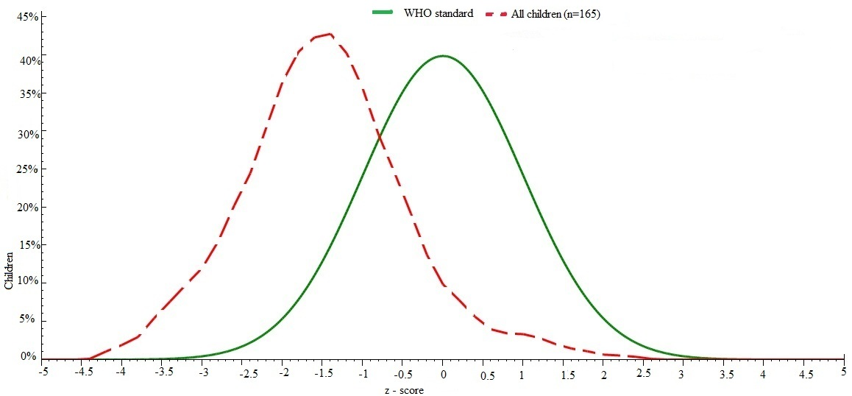
Fig 4.2 Distribution of underweight among children based on WHO standard (n=165)

4.1.2 Height for age
On giving contrast to Height for age, according to WHO classification 65.5% of children were classified as normal, 26.7% of children fall under moderately stunted while 7.9% of children were severely stunted. The age groups of 7 – 8 years children were highly stunted while the age group of 6 – 7 years children were least stunted which is shown in Table 4.2
Comparing this result with study done on Kavre district where the prevalence of stunting was 24.54%, showed that stunting was higher in this survey with 34.6% (Mansur et al., 2015). The median height for Age z-score of survey children was found to be -1.62 which is less than the reference to WHO standard as shown in fig. 4.3. This cause curve is skewed to the left side of WHO standard curve showing the prevalence of stunting among study population.
Table 4.2 Prevalence of stunting by age based z-score values of WHO
HAZ class
Age group (Year) | Normal | Moderate | Severe
5 – 6 | 17 (63.0%) | 7 (25.9%) | 3 (11.1%)
6 – 7 | 19 (86.4%) | 3 (13.6%) | 0 (0.0%)
7 – 8 | 16 (55.2%) | 11 (37.9%) | 2 (6.9%)
8 – 9 | 20 (52.6%) | 12 (31.6%) | 6 (15.8%)
9 – 10 | 36(73.5%) | 11 (22.4%) | 2 (4.1%)
Total | 108 (65.5%) | 44 (26.7%) | 13 (7.9%)
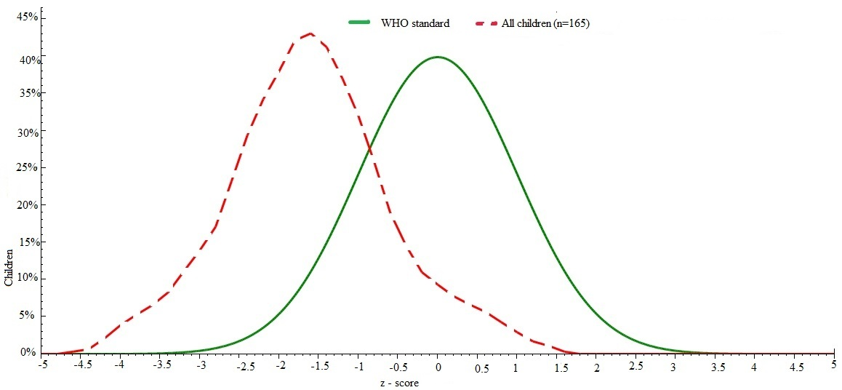
Fig. 4.3 Distribution of stunting among children based on WHO standard (n=165)

4.1.3 Body Mass Index for age
On analyzing BMI for age z-score, the result showed that 6.1% of children were moderately thinned, 0.6% of children were severely thinned, while 93.3% of children were normal as shown in table below (Table 4.3). There were no obese children found from the study result.
The prevalence of thinness was seen higher in age group 9 – 10 years followed by 5 – 6 years age group in second highest and 8 – 9 years age group in third highest rank while there was zero prevalence of thinness in other remaining age groups.
In the present study, it was concluded that the prevalence of thinness among children was found to be 6.7% which was almost comparable to the finding 10.05% reported by (Mansur et al., 2015)among children of Kavre district. The median BMI for Age z-score of survey children was found to be -0.62 which is less than the reference to WHO standard as shown in fig.4.4. This cause curve is slightly skewed to the left side of WHO standard curve showing the prevalence of thinness among study population.
Table 4.3 Prevalence of thinness by age based z-score values of WHO
BAZ class
Age group (Year) | Normal | Moderate | Severe
5 – 6 | 25 (92.6%) | 2 (7.4%) | 0 (0.0%)
6 – 7 | 22 (100%) | 0 (0.0%) | 0 (0.0%)
7 – 8 | 29 (100.0%) | 0 (0.0%) | 0 (0.0%)
8 – 9 | 36 (94.7%) | 2 (5.3%) | 0 (0.0%)
9 – 10 | 42 (85.7%) | 6 (12.2%) | 1 (2.0%)
Total | 154 (93.3%) | 10 (6.1%) | 1 (0.6%)
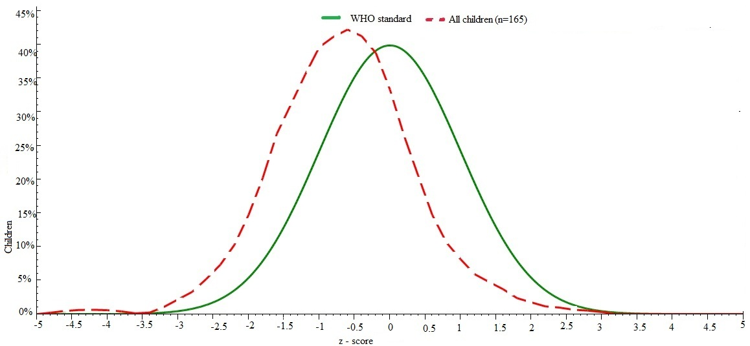
Fig 4.4 Distribution of thinness among children based on WHO standard (n=165)

4.1.4 Distribution of malnutrition based on sex
From the survey result we found that the prevalence of thinness was seen higher in male children in comparison with female child. 6.2% of male child were moderately thinned and 1.2% of male child were severely thinned while 5.9% of female child were moderately thinned and there were no any female child in the criteria of severely thinned as shown in table below (Table 4.4).
The prevalence of underweight was also seen higher in male child than in female children. 21.2% of male children were moderately underweight and 7.5% of male children were severely underweight while 17.6% of female children were moderately underweight and 7.1% of female children were severely underweight.
In case of prevalence of moderately stunting in male children was found higher than female children but in case of severely stunting female children were highly stunted than male children. 30.0% of male children were moderately stunted and 6.2% of male children were moderately stunted while 23.5% of female children were moderately stunted while 9.4% of female children were severely stunted.
Similar type of prevalence of stunting, underweight and thinness was found greater in male children than in female children in the study done on children in Kavre. In the study, the prevalence of underweight was higher among male children (29.59%) than female children (26.27%), the prevalence of stunting was higher among male (29.59%) than female children (21.24%) and prevalence of thinness was slightly higher among male (11.25%) than female children (9.27%) (Mansur et al., 2015).
From the study of results more prevalence of under nutrition was seen in male children with respect to female children where female children were less malnourished. This may be due to feeding of market fast foods to the male as male children are given more priority in Nepalese society and they are feed up with market foods known as expensive food.
Table 4.4 Distribution of malnutrition based on sex
Under nutrition | Normal | Moderate | Severe
Thinned
Male | 74(92.5%) | 5(6.2%) | 1(1.2%)
Female | 80(94.1%) | 5(5.9%) | 0(0.0%)
Underweight
Male | 57(71.2%) | 17(21.2%) | 6(7.5%)
Female | 64(75.3%) | 15(17.6%) | 6(7.1%)
Stunting
Male | 51(63.8%) | 24(30.0%) | 5(6.2%)
Female | 57(67.1%) | 20(23.5%) | 8(9.4%)

4.2 Socio-economic and demographic characteristics
Among 165 respondents, most of the respondents 131 (79.4%) were following Hindu religion followed by Buddhist religion 25 (15.2%) and least population were following Christian religion 9 (5.5%). Regarding their caste the majority of Childs were Janajati 85 (51.5%) followed by Dalit 47 (28.5%), Chettri 19 (11.65%) and least were from Brahmin caste. The majority of household had family size less than 5 members consisting 106 (64.2%) whereas 35.8% of household had members 5 or greater than 5.
Regarding education out of 165 mothers, 6.1% of mothers were illiterate, highest percentage of mother had studied up to primary level 83 (50.3%), 64 (38.8%) of mother had studied secondary level while very few 8(4.8%) of mother have studied higher secondary level and above.
Majority of the household 85(51.5%) had annual income between 1 to 3 lakhs, 52 (32.1%) of household had annual income below 1 lakh and 27 (16.4%) of people had annual income more than 3 lakhs. The major occupation of the community was labour 72 (43.6%) followed by agriculture 35 (21.2%), Foreign employment 34 (20.6%), service 15 (9.1) and Business 9 (5.5%) respectively.

Table 4.5 Socio-economic and demographic characteristics
Variables | Frequency | Percent
Religion
Hindu | 131 | 79.4
Buddhist | 25 | 15.2
Christian | 9 | 5.5
Caste
Brahmin | 14 | 8.5
Chhetri | 19 | 11.5
Janajati | 85 | 51.5
Dalit | 47 | 28.5
Mother's education
Illiterate | 10 | 6.1
Primary level | 83 | 50.3
Secondary level | 64 | 38.8
Higher Secondary level or more | 8 | 4.8
Annual income
Less than 1 lakhs | 53 | 32.1
1 to 3 Lakhs | 85 | 51.5
More than 3 lakhs | 27 | 16.4
Main occupation of house
Agriculture | 35 | 21.2
Service | 15 | 9.1
Labour | 72 | 43.6
Cont’d
Variables |  | Frequency |  | Percent
Business | 9 |  | 5.5
Foreign Employment | 34 |  | 20.6
Family size
less than 5 | 106 |  | 64.2
5 or greater than 5 | 59 |  | 35.8

4.3 Maternal characteristics
Most of the mother occupation was house wife 110 (66.7%) followed up by labour 34 (20.6%), service 12 (7.3%) on third place and least mother worked in service 12 (7.3%). Regarding education out of 165 mothers, 6.1% of mothers were illiterate, highest percentage of mother had studied up to primary level 83 (50.3%), 64 (38.8%) of mother had studied secondary level while very few 8 (4.8%) of mother have studied higher secondary level and above.
The mean age at marriage of the mothers was found to be 18.16±2.1. The mean age at first pregnancy of the mothers in this survey was found to be 19.5±1.95 years. 69.7% of mothers were pregnant first time at age group less or equal to 20 years while 30.3% of mother were above 20 years during their first pregnancy 84.2% of mothers were supplemented with iron tablets during their pregnancy while 15.8% of mothers don’t.
Regarding knowledge about malnutrition and baby food, 38.2% of respondent answered that they have knowledge about malnutrition while 61.8% replied that they don’t have knowledge about malnutrition. 21.5% of respondent answered that they have knowledge about baby food while 78.5% replied that they don’t have knowledge about baby food.
Table 4.5 Maternal characteristics
Variables | Frequency | Percent
Mother's education
Illiterate | 10 | 6.1
Primary level | 83 | 50.3
Secondary level | 64 | 38.8
Higher secondary level or more | 8 | 4.8
Occupation of mother
House wife | 110 |  | 66.7
Service | 12 |  | 7.3
Labour | 34 |  | 20.6
Business | 9 |  | 5.5
Age at first pregnancy
Less or equal to 20 | 115 |  | 69.7
Above 20 | 50 |  | 30.3
Intake of iron tablet
No | 26 |  | 15.8
Yes | 139 |  | 84.2
Knowledge about malnutrition
Yes | 63 |  | 38.2
No | 102 |  | 61.8
Knowledge about baby food
Yes | 47 |  | 28.5
No | 118 |  | 71.5

4.4 Child characteristics
The survey result shows that, 80(48.5%) were males 85(51.5%) were females. The most of the children included in survey fall between 9 – 10 (29.7%) years of age group followed by 8 – 9 (23.0%), 7 – 8 (17.6%), 5 – 6 (16.4%) and 6 – 7 (13.3%) respectively.
19.4% of children had birth weight less than 2.5 kg which is regarded as low birth weight, 66.1% of children had birth weight 2.5kg and above which is regarded as normal birth weight and 10.1% of respondents answered that thy do not remember their children’s birth weight.
153 (92.7%) of children were born by natural birth whereas 12 (7.3%) babies were delivered by surgical operation.110 (66.7%) families under study had only one child below 5 years of age while 46 (27.9%) of families had 2 child and 7(4.2%) of families had 3 and 2 (1.2%) families had 4 child under five respectively. 55.2% of children under study were eldest child of the household. 33.3% of the children under study were second child and 11.5% were third child and above.
Table 4.6 Child characteristics
Variables | Frequency | Percent
Gender
Female | 85 | 51.5
Male | 80 | 48.5
Birth weight
Less than 2.5 kg | 32 | 19.4
More or equal to 2.5 kg | 119 | 72.1
Don't Know | 14 | 8.5
Type of birth
Natural Birth | 153 | 92.7
Surgical Birth | 12 | 7.3
Age group(year)
5 – 6 | 27 | 16.4
6 – 7 | 22 | 13.3
7 – 8 | 29 | 17.6
8 – 9 | 38 | 23.0
9 – 10 | 49 | 29.7
Number of under 5 children
1 | 110 | 66.7
2 | 46 | 27.9
3 | 7 | 4.2
4 | 2 | 1.2
Cont’d
Table 4.6 Child characteristics
Variables | Frequency | Percent
Birth order
1 | 91 | 55.2
2 | 55 | 33.3
3 and above | 19 | 11.5

4.5 Caring and feeding practice
Table 4.8 shows that all of the 165 children taken in the survey were breastfeed with 100% rate. 106 (64.2%) of child were breastfed within 1 hour of delivery, followed by 22 (13.3%) of children were breastfed within 8 hours of delivery, 29(17.6%) of children were breastfed after 24 hours of delivery while 8(4.8%) of mother didn’t remember the time of initiation of breastfeeding.
161(97.6%) of children were fed with colostrum milk while 1 (0.6%) child was not colostrum fed and 3(1.8%) of mothers didn’t remember whether they fed or didn’t fed colostrum milk to their children. Feeding cow’s milk and alcohol as prelacteals was seen in this survey, 13 (7.9%) of total mothers fed cow’s milk to their child before initiation of breastfeeding and 2 (1.2%) fed alcohol to their child while 150 (90.9%) of mothers didn’t fed anything to their child before breastfeeding. Feeding of alcohol as prelacteals was due to their religious views specially in janajatis community Rai, Tamang and Limbu. Majority of mothers 138 (83.6%) exclusively breastfed their child until 6 months of age while 27 (16.4 %) of child were not exclusively breastfed. 16 (9.7%) of children were fed with commercial milk while 149 (90.3%) of children weren’t fed with commercial milk. Survey shows that majority of child initiated complimentary feeding at the age of 6 month with 87.9%, following at the age of 5 month with 8.5%, 7 month with 3% respectively. 27.9% of child fed with Sarbottam pitho while 72.1% of children were not fed.
All 100% of household use packaged iodized salt. This finding resembles the findings of National Demographic and Health Survey 2011 which revealed that more than 95% of households were using iodized salt (MoHP, 2012). This is due to readily availability of packaged iodized salt in market and easy access to it.

Table 4.7 Caring and feeding practice
Variables | Frequency | Percent
Breastfeeding status
No | Nil | Nil
Yes | 165 | 100
Time of initiation of breastfeeding
Within 1 hour | 106 | 64.2
within 8 hours | 22 | 13.3
After 24 hours | 29 | 17.6
Don't remember | 8 | 4.8
Colostrum feeding
Yes | 161 | 97.6
No | 1 | 0.6
Don't remember | 3 | 1.8
Feeding prelacteals
Nothing | 150 | 90.9
Cow's Milk | 13 | 7.9
Alcohol | 2 | 1.2
Exclusive breastfeeding
Yes | 138 | 83.6
No | 27 | 16.4
Feeding commercial milk
Yes | 16 | 9.7
No | 149 | 90.3
Time of initiation of complementary food
4 months | 1 | 0.6
5 months | 14 | 8.5
6 month | 145 | 87.9
7 month | 5 | 3
Cont’d

Table 4.7 Caring and feeding practice
Variables | Frequency | Percent
Feeding sarbottam pitho
Yes | 46 | 27.9
No | 119 | 72.1
Type of salt consumption
Iodised | 165 | 100
Non-iodised | Nil | Nil
Vitamin A and albendazole consumption
No | 6 | 3.6
Yes | 159 | 96.4
Place of first treatment
Nearest Health post or Hospital | 58 | 35.2
Pharmacy | 104 | 63
Dhami Jhakri or Religious Treatment | 3 | 1.8
Dhami Jhakri or Religious Treatment
Feeding of green leafy vegetable
Always | 29 | 17.6
Rarely | 74 | 44.8
When available | 62 | 37.6

4.6 Environmental characteristics
Table 4.9 shows that the major source of drinking water in this community was Drinking water tap. 84.2% of the household used Drinking water source as drinking tap water. 15.8% of household use river water for drinking proposes. 74.5% of household stated as they didn’t purified water before drinking while 25.5% of household used purified water before drinking. All household of the community had toilet facilities. The use of untreated water may bring episode of disease like diarrhea, dysentery, cholera etc. hence affecting the nutritional status of children.

Table 4.8 Hygiene and sanitation
Variables | Frequency | Percent
Drinking water source
Drinking Water Tap | 139 | 84.2
River | 26 | 15.8
Purification of water for drinking
No | 123 | 74.5
Yes | 42 | 25.5
Toilet facilities
Yes | 165 | 100

Part V

Conclusions and recommendations

5.1 Conclusions
From the study we can conclude the following things:
- The malnutrition is still an existing problem in Sukumbasi basti of Dharan. So, the intervention program for improving the malnutrition should be done.
- According to BMI for age z-score, the result showed that 6.1% of children were moderately thinned, 0.6% of children were severely thinned, while 93.3% of children were normal.
- According to Weight for Age showed that 73.3% of the children were normal and 26.7% were malnourished. 19.4% were found to be moderately underweight and 7.3% were severely underweight.
- According to WHO classification 65.5% of children were classified as normal, 26.7% of children fall under moderately stunted while 7.9% of children were severely stunted.
- Male child were more affected by underweight, thinness and stunting in comparison with female children in Sukumbasi basti of Dharan. This may be due to feeding of market fast foods to the male as male children are given more priority in Nepalese society and they are feed up with market foods known as expensive food.
- Most of the mothers in Sukumbasi basti were pregnant in their early age which may be the most contributing factor leading their child towards malnutrition.
- Poor hygiene and sanitation, lack of pure drinking water and low knowledge about feeding practice in mother are the risk factors that cause prevalence of malnutrition in children of Sukumbasi basti.

5.2 Recommendations
The following recommendations are made on the basis of analysis done.
- The prevalence of malnutrition was seen higher in Sukumbasi basti of Dharan, so nutrition intervention program should be conducted to overcome this problem.
- Most of the people drink unpurified water so awareness program should be conducted specially on hygiene and sanitation.
- Feeding of junk food to their children was seen and it should be stopped by giving proper counseling to their caretaker.
- Education level of community was poor. Education and poverty cause the vicious cycle of malnutrition. To break this cycle this generations children should be educated properly.
- Promote healthcare, volunteering in nutrition education, vaccination, family planning in the surveyed area to reduce malnutrition in future.
- At last, Apart from anthropometric indices other indices should also be used for assessing malnutrition accurately.

Part VI

Summary
Nutrition is the intake of food, considered in relation to the body’s dietary needs. Good nutrition (an adequate, well balanced diet combined with regular physical activity) is a cornerstone of good health. Poor nutrition can lead to reduced immunity, increased susceptibility to disease, impaired physical and mental development, and reduced productivity.
From the study we found that 19.4% were moderately underweight and 7.3% were severely underweight. According to Height for age 26.7% of children fall under moderately stunted while 7.9% of children were severely stunted. According to BMI for age z-score, the result showed that 6.1% of children were moderately thinned, 0.6% of children were severely thinned, while 93.3% of children were normal.
Prevalence of thinness was seen higher in male children in comparison with female child. 6.2% of male child were moderately thinned and 1.2% of male child were severely thinned while 5.9% of female child were moderately thinned and there were no any female child in the criteria of severely thinned. In case of prevalence of moderately stunting in male children was found higher than female children but in case of severely stunting female children were highly stunted than male children. 30.0% of male children were moderately stunted and 6.2% of male children were moderately stunted while 23.5% of female children were moderately stunted while 9.4% of female children were severely stunted.
Most of the household main occupation was labor and the parents are always busy on work outside the house. The main reason for malnutrition in the Sukumbasi Basti is lack of time for proper care to their children. Lack of awareness about hygiene and sanitation, use of unpurified water for drinking water proposes may be the cause of malnutrition in the community. So the awareness program must be conducted on the topic of feeding behavior, water handling and purification behavior technique.

References
Amruth, M., Kumar, S., Kulkarni, A., Kamble, S. and Ismail, I. (2012). A study on nutritional status and morbidity pattern among primary school children in Sullia town, South India. 4 (4), 100-112.
Beghin, I., Cap, M., Dujardin, B. and Organization, W. H. (1988). "A guide to nutritional assessment". Vol. 2nd.
Bengoa, J. M. (1998). The Problem of Chronic Malnutrtition [Report]. [Accessed 14 September 2016].
Bhatta, K., Mishra, S., & Gurung, G. M. (1998). Nutritional Status of Bishanku Narayan Village. 37, 614-619.
Bocabo, D. L. (1988). Nutrition in Development In D. Dissertation, A., 1995 (Ed.), prepared for NNC Seminar, Philippines.
Burk, M. (1984). Brief introduction for good economics to nutrition problem, integrating nutrition into agriculture and rural development project; A manual nutrition agriculture.
Caballero, B., Maqboal, A. . (2003). International Nutrition. In W. Walker, Watkins, JB.& Duggan, C. (Ed.), Nutrition in Pediatrics (pp. 195-204). London: BC Decker Inc.
Cameron, M., & Hofvander, Y. C. (1993). Manual in Feeding Infants.
Chandra, R., Kumari, S. (1994). Nutrition and Immunity: An Overview. 124 (18), 1433-1435.
Davidson. (1992). "A Text book for Doctors and Students" (16th ed.). Vol. 2nd.
De Onis, M. and Blössner, M. (2003). The World Health Organization global database on child growth and malnutrition: methodology and applications. 32 (4), 518-526.
Den Hartag, AP., D.W.J foeken. and Leiden. (1990). Adjustment of food habits in situations of seasonality. Seasons, food supply and nutrition in Africa. (43), 76-88.
Ensminger, M. E. and Ensminger, A. H. (1993). "Foods & Nutrition Encyclopedia, Two Volume Set". CRC press.
Ferruzzi, M., Coulston A.M. and Boushey C.J. (2013). "Nutrition in the Prevention and Treatment of Disease" (2 ed.).London.
Gomez, F., Galvan, R., Cuaiaton, J.& Frank, E. (1955). "Advance in Pediatrics". Vol. 7.New York.
Gopaldas, T., & Seshadari, S. (1987). "Nutrition Monitoring & Assessment". Oxford University Press.
Griesel, R. (1986). Malnutrition in Southern Africa. University of South Africa (UNISA),
Herrador, Z., Sordo, L., Gadisa, E., Moreno, J., Nieto, J. and Benito, A. (2014). Cross-sectional study of malnutrition and associated factors among school aged children in rural and urban settings of Fogera and Libo Kemkem districts. 9.
Hiernaux, J. (1964). Weight/height relationship during growth in Africans and Europeans. 36 (3), 273-293.
Jelliffe, D. (1966). "The assessment of the Nutritional Status of the community". World Health Organization. Geneva, Switzerland.
Karki, A. K. (2002). Movements from below: land rights movement in Nepal. 3 (2), 201-217.
Katwal, S. B. (1989). Livestock Production and its Impacts on the Nutritional Status of the People in Developing Countries.
Katwal., H. R. (1992). An Area Nutritional Survey. Central Campus of Technology, Tribhuvan University,
Keller, W. (1982). Choices of Indicator of Nutritional Status
Liang, P. H., Hie, T. T., Jan, O. H. and Giok, L. T. (1967). Evaluation of mental development in relation to early malnutrition. 20 (12), 1290-1294.
Mahavarkar, S. H., Madhu, C. and Mule, V. (2008). A comparative study of teenage pregnancy. 28 (6), 604-607.
Mansur, D., Haque, M., Sharma, K., Mehta, D. and Shakya, R. (2015). Study on Nutritional Status of Rural School going Children in Kavre District. 50 (2), 146-151.
Margo, G., Brain, Y., Brindley, M., Green, R., & Metz, J. . (1996). Protein Energy Malnutrition in Coloured Children in Western Township, Johannesburg Part. The Ecological Background. 50, 1205-1209.
Medhi, G., Barua, A. a. and Mahanta, J. (2006). Growth and nutritional status of school age children (6-14 years) of tea garden worker of Assam. 19, 83-85.
MoHP. (2011). Nepal Demographic and Health Survey [Report]. Ministry of Health and Population, New ERA, Nepal and ICF International Calverton Maryland, USA. Kathmandu, Nepal,
MoHP. (2012). Nepal Demographic and Health Survey 2011 [Report]. Ministry of Health and Population, New ERA, and ICF International, Calverton, Maryland. Kathmandu,
NMIS. (1996). Nepal Multiple Indicator Surveillance, Health and Nutrition, Cycle 1 [Report]. UNICEF.
Osei A, P. P., Spiro D, N. J., Shrestha R, Z, T., Quinn N and Haselow N. (2010). Household food insecurity and nutritional status children aged 6-23 months in karnali district of Nepal. 1.
Park, K. (2011). "Park's Text Book of Preventive and Social Medicine" (16th ed.).
Ramchandran, P. (1987). "In Nutrition:Monitoring and Assessment". Oxford University Press. India.
RAPA, P. (1988/11). Indicators for identification of nutrtition at risk communities and geographical area [Report]. RAPA, FAO. Bangkok,
Robinson, C. H. (1972). "Normal and Therapeutic Nutrition" (14th ed.). Willy Eastern P. Ltd. New Delhi.
Schmitt, B. A. (1979). "Nutrition Source and Their Relative Importance in Economics of Developing Countries". West View Press. London.
Scoane, N. and Lathan, N. C. (1971). Nutritional Anthropometry in identification of Malnutrition in Childhood.
Shrestha, P. and Aranya, R. (2015). Claiming Invited and Invented Spaces: Contingencies for Insurgent Planning Practices. 20 (4), 424-443.
Shrestha., R. (1996). A Study on Socioeconomic Status on Malnutrtition in Bungamati Village. M.A. (Sociology)
Sobsey, M. D., Stauber, C. E., Casanova, L. M., Brown, J. M. and Elliott, M. A. (2008). Point of use household drinking water filtration: a practical, effective solution for providing sustained access to safe drinking water in the developing world. 42 (12), 4261-4267.
Srilakshmi, B. (2011). "Dietetics". New Age International (P) Limited. New Delhi
Swaminathan, M. (1991). "Advanced Text Book on food and Nutrition". Vol. 2. The Banglore printing and publishing CO. LTD. Madras, India.
Swaminathan, M. (1997). "Principle of Nutrition and Dietetics". Banglore printing and Publication co. ltd. Banglore.
Swaminathan, M. and Bhagavan, R. K. (1976). "Our Food" (3rd ed.). Ganesh and Co. Madras, India.
UMN. (1995). Nutrition Program Director [Report].
UNICEF. (1996). Nepal Multiple Indicator Surveillance, Health and Nutrition, Cycle 1 [Report].
UNICEF. (2010). Vitamin and Mineral Deficiency, a global damage assessment report [Report]. UN Plaza, New York, NY 10017, USA, [Accessed 15 september 2016].
UNICEF. (2012). UNICEF; 2012.
UNICEF. (2016). Breastfeeding Week Promotes Better Nutrtition and Child Health in Nepal.
UNICEF, WHO and Bank, W. ( 2012). UNICEFWHO-World Bank Joint Child Malnutrition Estimates [Report]. New York; WHO, Geneva:The World Bank, Washington, DC,
Waterlow. (1972). Classification and Definition of Protein Calorie Malnutrition. 566-599.
Waterlow, J. and Ruthishause, I. (1974). "Malnutrition in man -in choice of indicator of nutrtitional status". Vol. 3. Hans Huber Publisher. Vienna.
Westcott, G., & Statt, R. (1979). The extent and causes of malnutrition in children in the Golo district Transkei. 52, 963-968.
WHO. (1993). Nutritional strategies for overcoming micronutrient problrm.
WHO. (2016). Global Health Observatory (GHO) data. Geneva, Switzerland: World Health Organization.
WHO and Fund, U. N. C. s. (2009). WHO child growth standards and the identification of severe acute malnutrition in infants and children [Report].
Williams, C. (1935). Kwasiorkor: a nutrtitional disease of children associated with a maize diet. 226 (5855), 1511-1512.
WorldBank. (2012). "World Development Indicators 2012". World Bank Publications.
Yadav, D. (1994). Nutrition Survey of Bhutneese refugee camp Beldangi ext-2, Damak Municipality, Jhapa. Central Campus of Technology, Tribhuvan University.,

APPENDICES
Appendix-A
Questionnaire Form
Survey Questionnaire
Code no.:- Date of Interview: 2073/ /

- General information
- Name of head of household:
- Ward No.:
- Respondent : Mother Father Other Family Members
- Mother’s Name:
- Mother’s Age:
- Child Name: DOB:
B. Family description
- No. of total family members:
Female: Male:
No. of children: Boys: Girls:
No. of children below 5 year:
- Type of family?
- Single 2. Large 3. Extended
- What is your religion?
- Hindu 2. Buddhist 3. Christian 4. Muslim 5. Others
- What is your caste?
- Brahmin 2. Chhettri 3. Janajati 4. Dalit 6. Others
- What is the main occupation of your family?
- Agriculture 2. Service 3. Labour and fpreign employment 4. Business
6. Others
- What is the main income source of your family?
- Agriculture 2. Service 3. Labour
- 4. Business 5. Foreign employment 6. Others

- How long is the family income sufficient to fulfill the needs of family members?
- <3 months 2. 3 – 6 months 3. 6-12 months
4. >12 months 5. Can save some
- Annual income of your family
- < 2 lakh 2. 2 to 5 lakh 3. > 5 lakh

- Mother’s educational qualification
1 Illiterate
2. Primary level
3. Secondary level
4. Higher secondary level and above
16. What is the occupation of mother?
1. Housewife 2. Service 3.Laboour 4.Business 5. Others
C. Personal and environmental hygiene
17. What is your source of drinking water?
1. Tube well 2. River 3. Well 4. Drinking water tap 5. Other
18. Do you purify drinking water?
1. No 2. Yes
19. Do you have toilet facility in your house?
1. No 2. Yes
21. How do you manage garbage coming out from your house?
…………………………………………………………………………………………………………………………………………

D. Questions to be asked for mother of under 5 children
22. No. of under 5 year children:
23. In your absence, who is responsible to take care of your child?
1. Mother/Father in-law 2. Husband 3. Brother/Sister of child 4. Other family member 5.Relatives 6.Neighbour/Friend 7. Leave alone in home 8. Self 9. Others
24. Birth order of child under study:……………………
25. Birth spacing: ……………… months/years
26. Where do you take your children for treatment during illness?
1. Nearby health post 2. Pharmacy 3.FCHV 4. Traditional healer
5. Don’t take anywhere 6. Others
E. Nutrition and breast feeding related information
30. Did you breast fed your child on the day of birth?
1. No 2. Yes
31. Did you breast fed your child?
1. No 2. Yes
32. If not, what is the reason?
1. Lack of tradition 2. It harms 3. It is unhygienic 4. Child cannot swallow 5. Others
33. If Yes then when did you initiate breast feeding?
1. within 1 hour of birth 2. Within 8 hours of birth 3.Within 24 hour of birth 4.Cannot remember 5. Other
34. Did you feed colostrum to your baby?
1. Yes 2. No 3. Cannot remember
35. What did you feed to your baby before feeding colostrum milk?
1. Nothing 2. Honey and Ghee 3.Cow’s milk 4.Alcohol 5. Others
36. Are you breast feeding your child ?
1. Yes 2. No
37. If yes, then how many times do you breast feed your child? ……………….. times/day
38. How long a child should be breast fed or how long did you breast feed your child?
………………… months/years
39. Did you exclusively breast fed your baby for six months?
1. Yes 2. No
40. Did you feed commercial or formula milk to your baby?
1. Yes 2. No
41. Are you feeding food other than breast milk to your baby?
1. Yes 2. No
42. When did you start giving foods other than breast milk to your child?
1. 4 months 2.5 months 3.6 months 4.7 months 5. More than 7 months
43. How many times do you feed food other than breast milk to your child? …………….. times/day
44. What do you feed to your child?
1. Lito 2. Jaulo 3.Supper flour porridge 4.Same as other family members 5. Others
45. Do you know about “Surbottam pitho”?
1. Yes 2. No

46. Do you know about malnutrition?
1. Yes 2. No
47. If yes, what is the main cause of malnutrition?
1. Inadequate balanced diet 2. Being touched by pregnant women 3. Curse of god 4. Others
48. What type of salt do you use in your home?
1. Rock Salt 2. Packaged Salt 3.Aayo Nun
49. Do you use iodized salt?
1. No 2. Yes
50. Did you give “Vit.A” capsule and “De-worming” tablet to your baby?
1. No 2. Yes
51. Do you feed green leafy vegetables to your child?
1. Always 2. Sometimes 3.When available 4.Never 5. Other
F. Child and maternal health related information
52. Mother’s age when she got married? ……………….. year
53. Mother’s age when she was pregnant for first time? …………….year
54. Type of birth?
1. Natural 2. Caesarian
55. Weight of child during birth?
1. less than 2.5 Kg 2. More than 2.5 Kg 3. Don’t know

56. Do pregnant mother require additional nutrients?
1. No 2.Yes

57. Did you take iron and folate tablet during pregnancy?
1. No 2. Yes
58. If yes, how long did you take it? ……………………

G. Anthropometric measurements
Age  (months) | Sex  (M/F) | Weight  (Kg) | Height  (Cm) | MUAC  (mm)
Z- Score
WFA | HFA

Appendix-B
Consent form
INFORMED CONSENT
Namaste!
I Mr. Pradip Khadka, graduate student in Department of Nutrition and Dietetics conducting a dissertation work for award of bachelor’s degree in Nutrition and Dietetics
The topic for the study is “Assessment of nutritional status of 5-10 years aged children in sukumbasi basti of Dharan”
I have been told in a language that I understand about the study. I have been told that this is for a dissertation procedure, that my and my son/daughter’s participation is voluntary and he/she reserve the full right to withdraw from the study at my own initiative at any time without having to give reason and that refresh to participate or withdraw from the study at any stage will not prejudice my/his/her rights and welfare. Confidentiality will be maintained and only be shared for academic purposes.
I hereby give consent to participate in the above study. I am also aware that I can withdraw this consent at any later date, if I wish to. This consent form being signed voluntarily indicates participate in the study until I decide otherwise. I understand that I will receive a signed and dated copy of this form.
I have signed this consent forms before my participation in the study.
Signature of parent/guardian: ___________ Sign of witness: ___________
Date: Date:
Place: Place:
I hereby state the study procedures were explained in the detail and all questions were fully and clearly answered to the above mentioned participant /his/her relative.
Investigator’s sign:
Date: Contact address:

Appendix-C

Map of Dharan Sub-metropoliton city
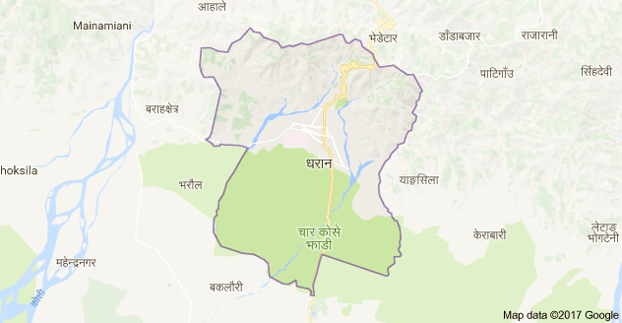

Appendix-D
Photo Gallery

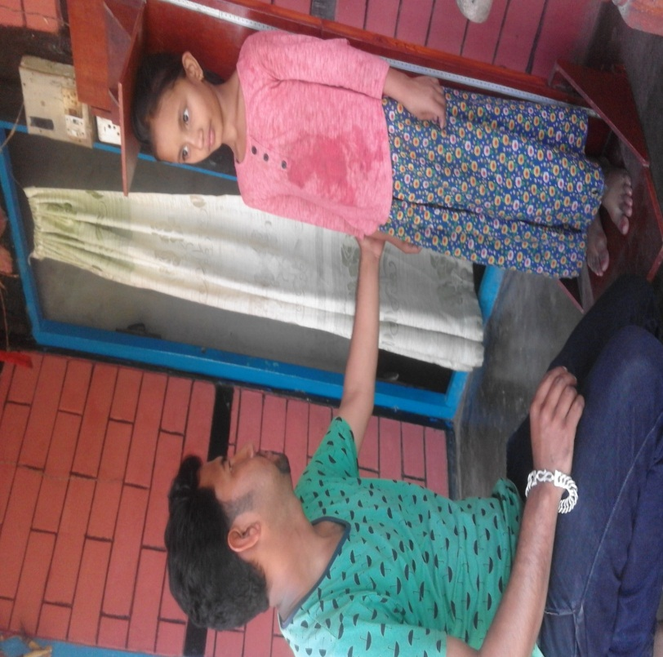
Fig. A Measurement of height
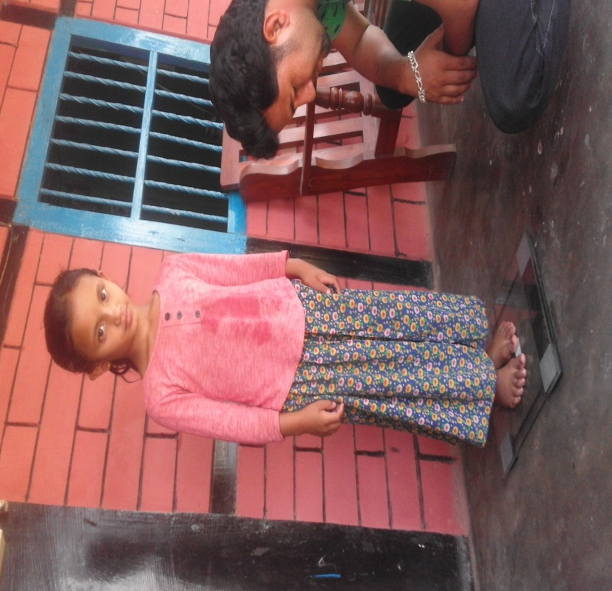
Fig. B weighing of child
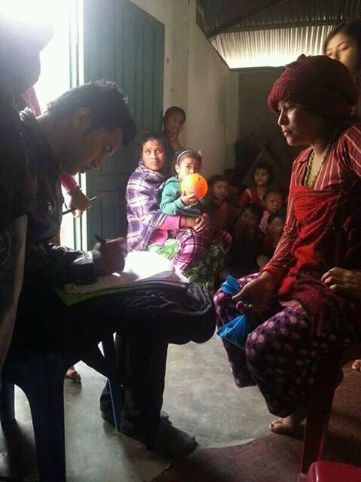
Fig. C Interviewing with child's mother

